HASSLER 27
API #05-043-40015

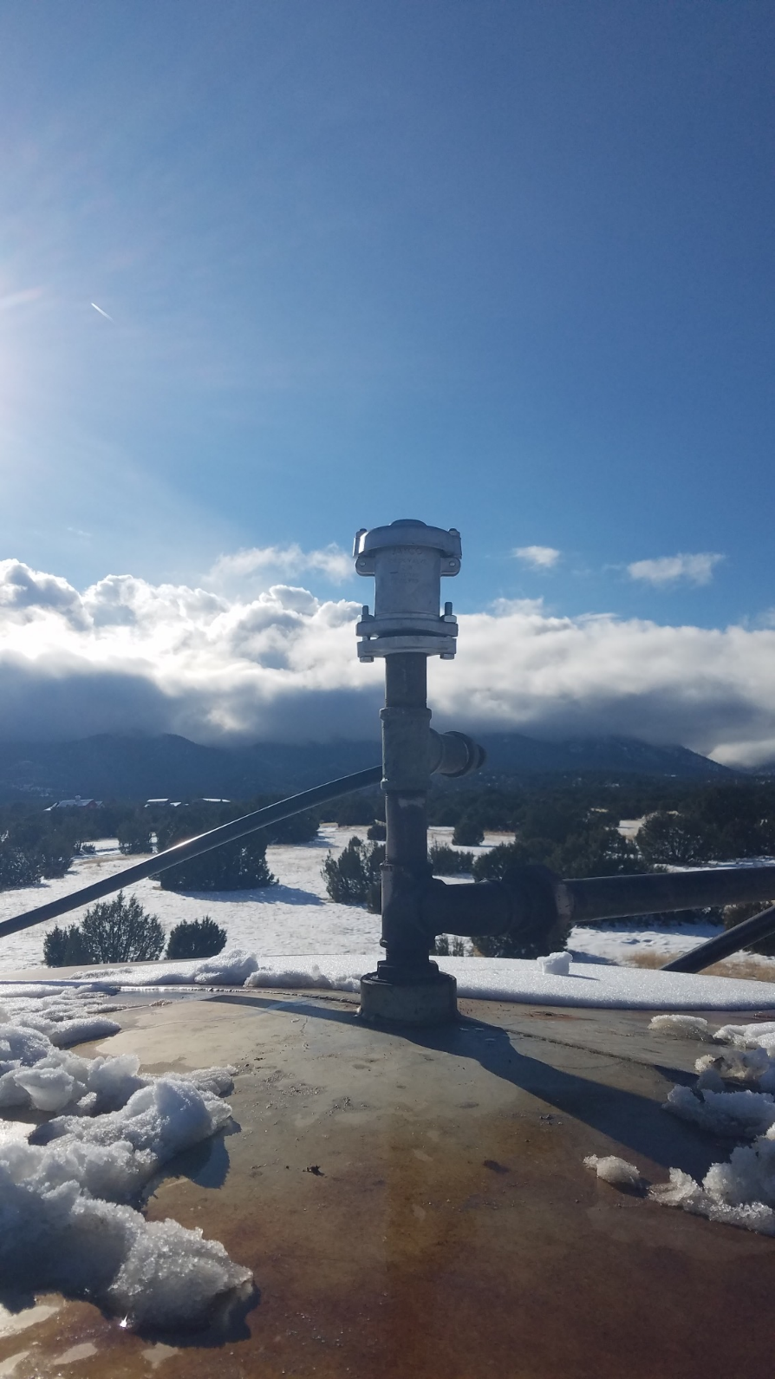
01/29/24

