FIRR Doc #403233777 Post CA photos

10/19/22 SMITH 1 API # 043-05071 Document Number: 695106890

COMMENT: UNUSED EQUIPMENT (OLD MOTOR AND PARTS).
CORRECTIVE ACTION: REMOVE UNUSED EQUIPMENT PER RULE 606. CA Date: 11/19/2022
Operator Corrective Action Date: 11/17/22

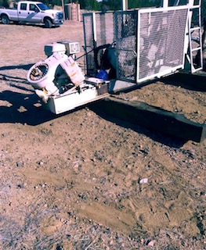

Unused equipment parts were removed from well location and area was cleaned up. Old motor, identified by inspector, is of proper weight to act as a counterweight on engine, and without it, the unit would fall off platform.

COMMENT: TRASH AND DEBRIS JUST EAST OF WELLHEAD.
CORRECTIVE ACTION: REMOVE TRASH AND DEBRIS PER RULE 606. CA Date: 11/19/2022
Operator Corrective Action Date: 11/17/22

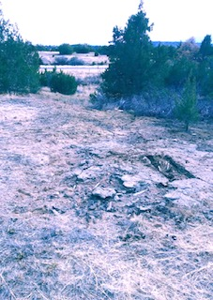
Trash and debris were picked up around location in addition to the east of wellhead.

COMMENT: AREA OF IMPACTED SOIL UNDER GEAR BOX OF PUMPJACK.
COMMENT: AREA OF IMPACTED SOIL AROUND WELLHEAD.
CORRECTIVE ACTION: Conduct maintenance on equipment, cleanup stained material and review self inspection processes. COMPLY WITH RULE 1002,.(2).D. CA Date: 11/19/2022
Operator Corrective Action Date: 11/17/22
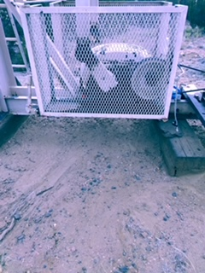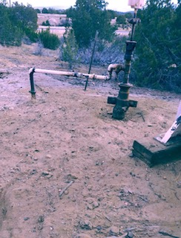

Cleaned area under gearbox and around wellhead; removed stained soil and replaced with clean soil.
Tightend fittings and greased zerks.

COMMENT: FLIR CAMPERA INDICATES THE WELLHEAD IS LEAKING IN MULTIPLE POINTS UNDER THE WELLHEAD CAP.
CORRECTIVE ACTION: Securely fasten all valves, pipes, fittings, and Production Facilities to ensure good mechanical condition, inspect at regular intervals and maintain in good mechanical condition per Rule 608.e. CA Date: 11/19/2022
Operator Corrective Action Date: 11/17/22
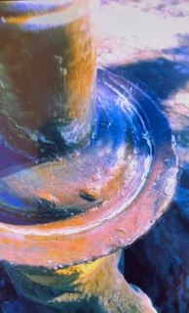
Wellhead was tightened and sealed to eliminate gas leaking. Inspection was conducted with soapy water and confirmed leak was repaired; no soap bubbles were observed.

COMMENT: Bradenhead inaccessible or not visible (WELL DOES NOT APPEAR TO HAVE A BRADENHEAD INSTALLED).
Operator Inspection Date: 11/17/22
Inspected wellhead again and determined there is no way to install valves on bradenhead. As indicated on a previous Bradenhead Test Report, Document Number: 402993100, Operator is unable to conduct a bradenhead test due to the wellbore construction. This well was completed in early 1900s. The production WH was stacked and welded to surface wellhead that has no valves. Unfortunately there is no possible way to install bradenhead valves.

COMMENT: RISER ON TOP OF CRUDE OIL TANK IS OPEN ENDED AND DOES NOT HAVE A PRESSURE RELEIF VALVE.
Corrective Action: Tanks will function as sealed and ventless with gas released only through a vapor control system or properly sized pressure relief valve. per Rule 608.a.(9). Corrective Action Date: 11/19/2022
Operator Corrective Action Date: 11/17/22

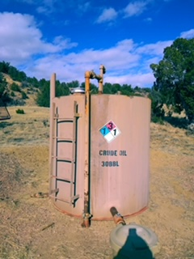

Crew installed bull plug on riser of oil tank to prevent venting at tank. Also cleaned oil staining from drips at thief hatch.

