

Site: RODGERS #1 FLOWLINE
08/25/2022
Site Inspection Report

Site Inspection Report

Inspection Details
Site/Location | Date |  |  | Time |  | Inspector
RODGERS #1 FLOWLINE | 08/25/2022 |  |  | 03:55 PM |  | COGCC Representative
Comments
Work Activity Notes |  | Crews were continuing to repurpose the flowline at the west excavation. A soil sample was collected at the base of the spill excavation
Changes since previous inspection? |  | Yes | Drive by inspection |  | No
Actively being worked? |  | Yes
Fieldwork Oversite Performed? |  | Yes | Oversite Type |  | Soil sampling
Were Oversite Samples Collected? |  | Yes | Sample Details |  | Marcom and I split one base sample at the bottom of the spill excavation. The PID reading was 800+ ppm. The sample was run for Table 915-1 Organics

Checklists

Remediation Activity Checklist
 | Photo
Question: Open excavation(s)? Note: Approximate size(s) (Length x Width x Depth, ft)  Response: Yes  Notes: 4 open excavations. Two at the ends of the flowline and two spill locations. | 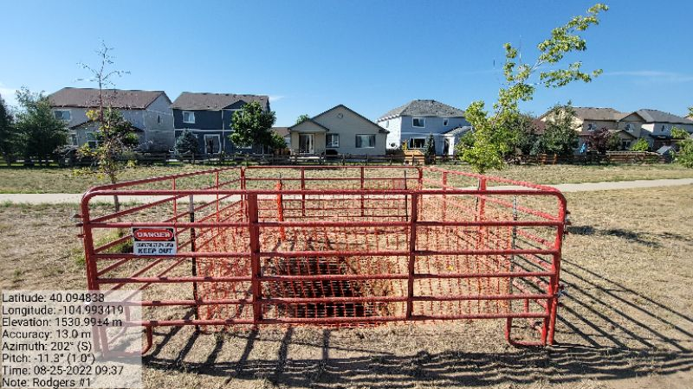
Question: Open excavation(s)? Note: Approximate size(s) (Length x Width x Depth, ft)  Response: Yes  Notes: 4 open excavations. Two at the ends of the flowline and two spill locations. | 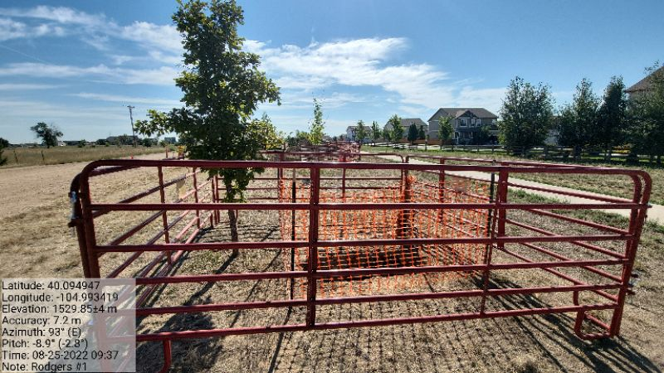
Question: Open excavation(s)? Note: Approximate size(s) (Length x Width x Depth, ft)  Response: Yes  Notes: 4 open excavations. Two at the ends of the flowline and two spill locations. | 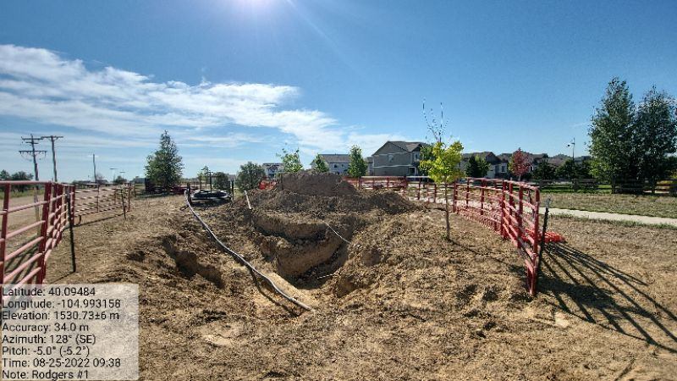
Question: Open excavation(s)? Note: Approximate size(s) (Length x Width x Depth, ft)  Response: Yes  Notes: 4 open excavations. Two at the ends of the flowline and two spill locations. | 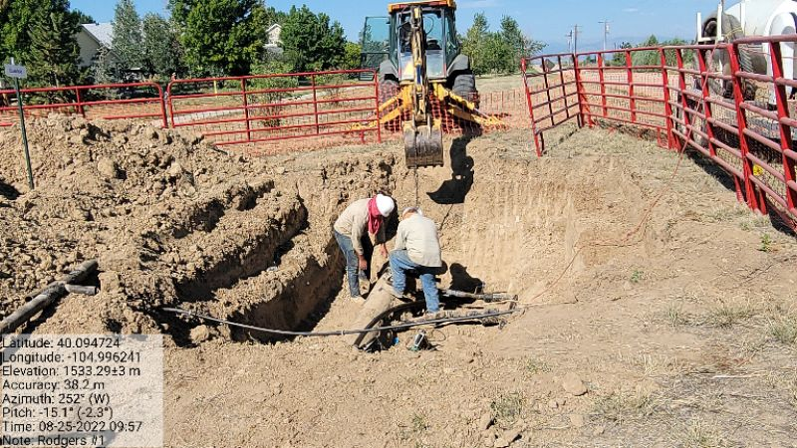
Question: Stockpiled E&P waste and approximate volume (cubic feet)?  Response: Yes  Notes: Both stockpiles are clean. | No Photo
Question: Groundwater present within excavation? Note: Depth to water below grade surface (ft), free product/sheen  Response: No  Notes: | No Photo
Question: Monitoring well(s) present? Note: Number, approximate location(s), condition  Response: No  Notes: | No Photo
Question: Soil impacts remain in situ?  Response: Yes  Notes: | No Photo

Site Condition Checklist
 | Photo
Question: E&P waste signage present, legible, accurate and up to date (labelled per KPK CWMP)?  Response: Yes  Notes: | 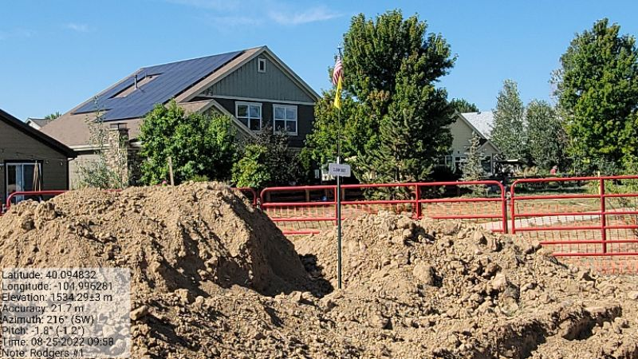
Question: Emergency signage in compliance with 605.g.? Note: Location of signage - Location entrance, Tank Battery, Wellhead(s).  Response: No  Notes: No signage | No Photo
Question: Ground surface appears clean (no evidence of new equipment leaks, oil leaks, spills, or releases)?  Response: No  Notes: | 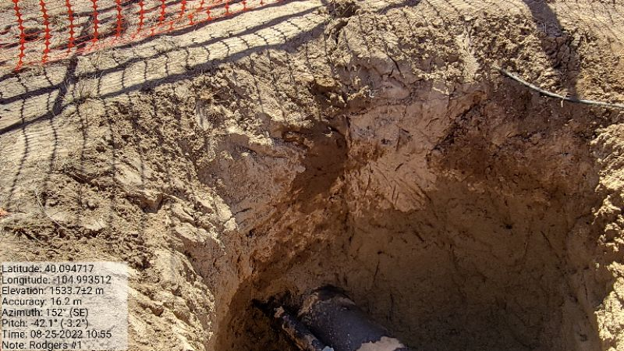
Question: Ground surface appears clean (no evidence of new equipment leaks, oil leaks, spills, or releases)?  Response: No  Notes: | 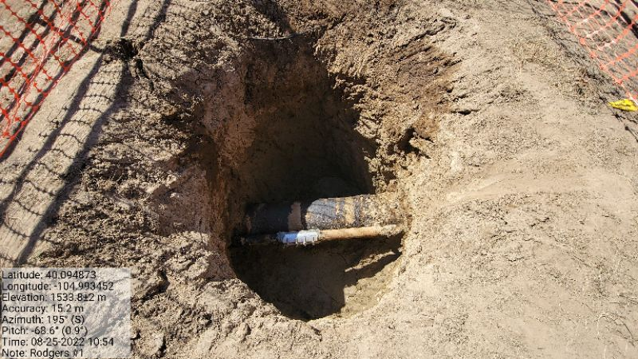
Question: Ground surface appears clean (no evidence of new equipment leaks, oil leaks, spills, or releases)?  Response: No  Notes: | 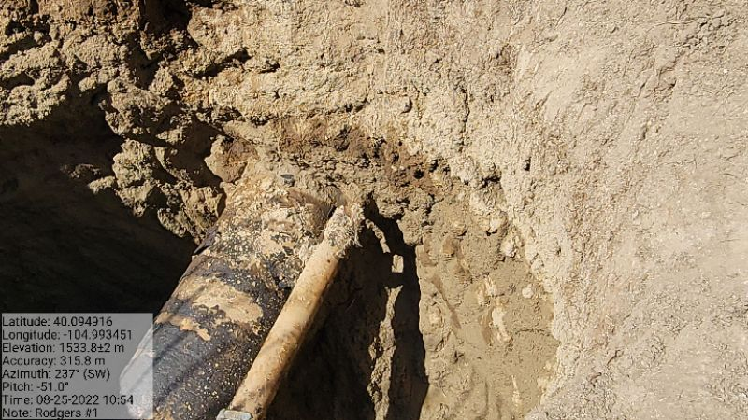
Question: Ground surface appears clean (no evidence of new equipment leaks, oil leaks, spills, or releases)?  Response: No  Notes: | 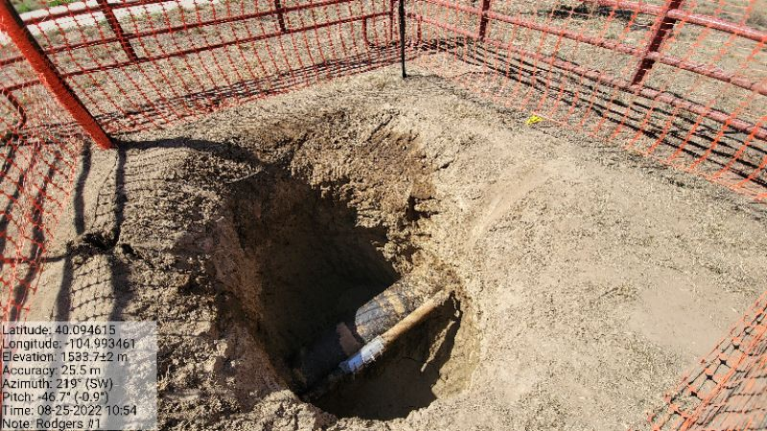
Question: Open excavation properly fenced/covered (in accordance with Rule 913.b.(5)B.i.)?  Response: Yes  Notes: | 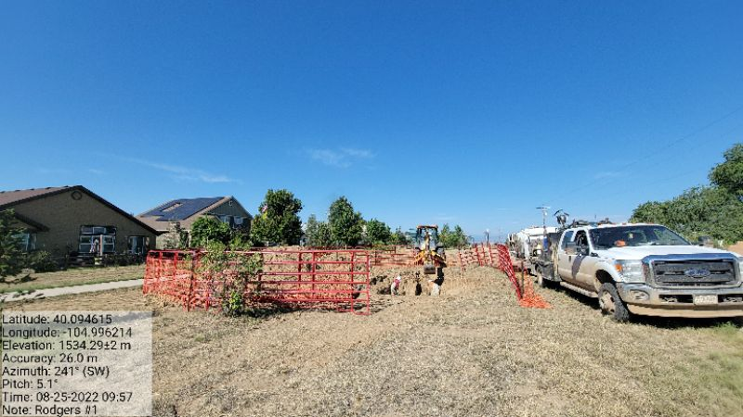
Question: Open excavation properly fenced/covered (in accordance with Rule 913.b.(5)B.i.)?  Response: Yes  Notes: | 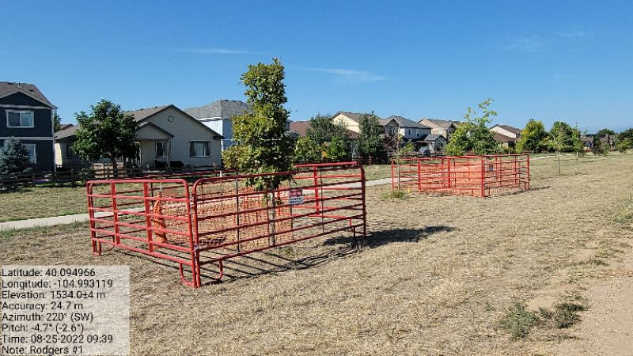
Question: Open excavation properly fenced/covered (in accordance with Rule 913.b.(5)B.i.)?  Response: Yes  Notes: | 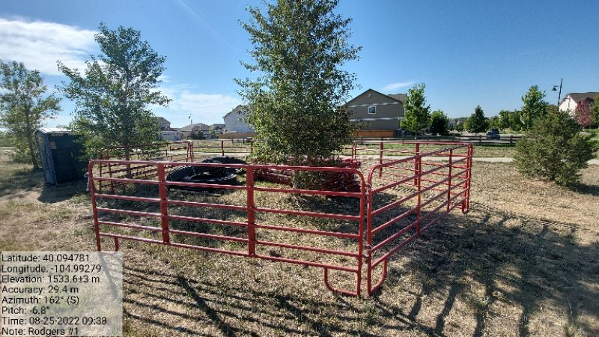
Question: Open excavation properly fenced/covered (in accordance with Rule 913.b.(5)B.i.)?  Response: Yes  Notes: | 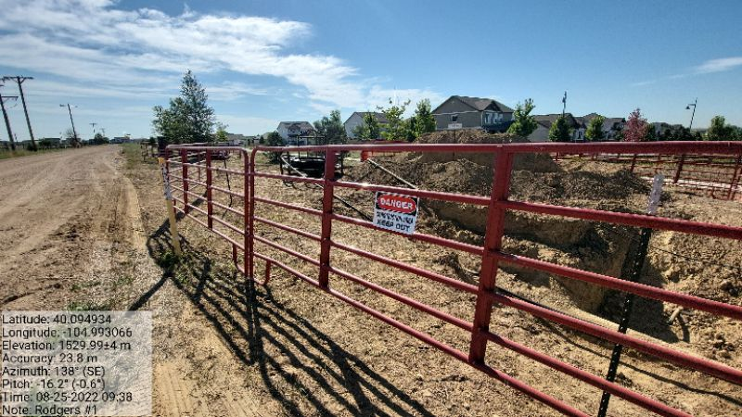
Question: Open excavation properly fenced/covered (in accordance with Rule 913.b.(5)B.i.)?  Response: Yes  Notes: | 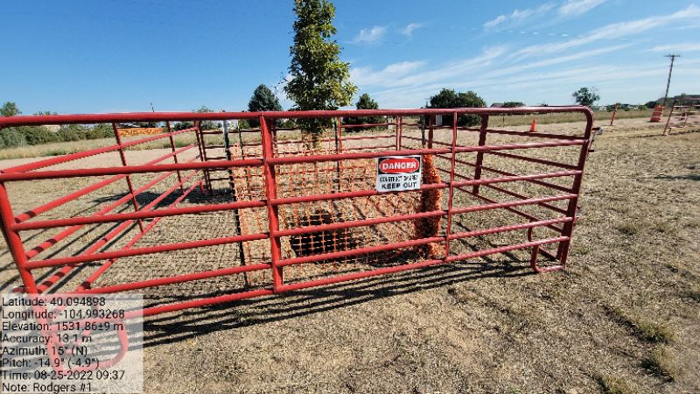
Question: Is fencing adequate/appropriate for site and well(s) and maintained?  Response: Yes  Notes: | 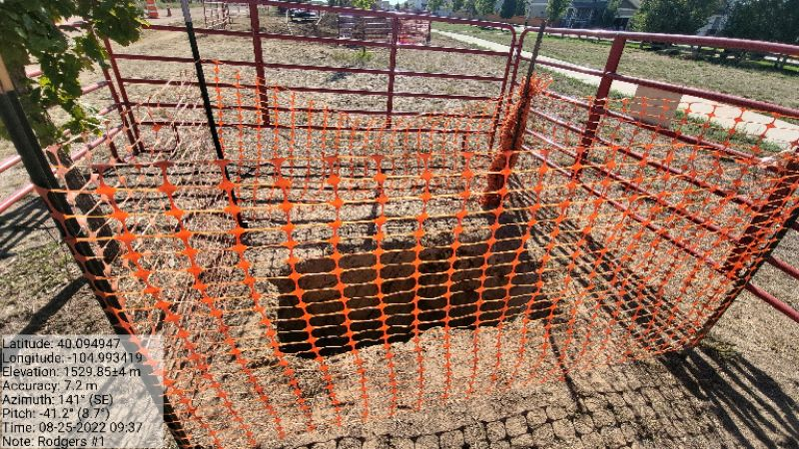
Question: Is fencing adequate/appropriate for site and well(s) and maintained?
Response: Yes
Notes:
Question: Is fencing adequate/appropriate for site and well(s) and maintained?
Response: Yes
Notes:
Question: Exposed buried/underground flowlines within excavation?
Response: Yes
Notes:
Question: Exposed buried/underground flowlines within excavation?
Response: Yes
Notes:
Question: Exposed buried/underground flowlines within excavation?  Response: Yes  Notes: | 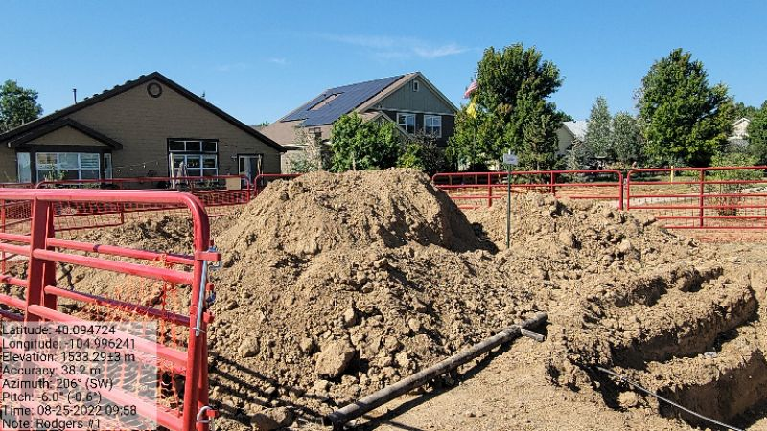
Question: If flowlines are exposed are they properly capped (bullnose plug, etc.)?  Response: Yes  Notes: | No Photo
Question: Site is protected from vehicular traffic (properly fenced, gated or barricaded)?  Response: Yes  Notes: | 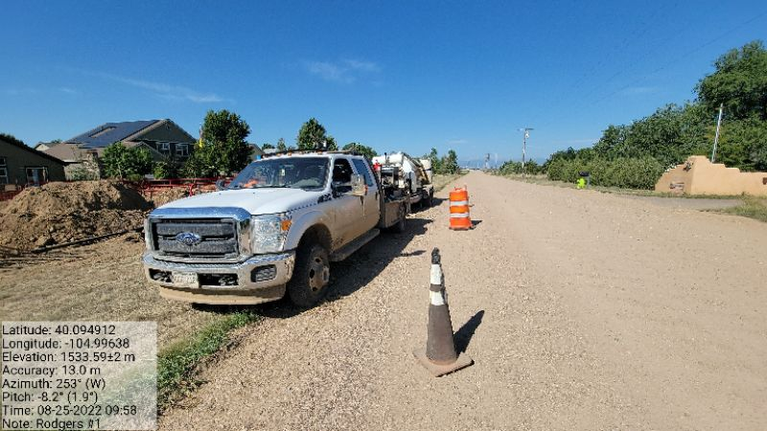
Question: Site is protected from vehicular traffic (properly fenced, gated or barricaded)?  Response: Yes  Notes: | 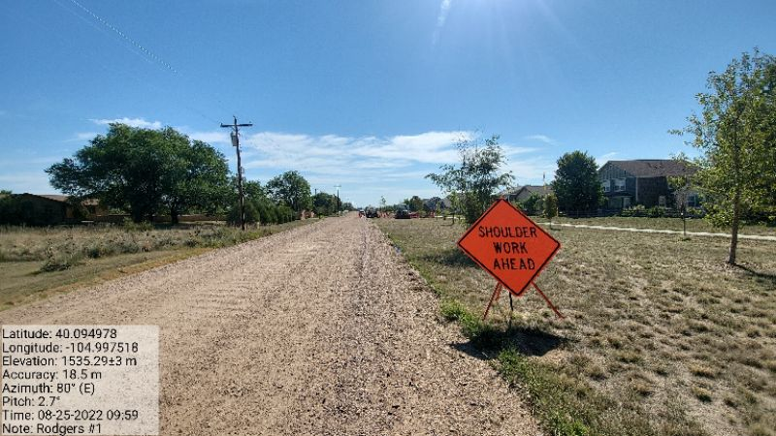
Question: Site is protected from vehicular traffic (properly fenced, gated or barricaded)?  Response: Yes  Notes: | 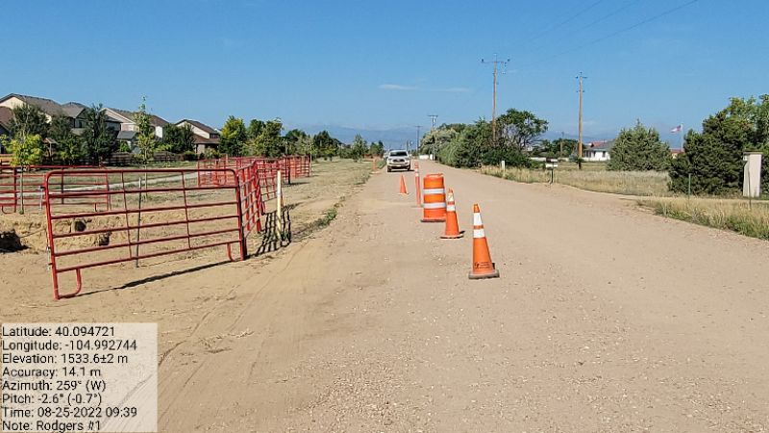
Question: Is earthen berm secondary containment present and in good condition (compacted, complete, no evidence of erosion, animal burrowing, etc.)?
Response: Yes
Notes:
Question: Is earthen berm secondary containment present and in good condition (compacted, complete, no evidence of erosion, animal burrowing, etc.)?  Response: Yes  Notes: | 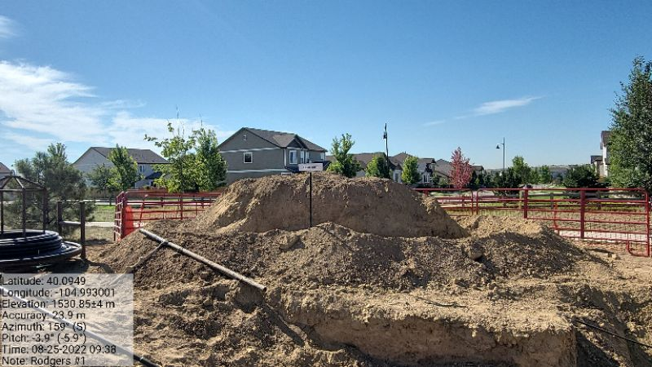
Question: Is work being conducted in a minimal footprint? Note: Any property/crop damage  Response: Yes  Notes: | No Photo
Question: Is location adjacent to any Potential Receptors? Note: Livestock, surface water, occupied structure, adjacent land use, etc.
Response: Yes
Notes: Neighborhood
Question: Stockpiled waste stored and handled in compliance with Rule 913.b.(5).B.iv.?  Response: Yes  Notes: | No Photo

Stormwater Checklist
 | Photo
Question: Evidence of pollutants being discharged off-site?  Response: No  Notes: | No Photo
Question: All stormwater erosion control measures and BMPs are present and in good/working condition?  Response: Yes  Notes: | No Photo
Question: Site free of unused equipment, weeds, debris/trash?  Response: Yes  Notes: | No Photo

GENERAl site Photos

General Site - 1  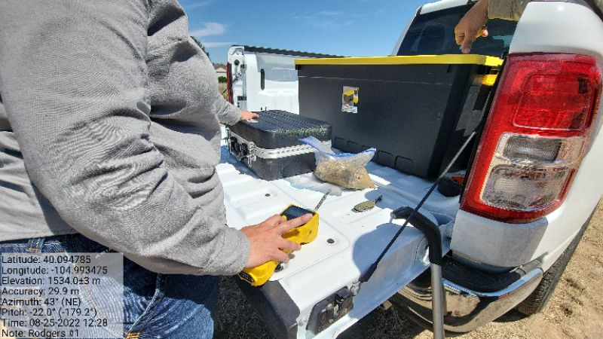 | General Site - 2  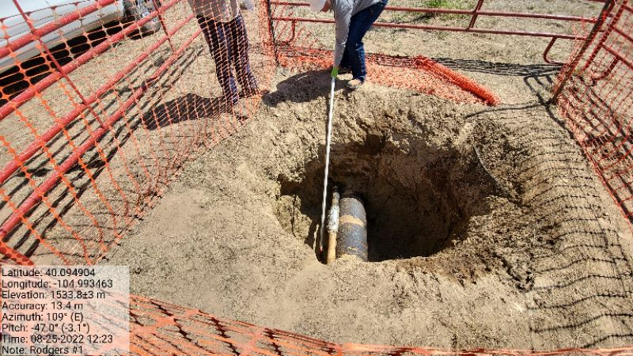
General Site - 3  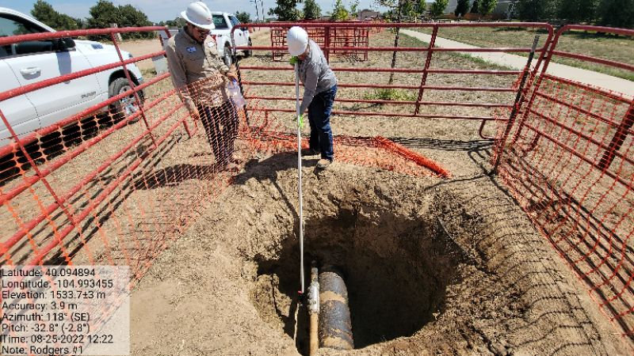 | General Site - 4  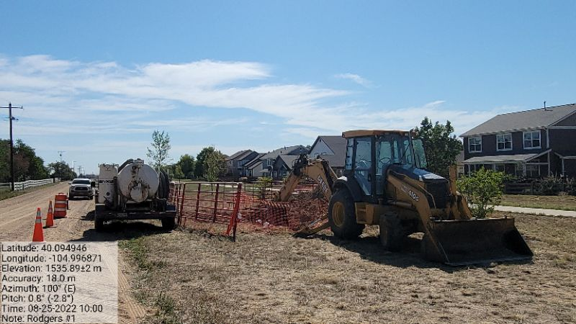
General Site - 5 | General Site - 6
General Site - 7  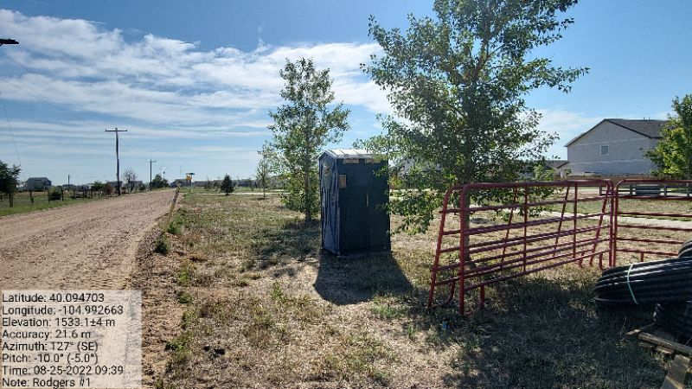 | General Site - 8  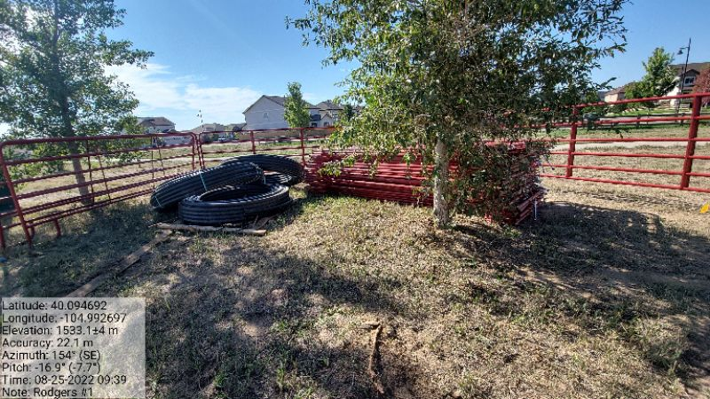
General Site - 9 | General Site - 10
General Site - 11

