

Site: FAC 5 WEST CONSOLIDATION
06/16/2022
Site Inspection Report

Site Inspection Report

Inspection Details
Site/Location | Date |  |  | Time |  | Inspector
FAC 5 WEST CONSOLIDATION | 06/16/2022 |  |  | 03:07 PM |  | COGCC Representative
Comments |  | Staining is seen about 50 feet south of excavation along the flowline path.
Work Activity Notes
Changes since previous inspection? |  | Yes | Drive by inspection |  | No
Actively being worked? |  | No
Fieldwork Oversite Performed? |  | No | Oversite Type
Were Oversite Samples Collected? |  | No | Sample Details

Checklists

Remediation Activity Checklist
 | Photo
Question: Open excavation? Approximate size (Length x Width x Depth, ft)  Response: Yes  Notes: 42x12x2 | 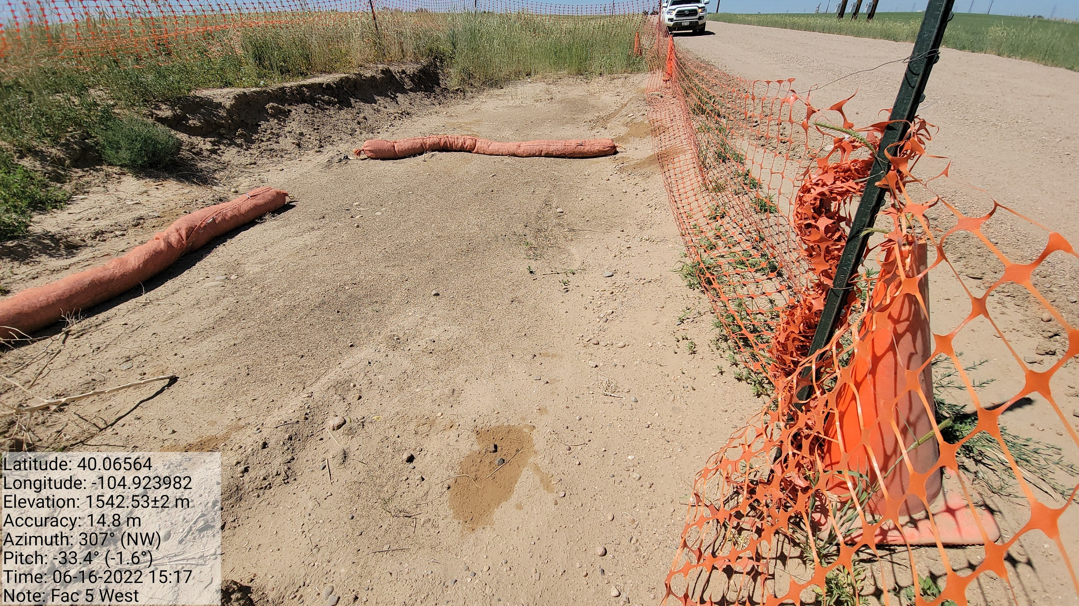
Question: Stockpiled waste and approximate volume (cubic yards)  Response: No  Notes: Stockpile has been hauled from the excavation | No Photo
Question: Groundwater present? (Depth, ft) Note: Free product/Sheen  Response: No  Notes: | No Photo
Question: Monitoring well(s) present? If so note number and approximate location  Response: No  Notes: | No Photo
Question: Soil impacts remain in situ?  Response: Yes  Notes:  Staining is seen within the excavation and 50 feet south of excavation along the flowline path. | 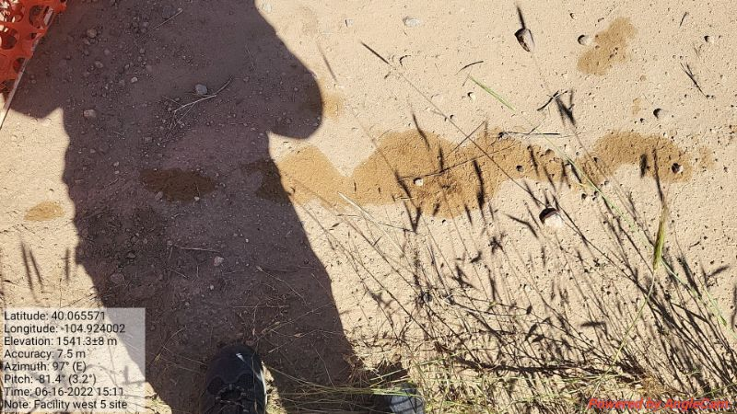

Site Condition Checklist
 | Photo
Question: Waste signage present, legible is accurate and up to date (in accordance with rule 913.b.(5)B.iv)?  Response: N/A  Notes: | No Photo
Question: Emergency sign in compliance with 605.g?  Response: Yes  Notes: | 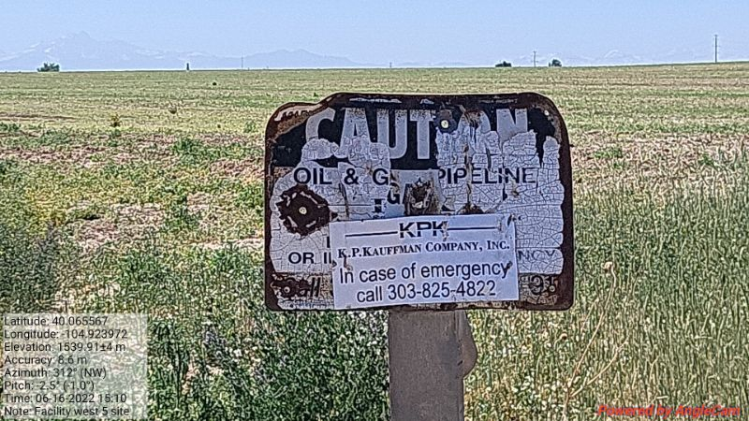
Question: Ground surface appears clean (no evidence of new equipment leaks, oil leaks, spills, or releases)?  Response: No  Notes: Staining seen along flowline outside excavation boundaries. Staining has high gasoline odor. | 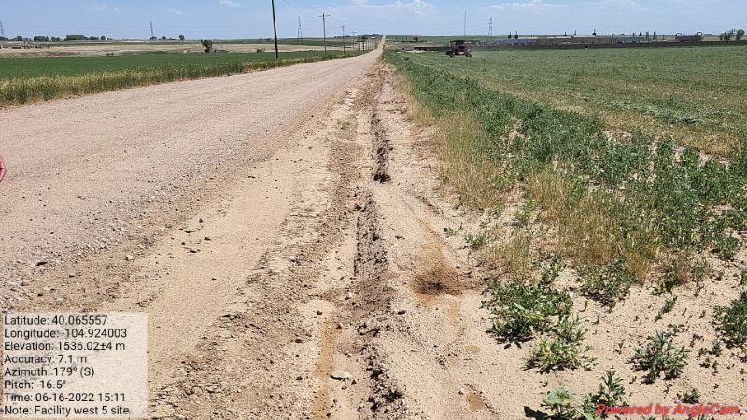
Question: Ground surface appears clean (no evidence of new equipment leaks, oil leaks, spills, or releases)?
Response: No
Notes: Staining seen along flowline outside excavation boundaries. Staining has high gasoline odor.
Question: Ground surface appears clean (no evidence of new equipment leaks, oil leaks, spills, or releases)?  Response: No  Notes: Staining seen along flowline outside excavation boundaries. Staining has high gasoline odor. | 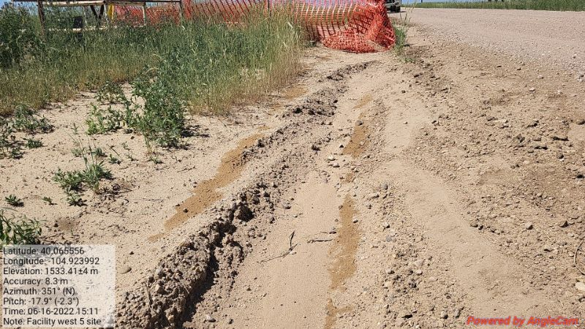
Question: Open excavation properly fenced/covered (in accordance with Rule 913.b.(5)B.i.)?  Response: Yes  Notes: | 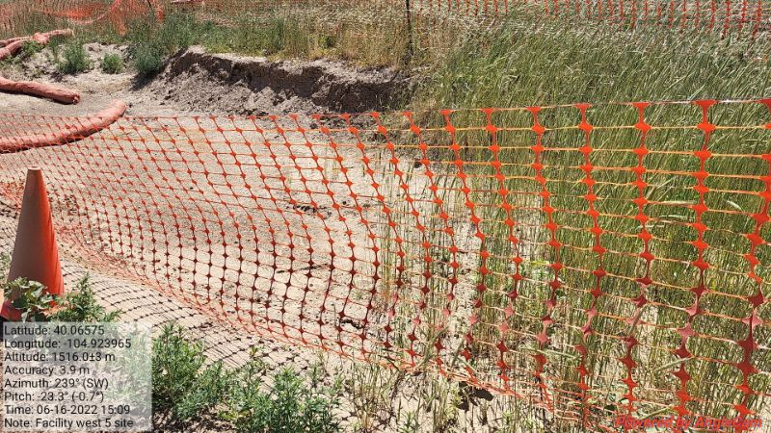
Question: Is fencing adequate/appropriate for site and well maintained?  Response: Yes  Notes: | No Photo
Question: Exposed buried/underground flowlines?  Response: No  Notes: | No Photo
Question: If flowlines are exposed are they properly capped (bullnose plug, etc.)?  Response: N/A  Notes: | No Photo
Question: Site is protected from vehicular traffic?  Response: Yes  Notes: | No Photo
Question: Is an earthen berm secondary containment present and in good condition (no evidence of erosion, animal burrowing, etc.)?  Response: N/A  Notes: | No Photo
Question: Is work being conducted in a minimal footprint? (Note if any property/crop damage)  Response: Yes  Notes: | No Photo
Question: Is location adjacent to any Potential Receptors? (livestock, surface water, occupied structure, adjacent land use, etc.)  Response: Yes  Notes: Crops, farmland | No Photo

Stormwater Checklist
 | Photo
Question: Evidence of pollutants being discharged off-site?  Response: No  Notes: | No Photo
Question: All stormwater erosion control measures and BMPs are present and in good/working condition?  Response: Yes  Notes: | No Photo
Question: Site free of unused equipment, weeds, debris/trash?  Response: No  Notes: Trash in excavation | 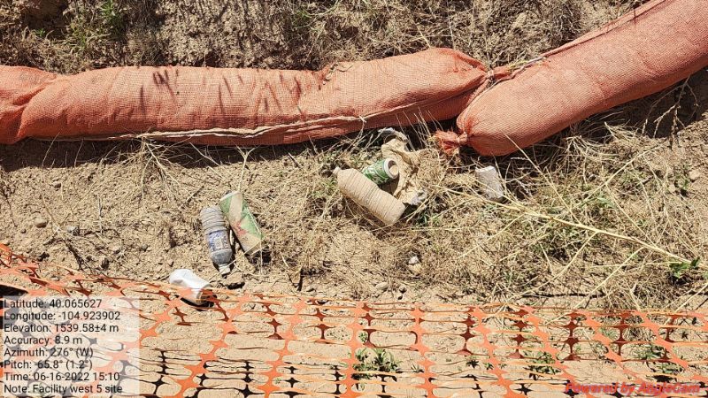
Question: Potential pollutants (trash, material stockpiles) are properly contained?  Response: Yes  Notes: | No Photo
Question: Evidence of sediment/debris observed on adjacent roads? (If yes, is note tracking control BMP presence/conditions)  Response: No  Notes: | No Photo
Question: Additional stormwater control measures/maintenance recommended?  Response: No  Notes: | No Photo

GENERAl site Photos

General Site Photos


