

Site: GRANT TANK BATTERY
06/08/2022
Site Inspection Report

Site Inspection Report

Inspection Details
Site/Location | Date |  |  | Time |  | Inspector
GRANT TANK BATTERY | 06/08/2022 |  |  | 03:25 PM |  | COGCC Contractor
Comments
Work Activity Notes
Changes since previous inspection? |  | No | Drive by inspection |  | No
Actively being worked? |  | No
Fieldwork Oversite Performed? |  | No | Oversite Type |  | N/A
Were Oversite Samples Collected? |  | No | Sample Details |  | N/A

Checklists

Remediation Activity Checklist
 | Photo
Question: Open excavation? Approximate size (Length x Width x Depth, ft)  Response: Yes  Notes: 75x25x10 | 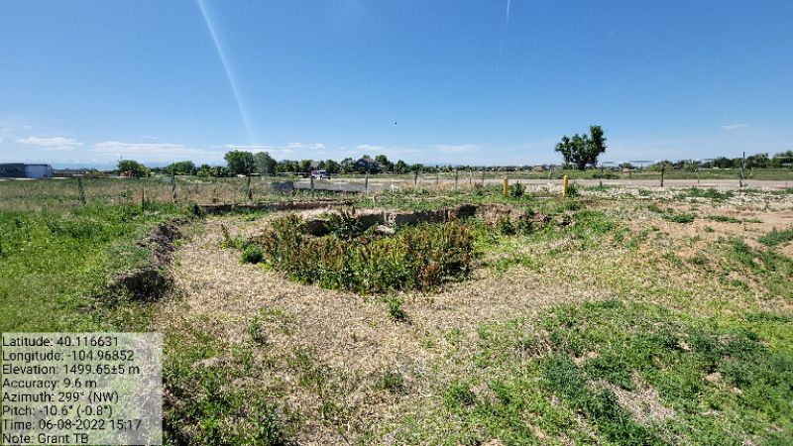
Question: Open excavation? Approximate size (Length x Width x Depth, ft)  Response: Yes  Notes: 75x25x10 | 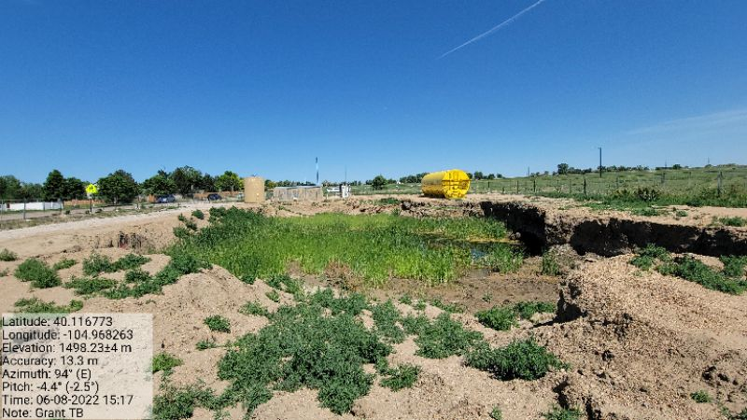
Question: Open excavation? Approximate size (Length x Width x Depth, ft)  Response: Yes  Notes: 75x25x10 | 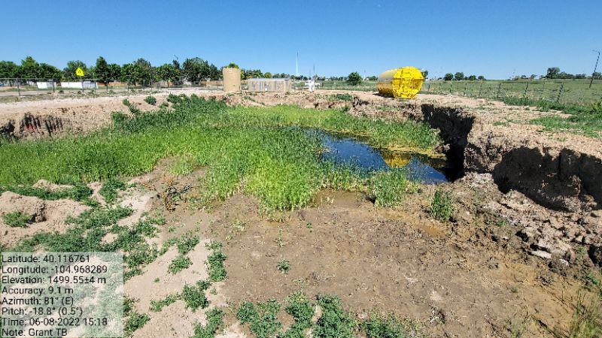
Question: Stockpiled waste and approximate volume (cubic yards)  Response: No  Notes: Stockpile has been hauled offsite | No Photo
Question: Groundwater present? (Depth, ft) Note: Free product/Sheen  Response: Yes  Notes: Depth – 10 ft | 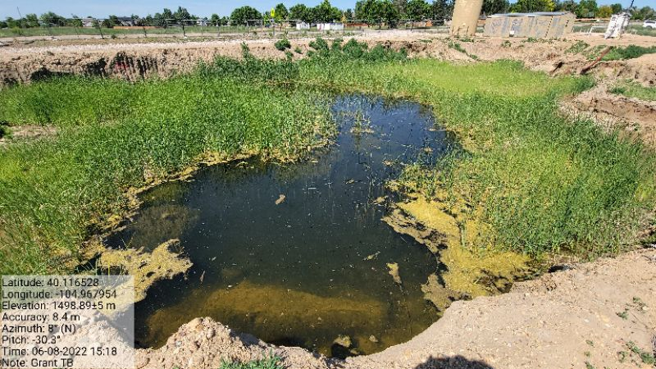
Question: Monitoring well(s) present? If so note number and approximate location  Response: Yes  Notes: Multiple | No Photo
Question: Soil impacts remain in situ?  Response: Yes  Notes: Soil impacts are visible | No Photo

Site Condition Checklist
 | Photo
Question: Waste signage present, legible is accurate and up to date (in accordance with rule 913.b.(5)B.iv)?  Response: N/A  Notes: | No Photo
Question: Emergency sign in compliance with 605.g?  Response: Yes  Notes: The emergency sign has faded. Recommend updating current signage | 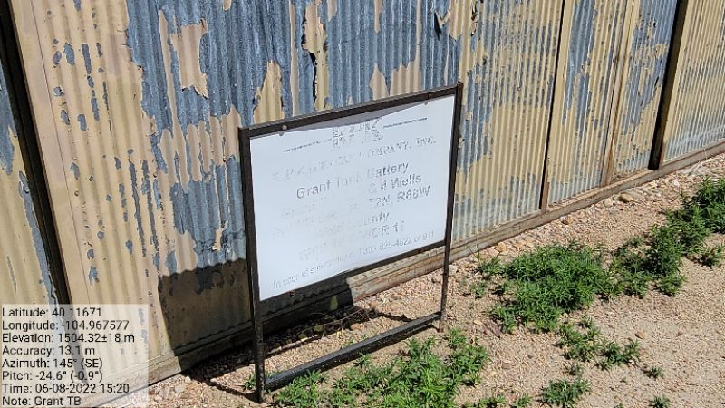
Question: Emergency sign in compliance with 605.g?  Response: Yes  Notes: | 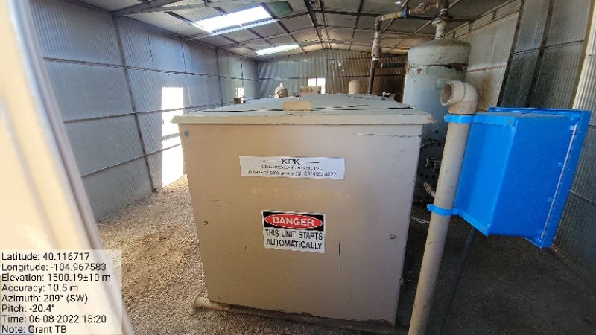
Question: Ground surface appears clean (no evidence of new equipment leaks, oil leaks, spills, or releases)?  Response: No  Notes: Ground surface within the excavation has visible impacts | No Photo
Question: Open excavation properly fenced/covered (in accordance with Rule 913.b.(5)B.i.)?  Response: No  Notes: Fencing around the perimeter of the site is not adequate. | 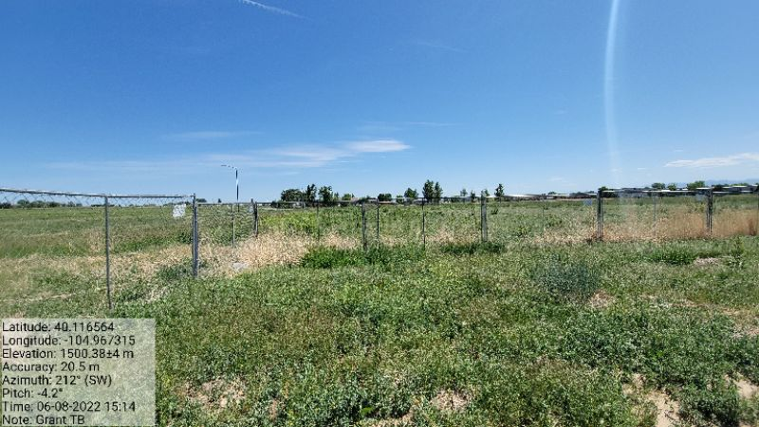
Question: Open excavation properly fenced/covered (in accordance with Rule 913.b.(5)B.i.)?  Response: No  Notes: Fencing around the perimeter of the site is not adequate. | 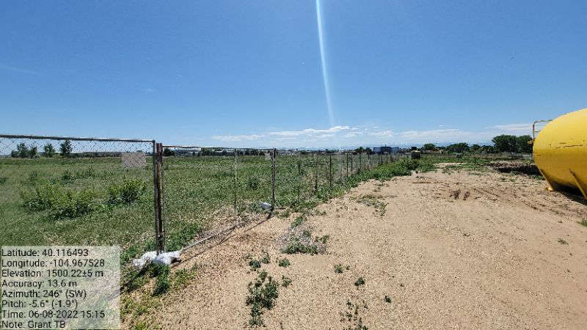
Question: Open excavation properly fenced/covered (in accordance with Rule 913.b.(5)B.i.)?  Response: No  Notes: Fencing around the perimeter of the site is not adequate. | 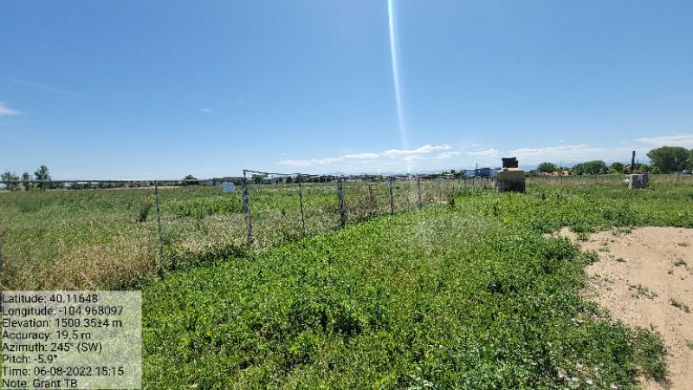
Question: Open excavation properly fenced/covered (in accordance with Rule 913.b.(5)B.i.)?  Response: No  Notes: Fencing around the perimeter of the site is not adequate. The gaps in fencing do not provide an effective/adequate means of excluding entry of people. | 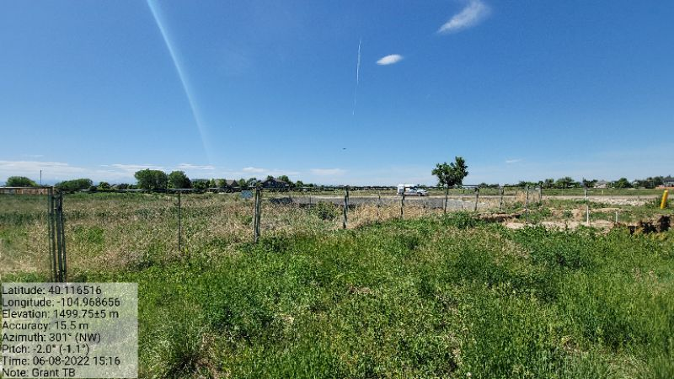
Question: Is fencing adequate/appropriate for site and well maintained?  Response: No  Notes: Fencing around the perimeter of the site is not adequate. The gaps in fencing do not provide an effective/adequate means of excluding entry of people. | 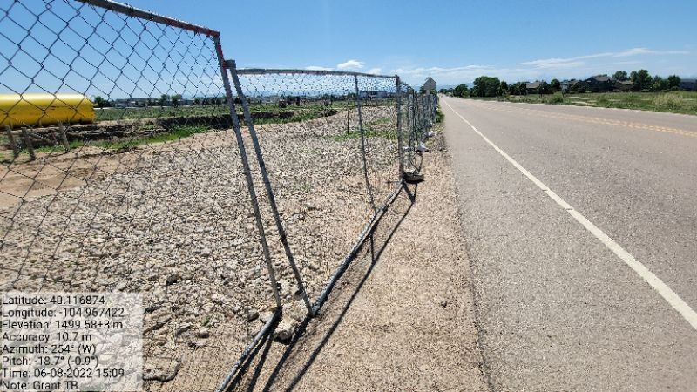
Question: Is fencing adequate/appropriate for site and well maintained?  Response: No  Notes: Fencing around the perimeter of the site is not adequate. The gaps in fencing do not provide an effective/adequate means of excluding entry of people. | 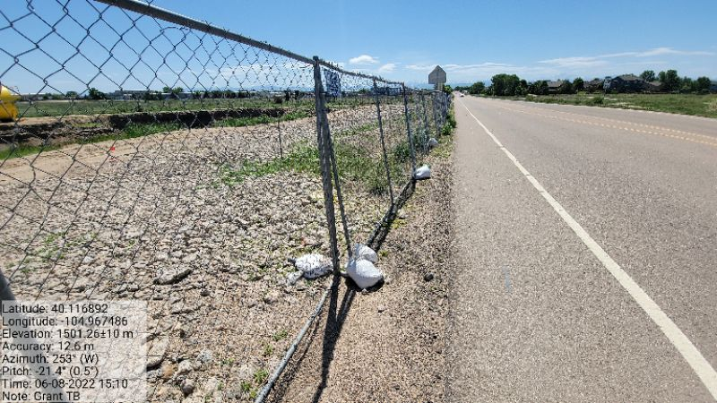
Question: Is fencing adequate/appropriate for site and well maintained?  Response: No  Notes: Fencing around the perimeter of the site is not adequate. The gaps in fencing do not provide an effective/adequate means of excluding entry of people. | 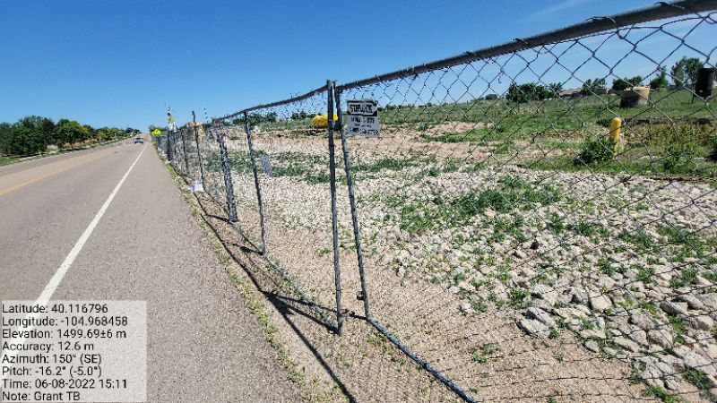
Question: Is fencing adequate/appropriate for site and well maintained?
Response: No
Notes: Fencing around the perimeter of the site is not adequate. The gaps in fencing do not provide an effective/adequate means of excluding entry of people.
Question: Is fencing adequate/appropriate for site and well maintained?  Response: No  Notes: Fencing around the perimeter of the site is not adequate. The gaps in fencing do not provide an effective/adequate means of excluding entry of people. | 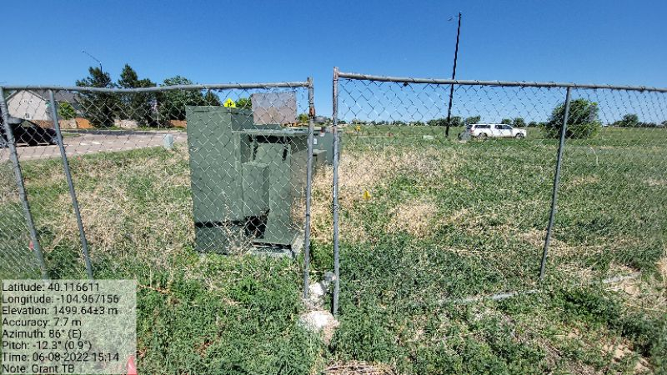
Question: Exposed buried/underground flowlines?  Response: yes  Notes: | No Photo
Question: If flowlines are exposed are they properly capped (bullnose plug, etc.)?  Response: No  Notes: Flowlines within the excavation are not properly capped | 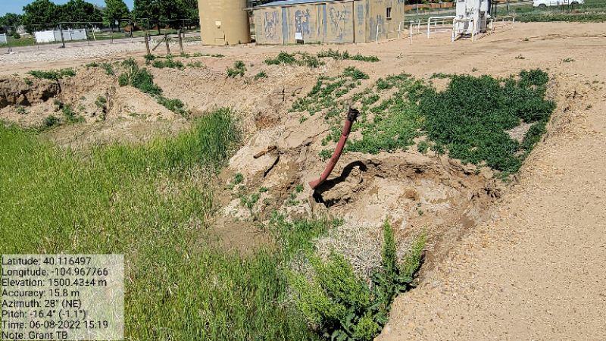
Question: Site is protected from vehicular traffic?  Response: Yes  Notes: | No Photo
Question: Is an earthen berm secondary containment present and in good condition (no evidence of erosion, animal burrowing, etc.)?  Response: Yes  Notes: | 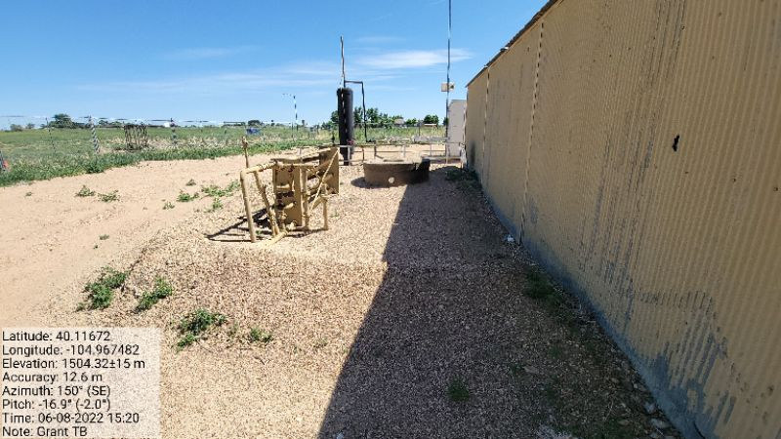
Question: Is work being conducted in a minimal footprint? (Note if any property/crop damage)  Response: Yes  Notes: | No Photo

Stormwater Checklist
 | Photo
Question: Evidence of pollutants being discharged off-site?  Response: No  Notes: | No Photo
Question: All stormwater erosion control measures and BMPs are present and in good/working condition?  Response: Yes  Notes: | 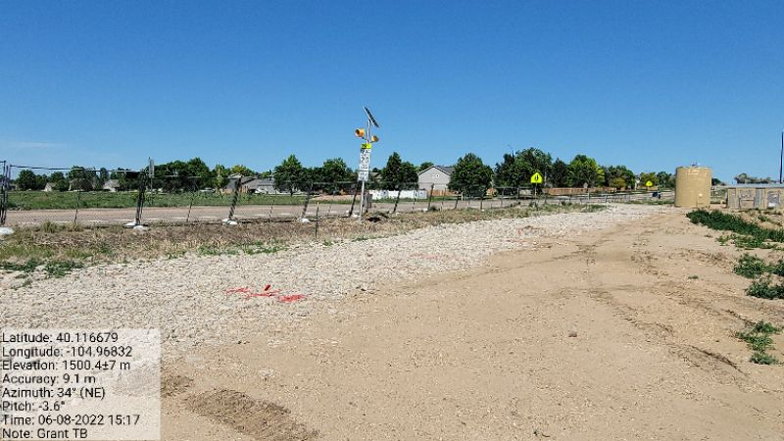
Question: Site free of unused equipment, weeds, debris/trash?  Response: No  Notes: Unused equipment still onsite. Weeds growing all throughout the site | 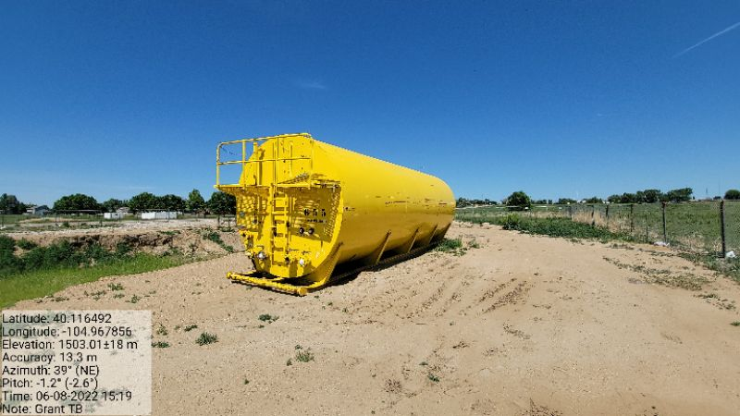
Question: Site free of unused equipment, weeds, debris/trash?  Response: No  Notes: Unused equipment still onsite. Weeds growing all throughout the site | 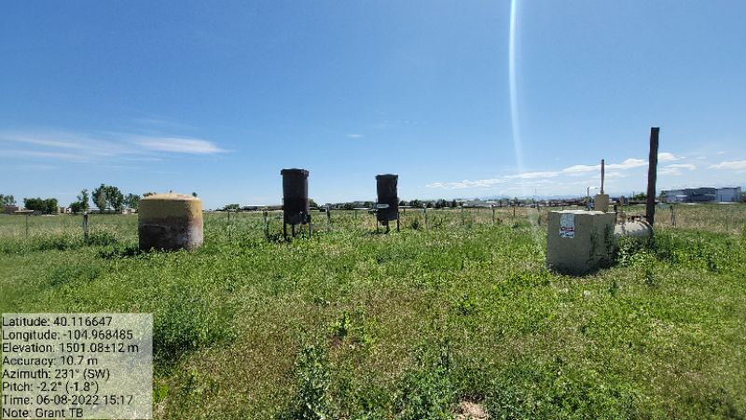
Question: Site free of unused equipment, weeds, debris/trash?  Response: No  Notes: Unused equipment still onsite. Weeds growing all throughout the site | 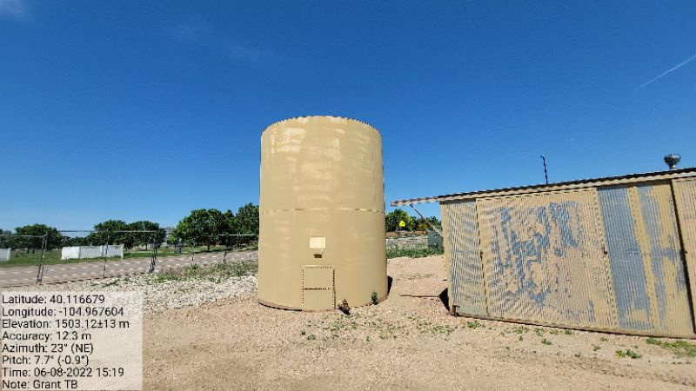
Question: Potential pollutants (trash, material stockpiles) are properly contained?  Response: Yes  Notes | No Photo
Question: Evidence of sediment/debris observed on adjacent roads? (If yes, is note tracking control BMP presence/conditions)  Response: No  Notes: Tracking control is adequate | No Photo
Question: Additional stormwater control measures/maintenance recommended?  Response: No  Notes: | No Photo

GENERAl site Photos

General Site - 1


