Energy Inc.

Form Information

Form Name: Compliance Follow Up Form Submitter Name: Aaron Easley
Submission Date: 8/3/2021
Server Receive Date: 8/3/2021
Reference Number: 693903414
Location: Eldridge 25-01 2

Information

Name Aaron Easley
Date of work completion: 7/29/2021
Well Name Eldridge 25-01 2
API Number 0506709566
Select State Colorado
Work type COGCC Inspection
Inspection Number (Inspection # from SOW) 693903414
Special Notes: Click here to enter text.
Action Complete
Chemical Treatment of weeds
Photo of above state work completion
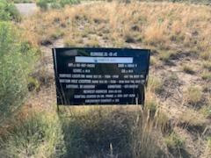

Chemical Treatment of weeds
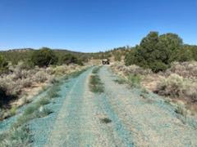

Chemical Treatment of weeds
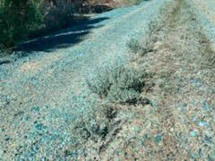
Chemical Treatment of weeds
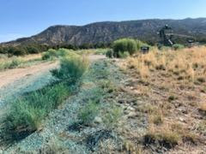
Chemical Treatment of weeds
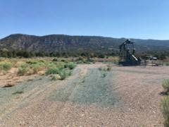
Chemical Treatment of weeds

