Energy Inc.

Form Information

Form Name: Compliance Follow Up Form Submitter Name: Aaron Easley
Submission Date: 6/23/2021
Server Receive Date: 6/23/2021
Reference Number: 693902629
Location: Anderson C1

Information

Name Aaron Easley
Date of work completion: 6/7/2021
Well Name Anderson C1
API Number 0506707771
Select State Colorado
Work type COGCC Inspection
Inspection Number (Inspection # from SOW) 693902629
Special Notes: Treated Noxious Weeds
Action Complete
Chemical Treatment of weeds
Photo of above state work completion
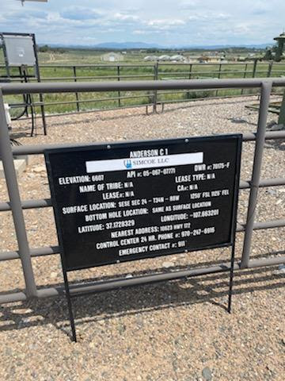

Chemical Treatment of weeds
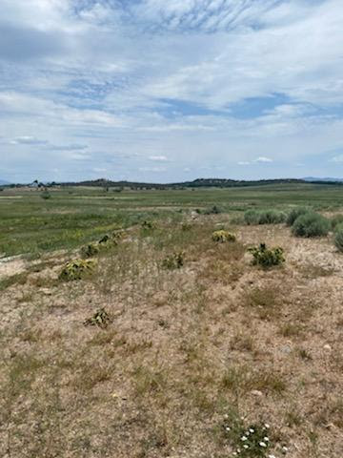

Chemical Treatment of weeds
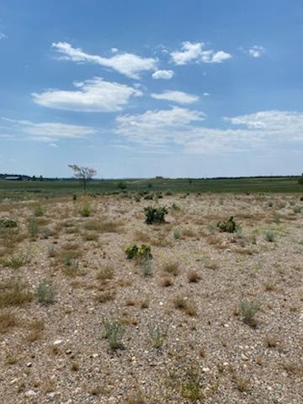
Chemical Treatment of weeds
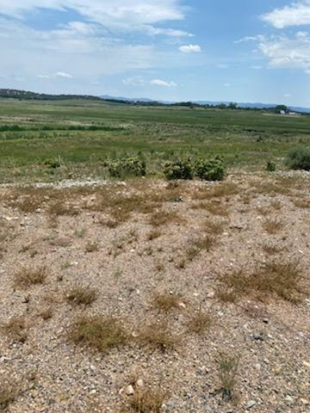
Chemical Treatment of weeds
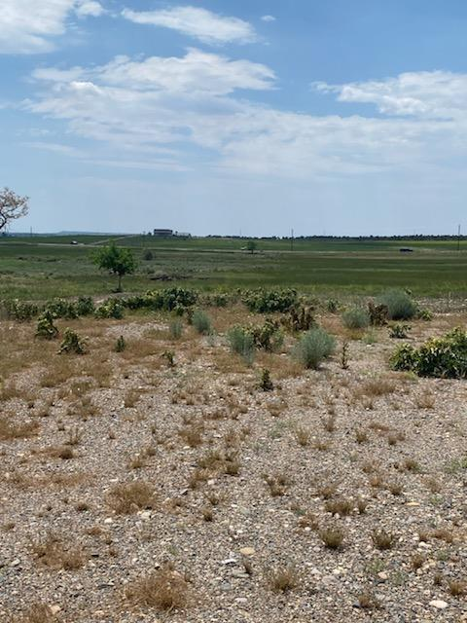
Chemical Treatment of weeds

