Energy Inc.

Form Information

Form Name: Compliance Follow Up Form Submitter Name: Aaron Easley
Submission Date: 6/14/2021
Server Receive Date: 6/14/2021
Reference Number: Click here to enter text.
Location: Holman Canyon 1

Information

Name Aaron Easley
Date of work completion: 6/1/2021
Well Name Holman Canyon 1
API Number 0506707189
Select State Colorado
Work type COGCC Inspection
Inspection Number (Inspection # from SOW) Click here to enter text.
Special Notes: Treated Noxious weeds at the Holman Canyon 1 on the same day that I treated the Holman Canyon 2. I didn’t know that it was an outstanding inspection, so I don’t have photos, but did find and treat musk thistle and scotch thistle on the S/SW portion of the site. Photo below is of application record.
Action Complete
Chemical Treatment of weeds
Photo of above state work completion
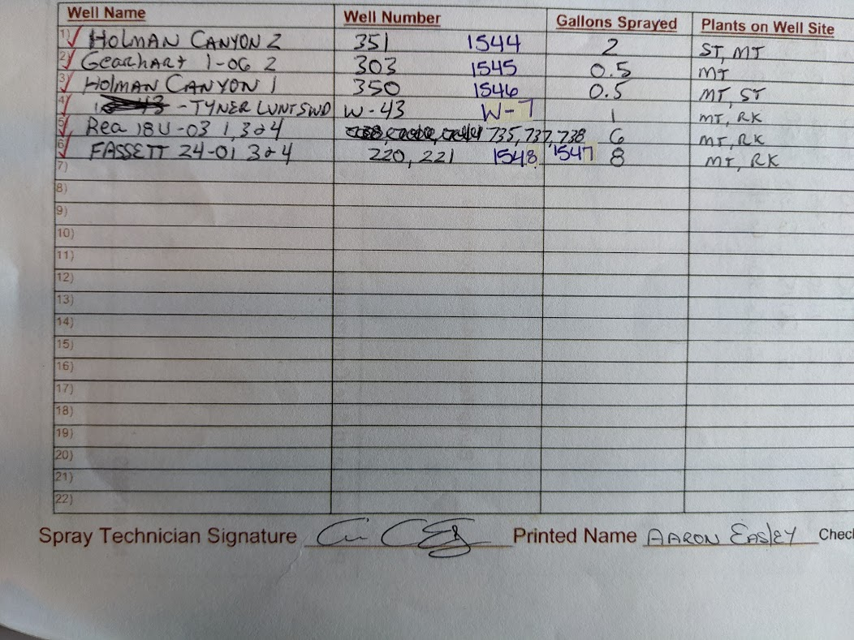

Chemical Treatment of weeds


Chemical Treatment of weeds
Chemical Treatment of weeds
Chemical Treatment of weeds
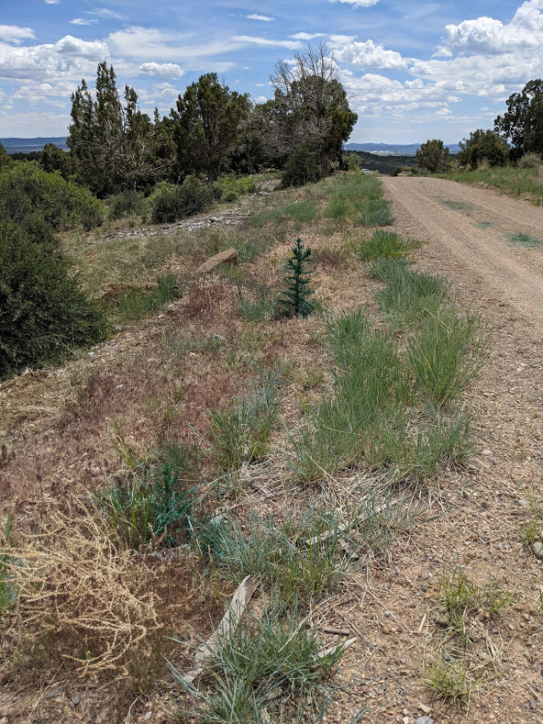
Chemical Treatment of weeds

