Energy Inc.

Form Information

Form Name: Compliance Follow Up Form Submitter Name: Aaron Easley
Submission Date: 6/7/2021
Server Receive Date: 6/7/2021
Reference Number: 693902486
Location: Rea 18U-03-3 and 4

Information

Name Aaron Easley
Date of work completion: 6/1/2021
Well Name Rea 18U-03-3 and 4
API Number 0506709189
Select State Colorado
Work type COGCC Inspection
Inspection Number (Inspection # from SOW) 693902486
Special Notes: Treated Noxious weeds – Photo 4 – Shows dead Russian knapweed from last years treatment. Russian knapweed is in all adjacent fields – I went out as far as I was comfortable with, did not want to treat in ag fields adjacent to pad. Photo 5 – Russian knapweed infestation in adjacent ag fields.
Action Complete
Chemical Treatment of weeds
Photo of above state work completion
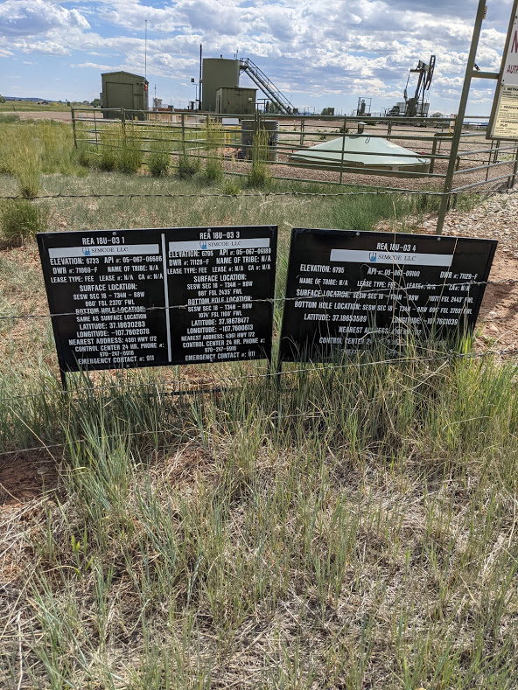

Chemical Treatment of weeds
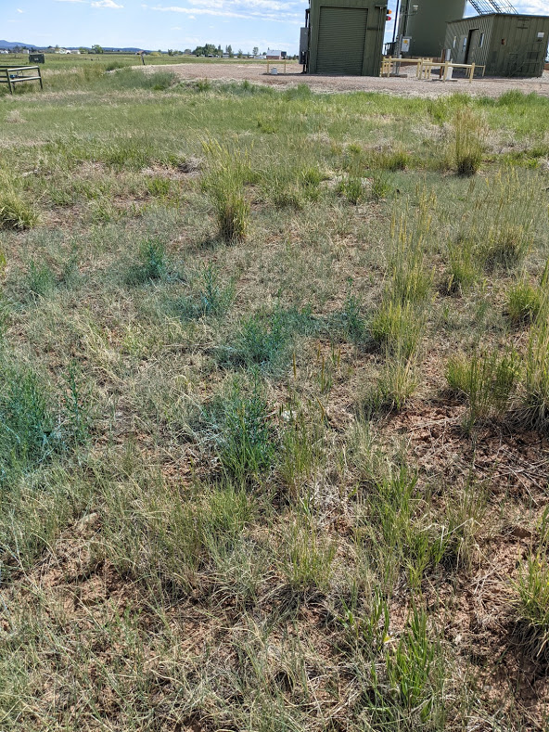

Chemical Treatment of weeds
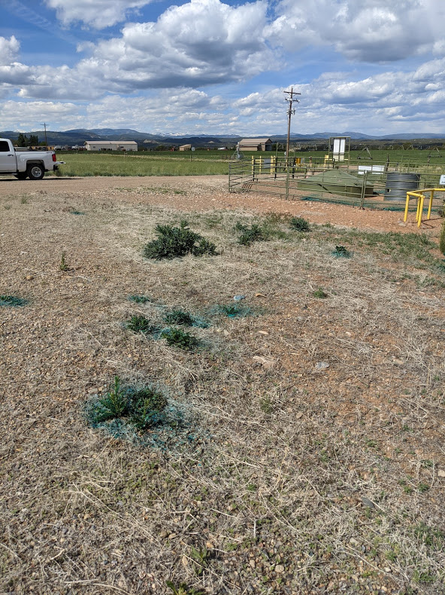
Chemical Treatment of weeds
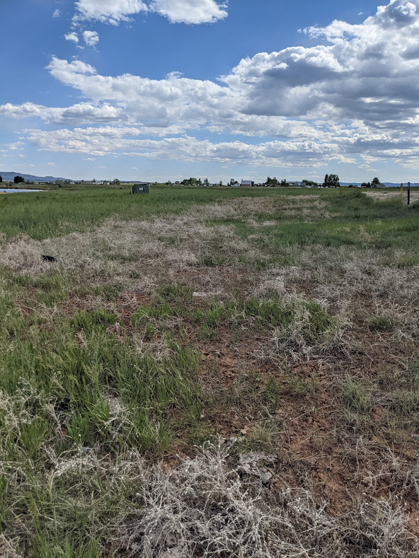
Other *must specify in notes*
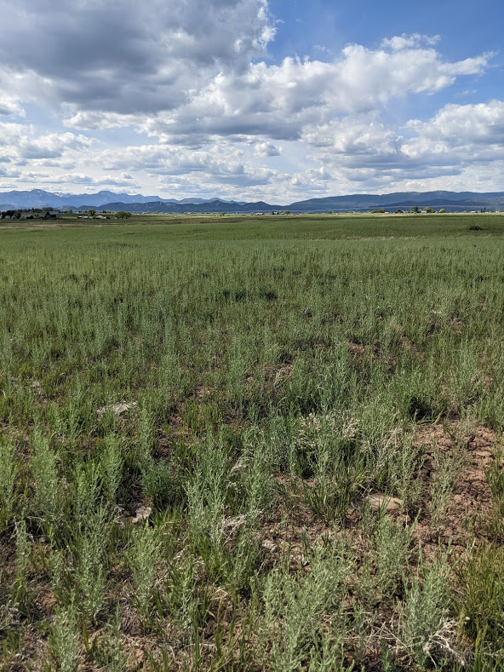
Other *must specify in notes*

