Energy Inc.

Form Information

Form Name: Compliance Follow Up Form Submitter Name: Aaron Easley
Submission Date: 6/7/2021
Server Receive Date: 6/7/2021
Reference Number: 693903212
Location: Martinez A1 and A3

Information

Name Aaron Easley
Date of work completion: 5/23/2021
Well Name Martinez A1 and A3
API Number 0506709822
Select State Colorado
Work type COGCC Inspection
Inspection Number (Inspection # from SOW) 693903212
Special Notes: Treated Noxious weeds – Site was treated approximately 2 weeks before photos were taken during routine weed control spraying – photos are of dying noxious weeds.
Action Complete
Chemical Treatment of weeds
Photo of above state work completion
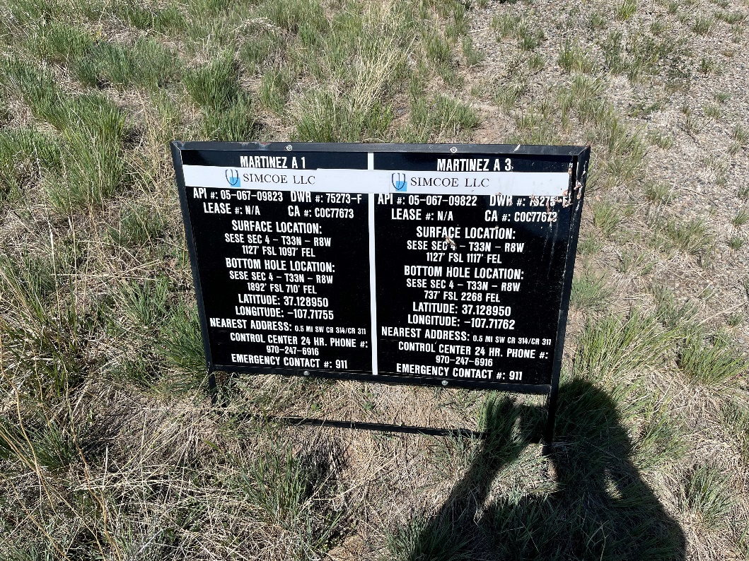

Chemical Treatment of weeds
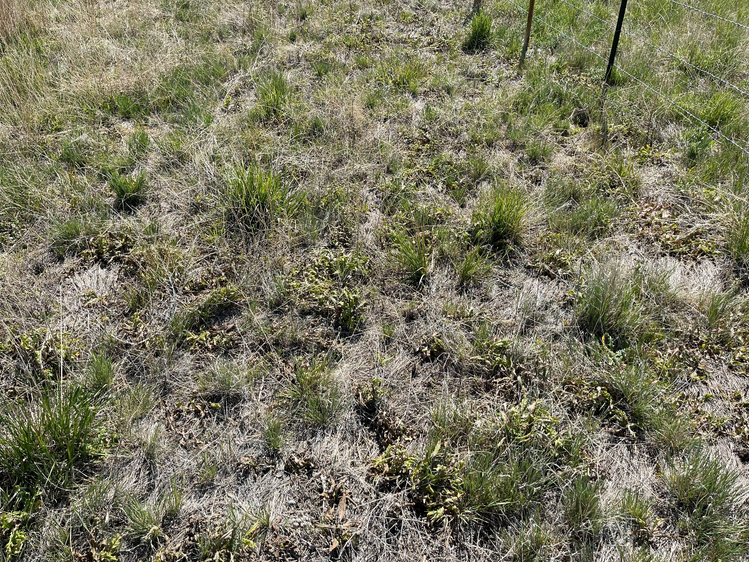

Other *must specify in notes*
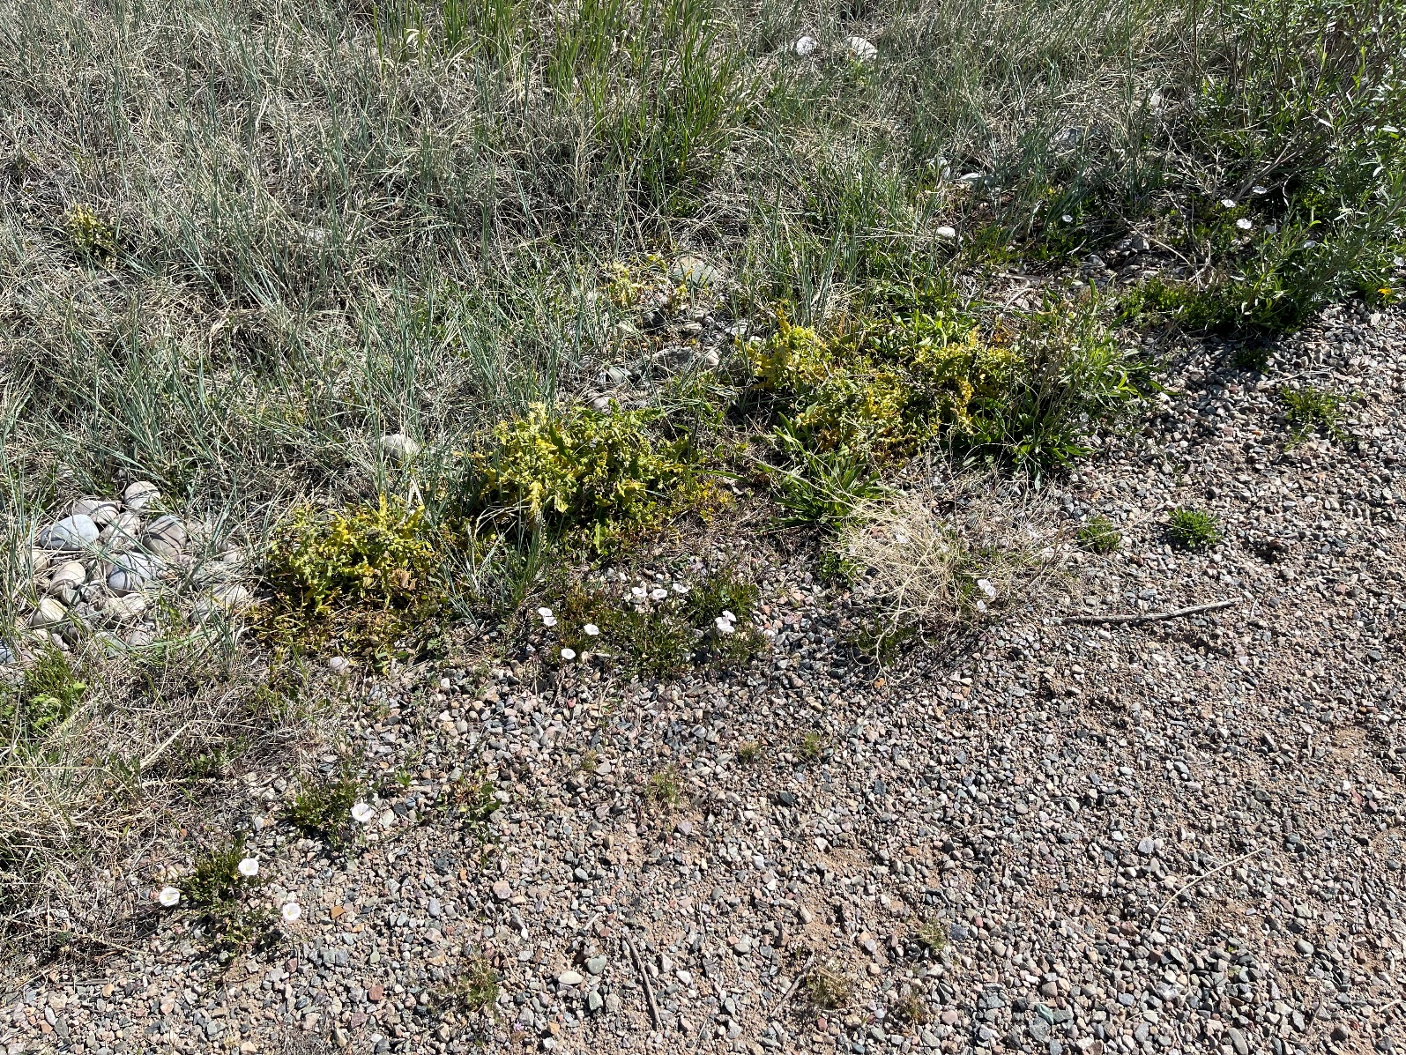
Chemical Treatment of weeds

Chemical Treatment of weeds
Chemical Treatment of weeds

