Energy Inc.

Form Information

Form Name: Compliance Follow Up Form Submitter Name: Aaron Easley
Submission Date: 4/21/2021
Server Receive Date: 4/21/2021
Reference Number: 693902213
Location: Garcia 1

Information

Name Aaron Easley
Date of work completion: 4/21/2021
Well Name Garcia 1
API Number 0506707246
Select State Colorado
Work type COGCC Inspection
Inspection Number (Inspection # from SOW) 693902213
Special Notes: Seeded, Applied Soil Amendments and Mulched Slopes
Action Complete
Seeding of bare soils
Photo of above state work completion
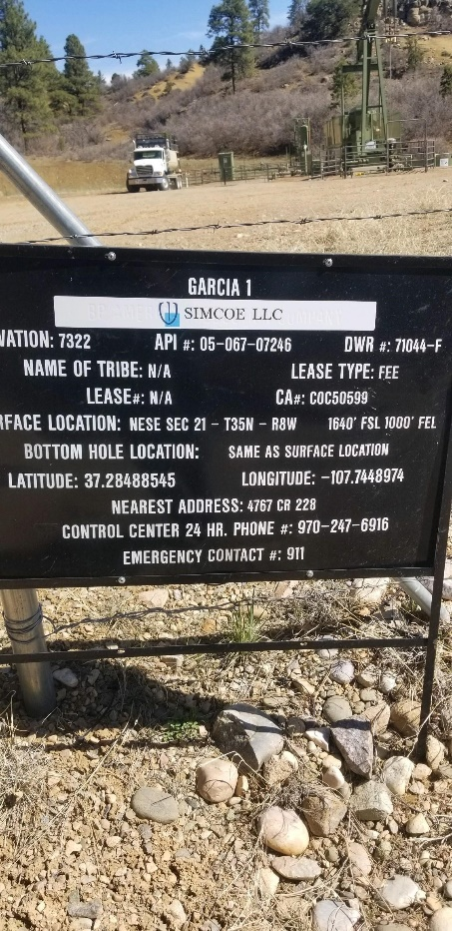

Seeding of bare soils
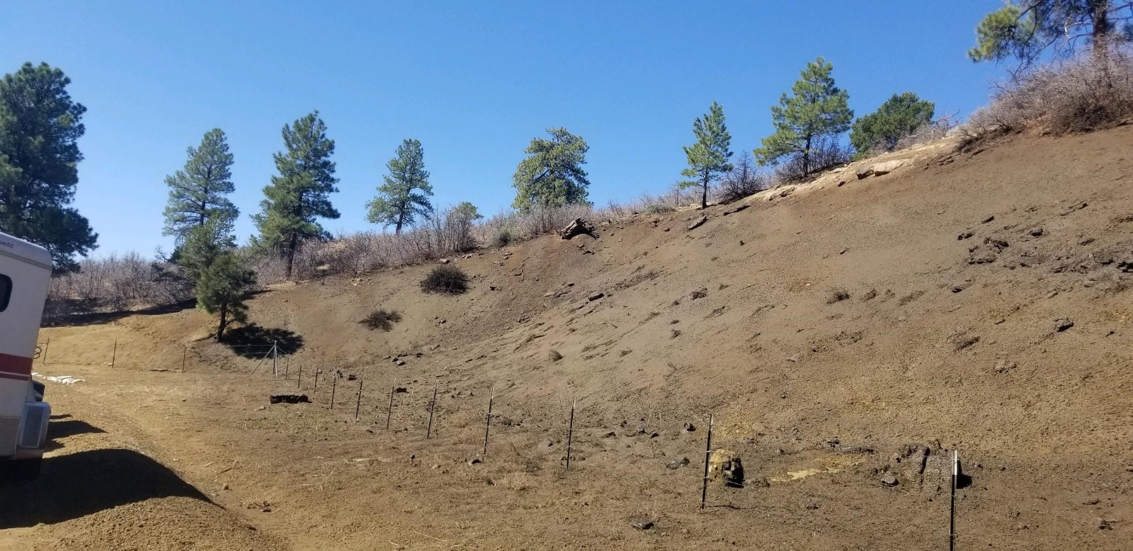

Seeding of bare soils
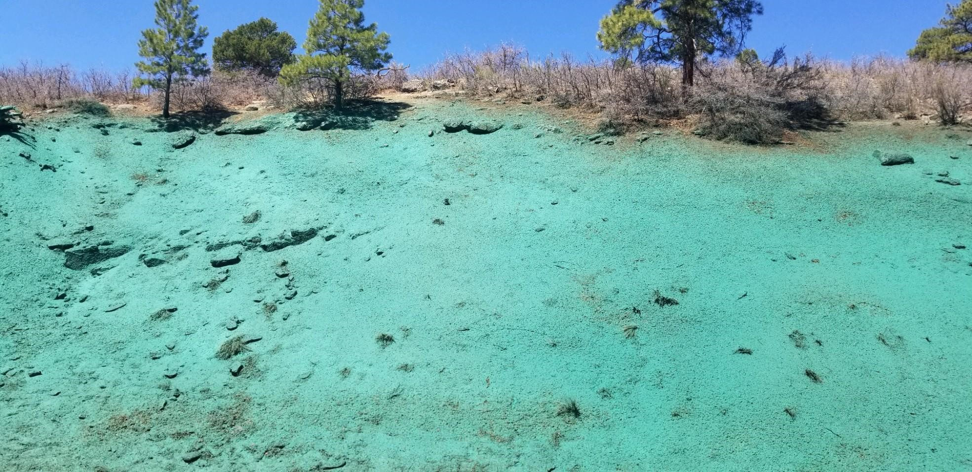
Seeding of bare soils
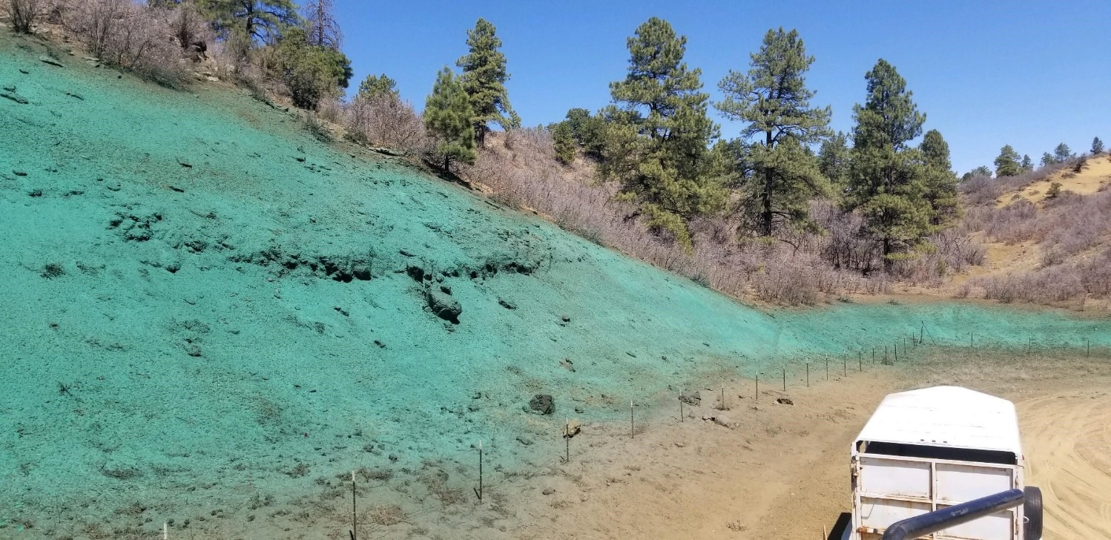
Seeding of bare soils
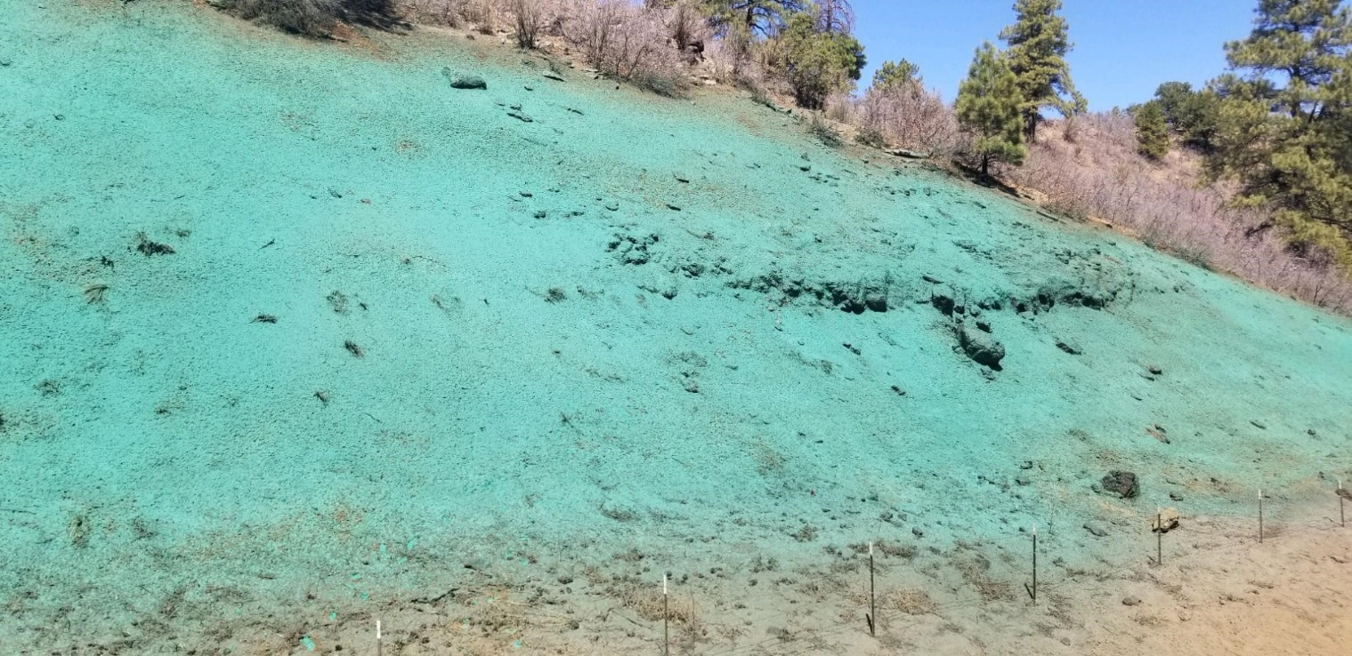
Seeding of bare soils


