Energy Inc.

Form Information

Form Name: Compliance Follow Up Form Submitter Name: Aaron Easley
Submission Date: 4/6/2021
Server Receive Date: 4/6/2021
Reference Number: 693903005
Location: State MZ 2

Information

Name Aaron Easley
Date of work completion: 4/5/2021
Well Name State MZ 2
API Number 0506710003
Select State Colorado
Work type COGCC Inspection
Inspection Number (Inspection # from SOW) 693903005
Special Notes: Removed debris and plastic
Action Complete
Mechanical Removal of weeds
Photo of above state work completion
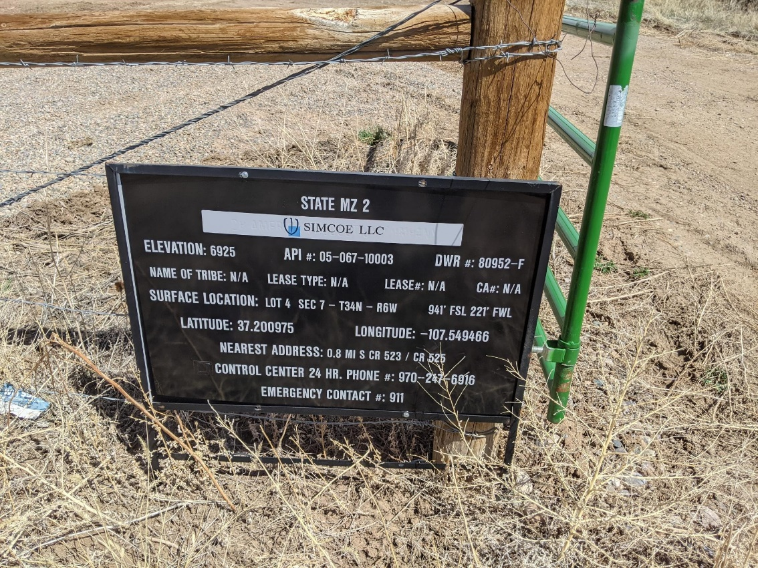

Mechanical Removal of weeds
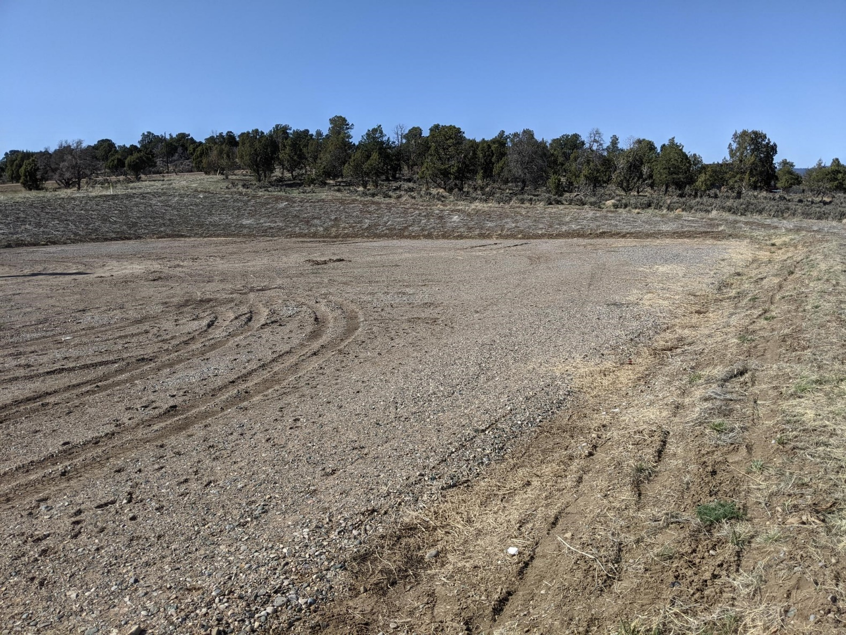

Mechanical Removal of weeds
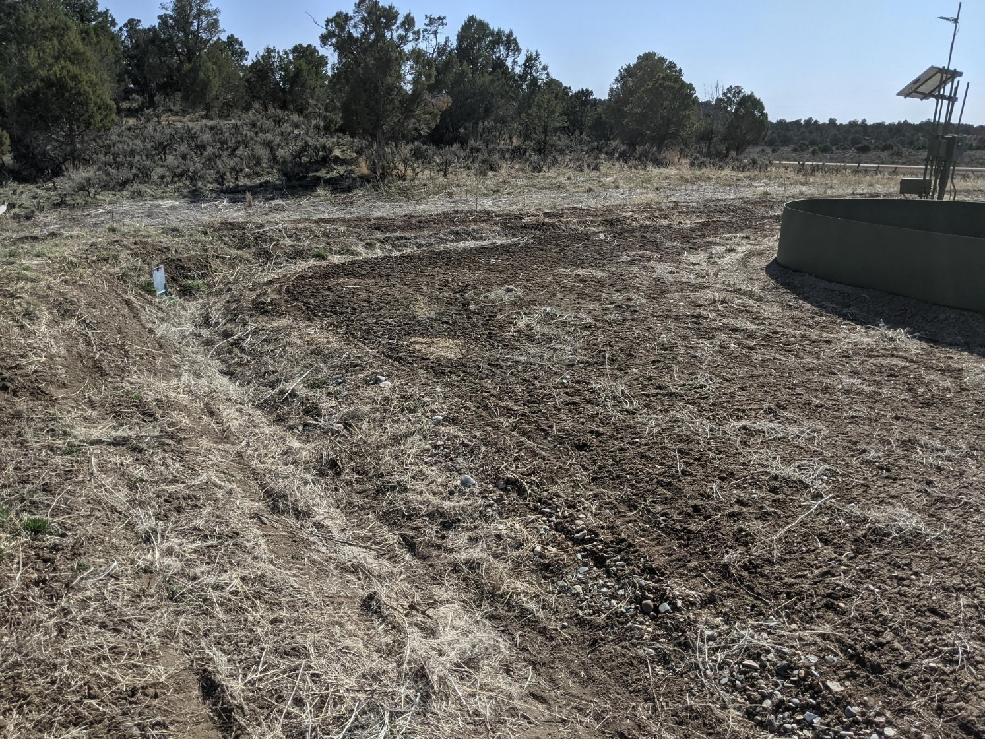
Mechanical Removal of weeds
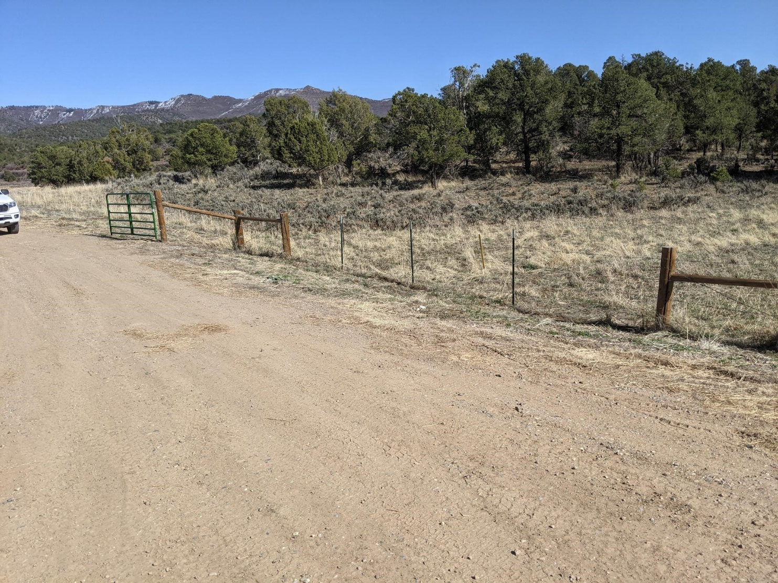
Mechanical Removal of weeds
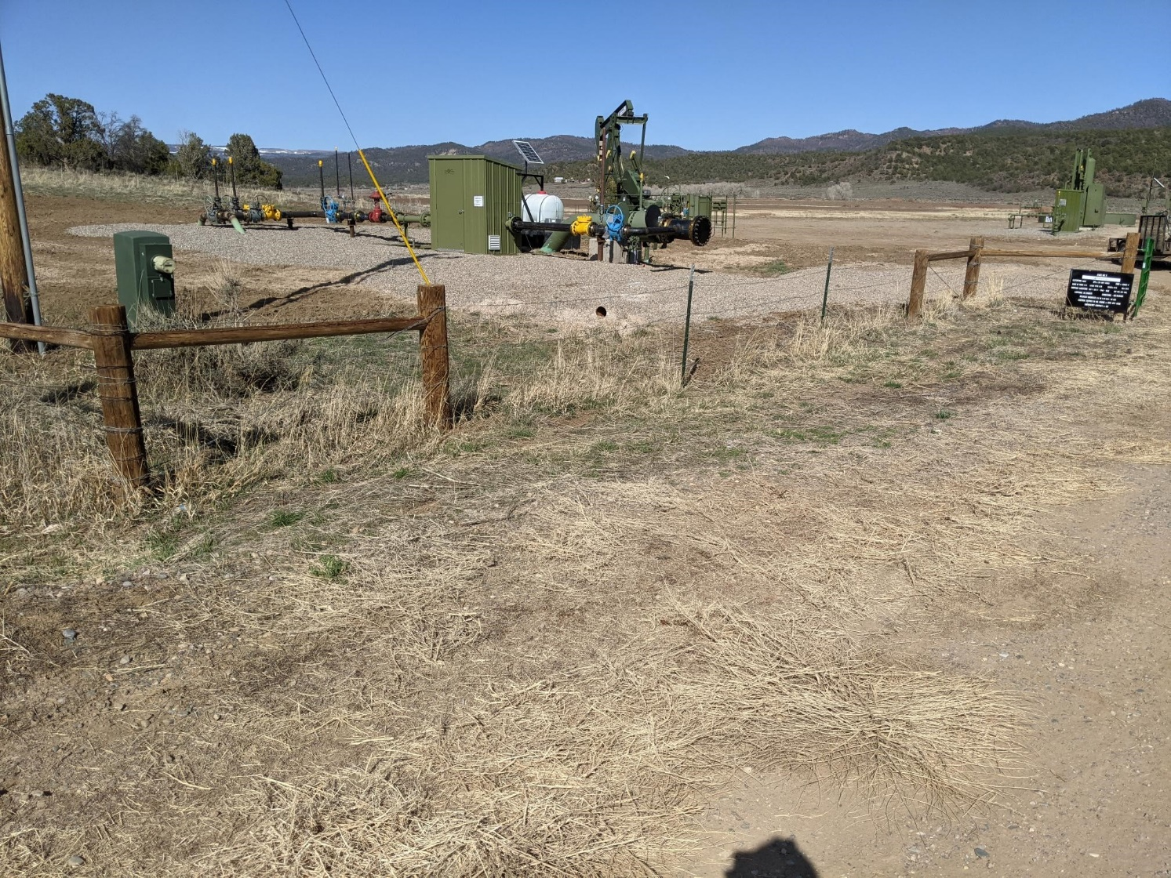
Mechanical Removal of weeds


