August 4, 2020
Ryan Beam
PDC Energy

Mr. Beam, and to whom others it may concern;

JAMM Power Service used the Fluke 1623 Earth/Ground Tester on August 4th, 2020, to complete testing at the listed locations. All readings are listed in Ohms readings.

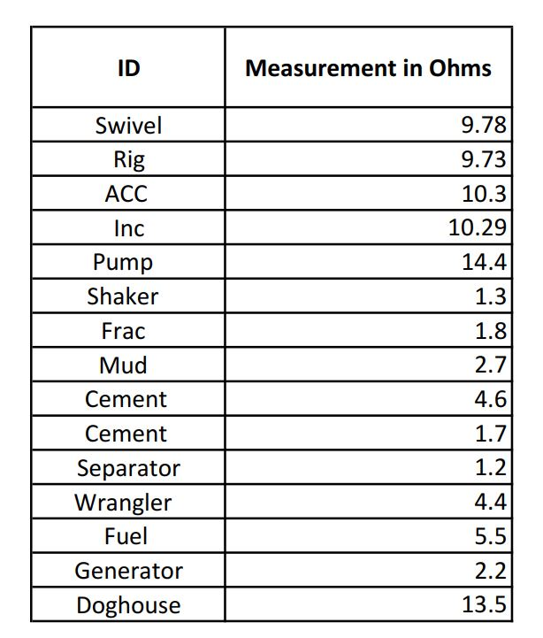

Please do not hesitate to contact myself or our office with any questions, comments, or concerns.
Sincerely,
Jason Allen
Master Electrician
JAMM Power Services
970 294 1263
jason@jammpower.com

