Bonds 3 E stormwater and weed actions completed 3/12/2020
Erosion repairs with cut seeding and stabilization were performed.
Seeding was performed on bare areas throughout the location. The cut was seeded and then stabilized with 100% biodegradable coconut matting to reduce stormwater flows and keep seed in contact and place for better germination. Bare areas on pad were seeded and mulched. Stormwater trap created with armored outlet to slow down flow off area and prevent channeling.
Preemergent herbicide applied 1 week prior to completing work.
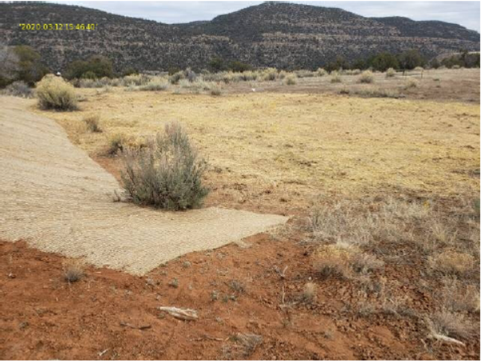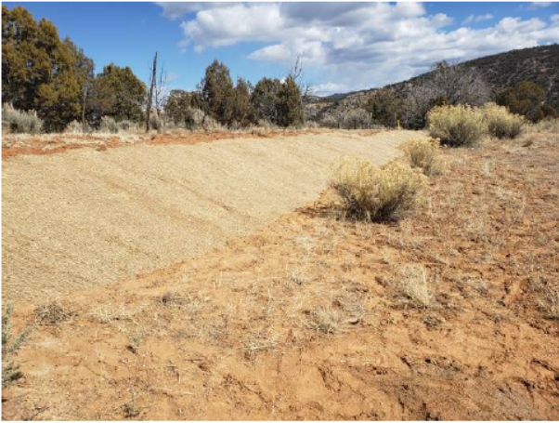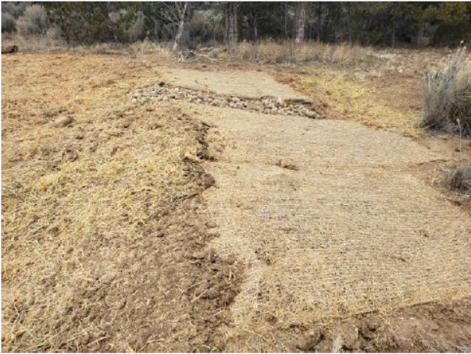
During equipment removal work performed by Red Cedar on their items left on pad additional disturbance was created so those areas were seeded and mulched for stabilization as well. Additional disturbance was also created by landowner during the removal of all of their agricultural equipment from location.
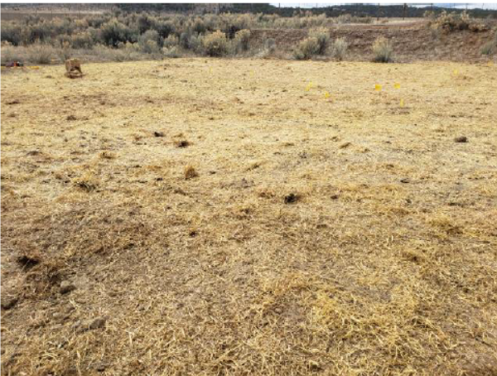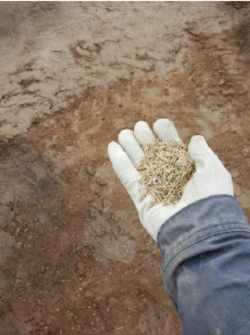
BPX well sign and miscellaneous debris was cleaned up from location and disposed of.
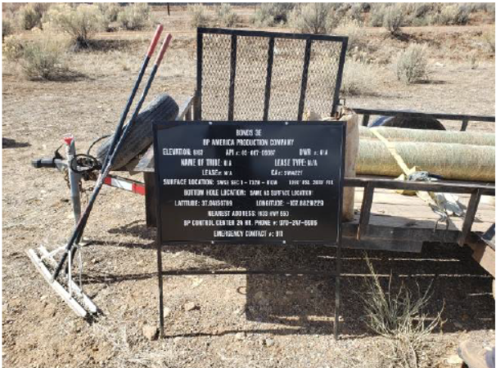
Photo below is of cathodic equipment belonging to Red Cedar and is still in service of the active pipeline for corrosion protection. This cannot be removed until such time that the active line is plugged and abandoned.
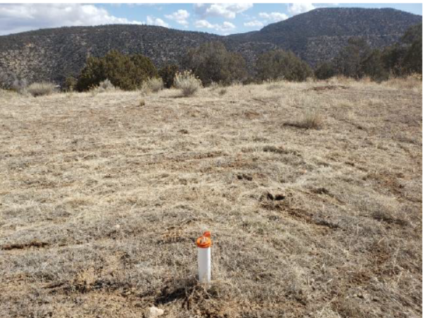
Entrance was decompacted, seeded and mulched.


