Samples to be collected at all sites
Two or three 1 gallon LDPE cubitainers (HNO₃ preservative already included), 2 cubitainers if sample very oily or 3 cubitainers if not a lot of liquid hydrocarbons in water. Lab may provide 8-12 1 liter bottles instead as the cubitainers are currently on backorder from supplier.
Do not overfill
Label analysis for rad chem
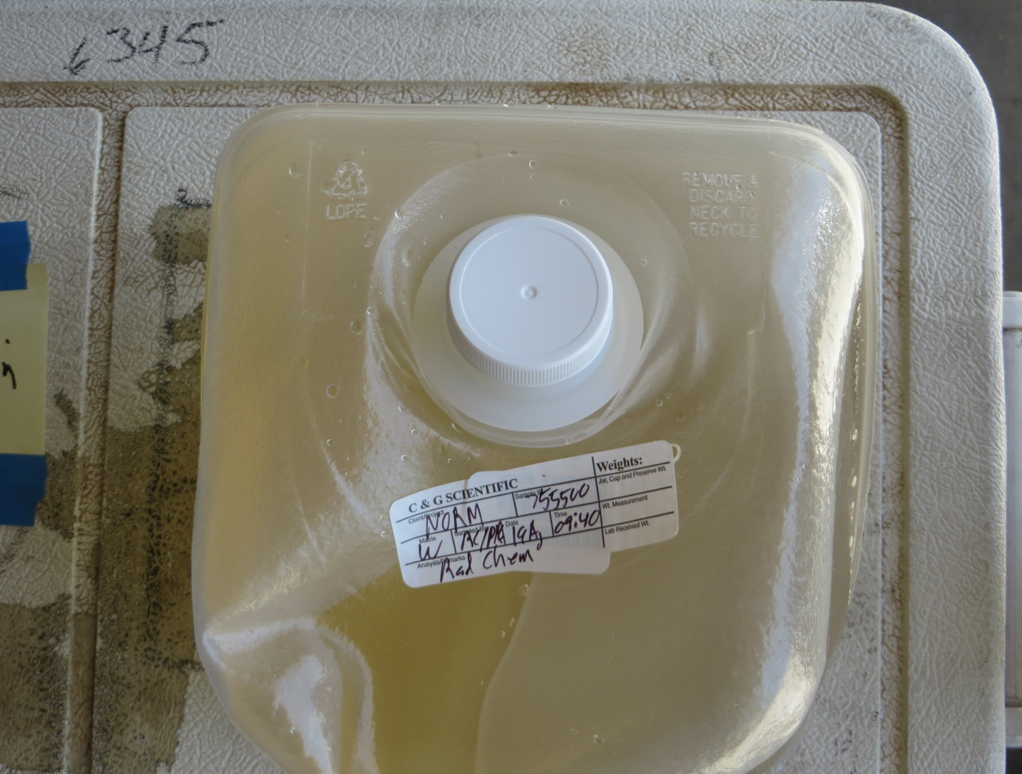
Three 40ml VOA vials (no preservative)
Gently fill as for VOA with meniscus above top of bottle and seal with screw cap
Check for bubbles and refill if necessary to minimize bubbles
Label analysis for Rn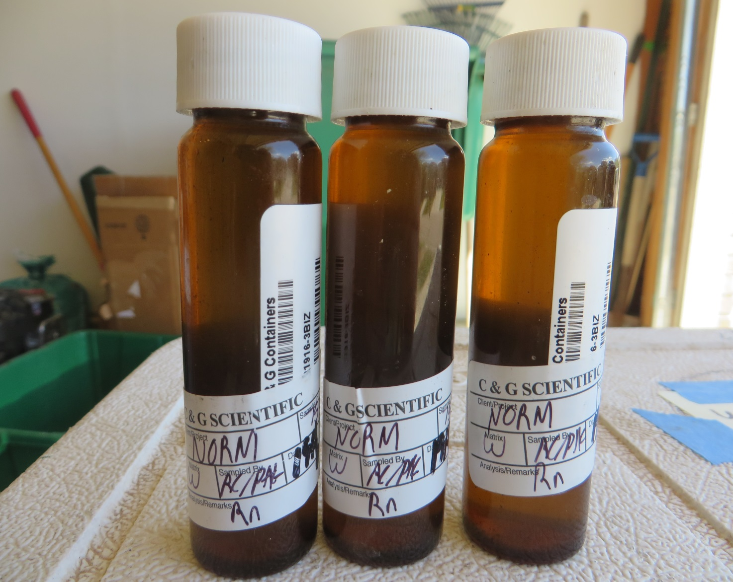

One 1 liter HPDE bottle (no preservative)
Label 1l HDPE (no preservative) as analysis for wet chem
One 500ml HDPE bottle (HNO3 preservative already included)
Do not overfill
Label analysis 500ml HDPE (HNO3 preservative) as analysis for total metals
One 250ml HDPE bottle no preservative
Label 250 ml HDPE with no preservative as analysis for dissolved metals (to be filtered at lab)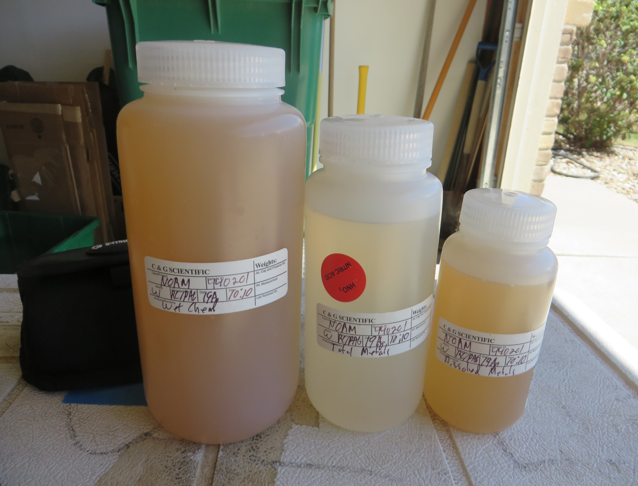

One 40ml VOA (no preservative)
Fill as for VOA with meniscus above top of bottle and seal with screw cap
Label analysis for δ¹⁸O and δD H₂O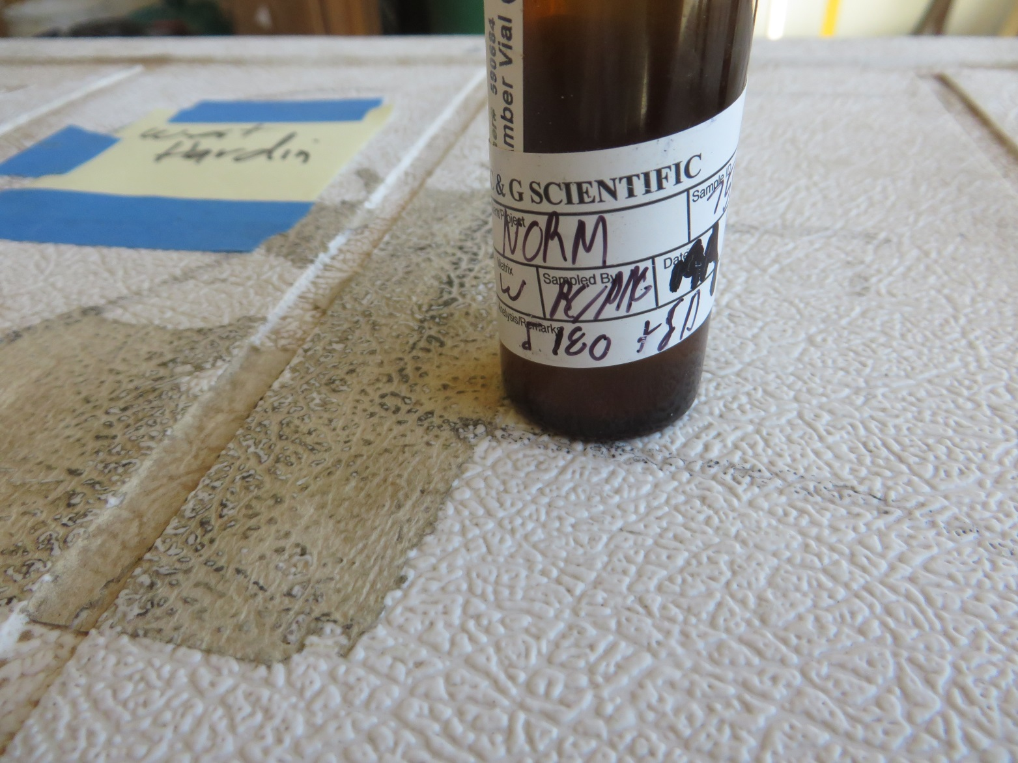

One 40ml VOA vial (no preservative)
Remove plunger from syringe and fill 60ml syringe with water. Insert plunger and push water through syringe as rinse. Remove plunger and refill syringe. Insert plunger and turn syringe upwards and push any bubbles of air or gas out of syringe. Attach 0.45µm filter using Luer lock on syringe tip. Push 5ml of water through syringe filter and dispose. Filter enough water to fill 40ml vial with meniscus above top of bottle and seal with cap.
Label analysis for δ¹³C of DIC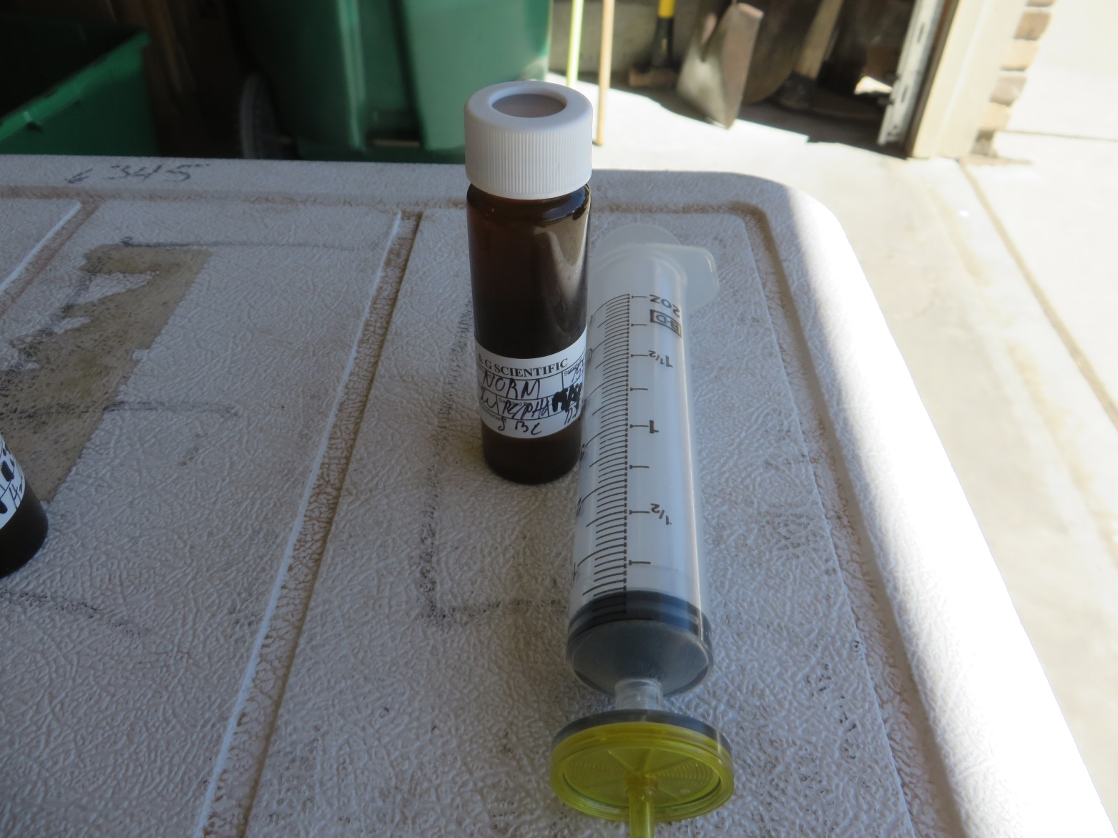

Samples to be collected at selected sites mostly in the GWA/DJ Basin
One 1 liter or two 500ml Tedlar (TO-14) bags
Use manifold and connect to gas pipe with valve. Connect bag to manifold using tubing from manifold and valve and port on bag. Slowly and gently inflate fill bag by opening needle valve fractional amount.
Do not overfill or bag will split.
Label analysis for Rn
Do not ship the gas samples without appropriate training and documentation
One 1 liter HPDE bottle (no preservative)
Fill to top and seal tightly with cap
Label analysis for ¹⁴C of DIC
One 1 liter or two 500ml HDPE bottles (no preservative)
Do not collect this sample if wearing watch with luminescent numbers/hands and do not collect inside a building especially if clocks with luminescent number are on the walls or on any equipment in the room. Most of the dials contain tritium.
Fill to top and seal tightly with cap
Label analysis for low level tritium (³H)

Samples collected from unpressurized buried vaults by disposable bailer
In the photo below a COGCC staff member is collecting produced water samples from an unpressurized vault by bailing. Vault served four wells. Operator’s foreman scurrying out of photo at left opened the hatch for us and advised us on safety procedures at the site and also that the separator would not produce enough water in a short time for us to sample from the nearby horizontal separator. Disposable bucket(s) and disposable large funnel at Bob’s feet were useful in this situation. Bob emptied the water into a bucket from the bailer and then we poured into bottles from the bucket. If you have to pour samples from a bucket into bottles or cubitainers the large funnel is very useful as is a second pair of hands.
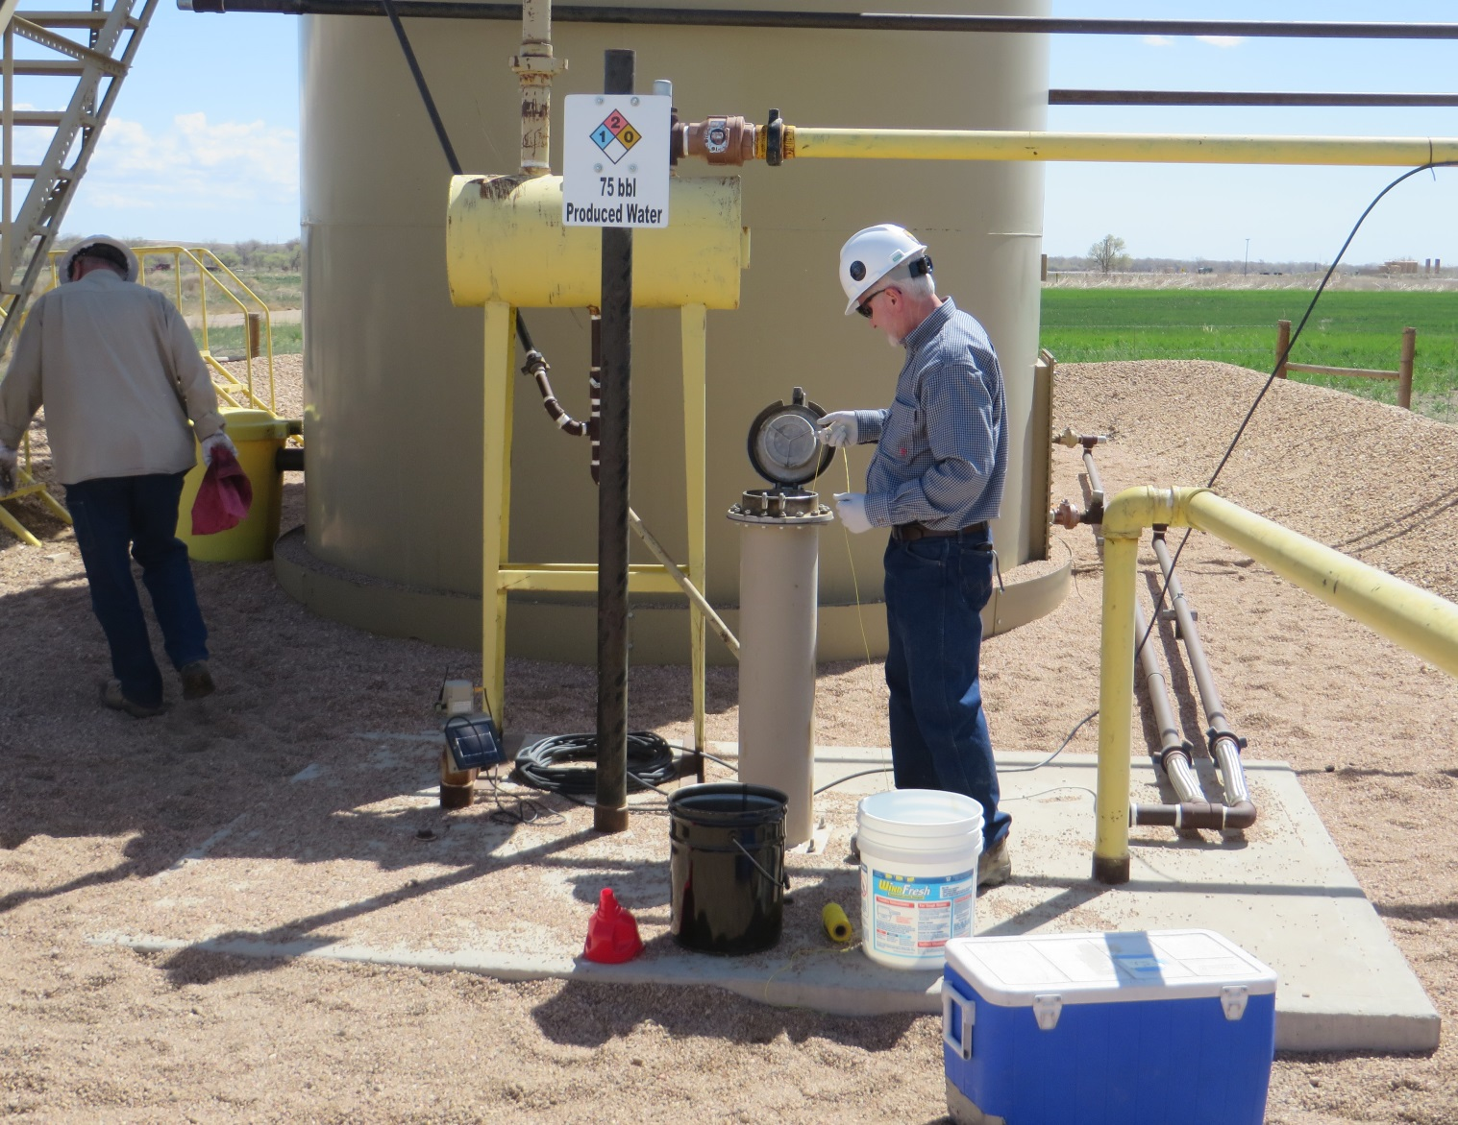

If you believe you will need a bailer, please contact Bob in advance. A small supply of these disposable bailers resides in the Denver office. The bailer we used is pictured below. Don’t forget you need some rope to attach to the bailer. PDC advised us to use a metal bucket at a different location when sampling from a horizontal separator due to concerns about static buildup using a plastic bucket and possible ignition of vapors coming along with the water from the pipe and valve into the separator tank. They grounded the metal bucket with one section of a jumper cable. Mike Leonard confirmed to me that is a standard operating procedure for many years when free volatile hydrocarbons might be present from opening the water line valve coming from the separator.
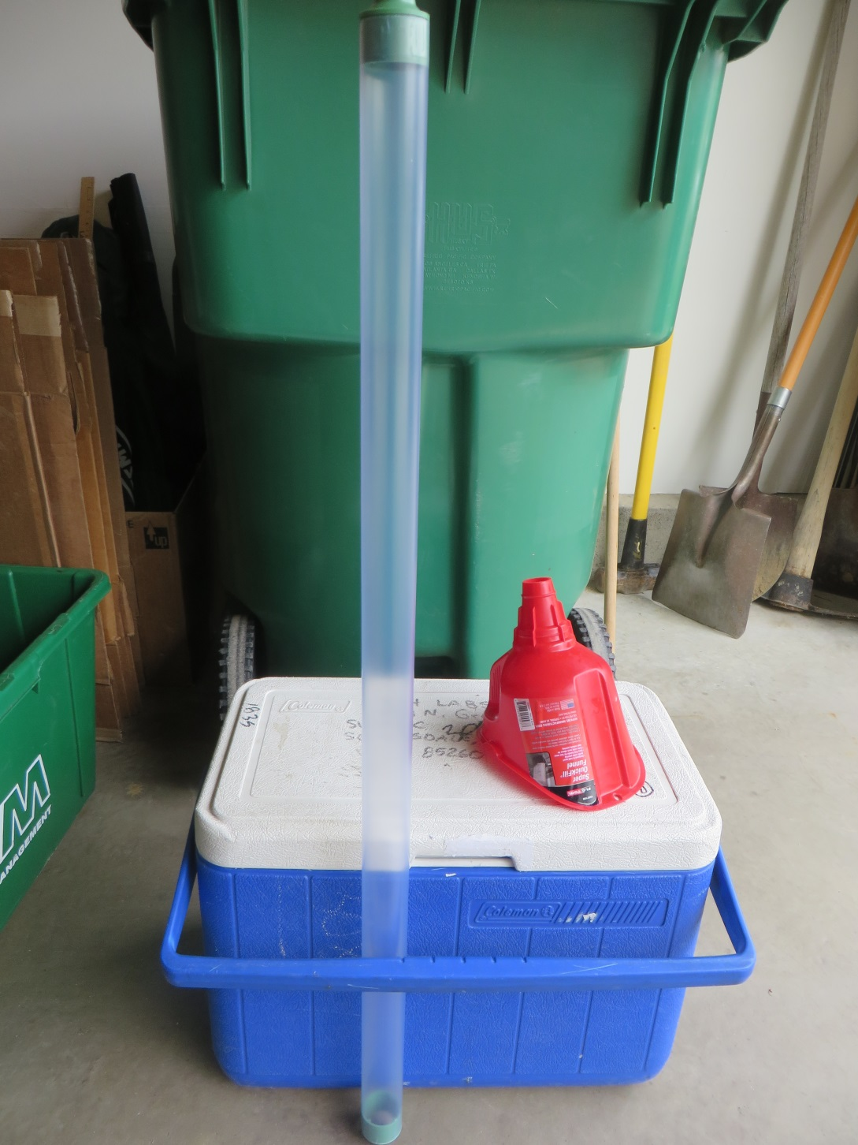

Samples collected from unpressurized buried vaults at bottom drain on tank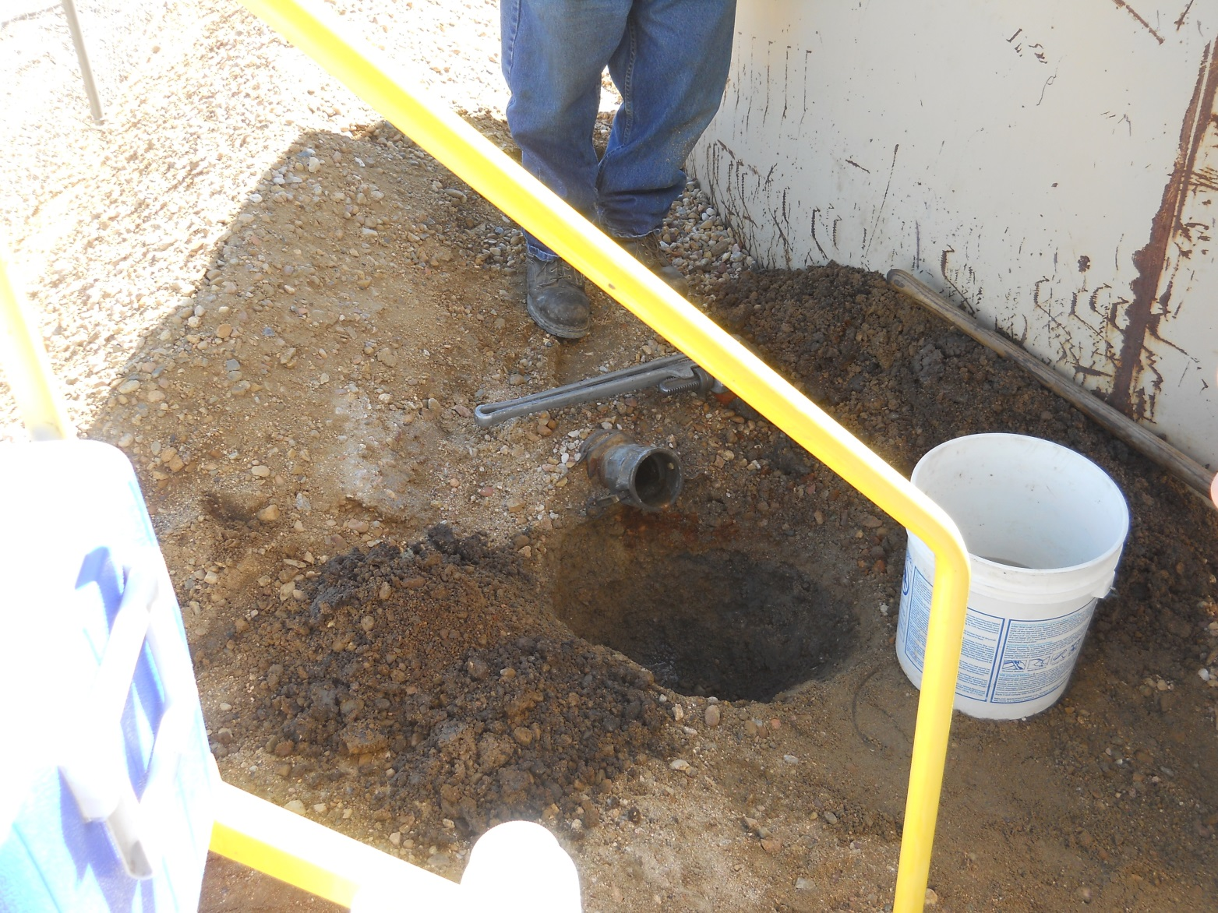
In the photo above the operator excavated a shallow hole to allow the disposable plastic bucket to receive produced water from the tank. Samples were poured into lab provided containers using a funnel as shown previously.
Samples collected from heated horizontal separator from water line valve
These systems may be pressurized. Consult with operator and obtain their assistance in opening valve safely. Sampling into disposable metal bucket with bucket grounded to minimize chances of static induced ignition of hydrocarbons present in this stream of produced water. Small enclosure at end of horizontal separator had doors on three sides which were kept open during sampling to maximize air flow.

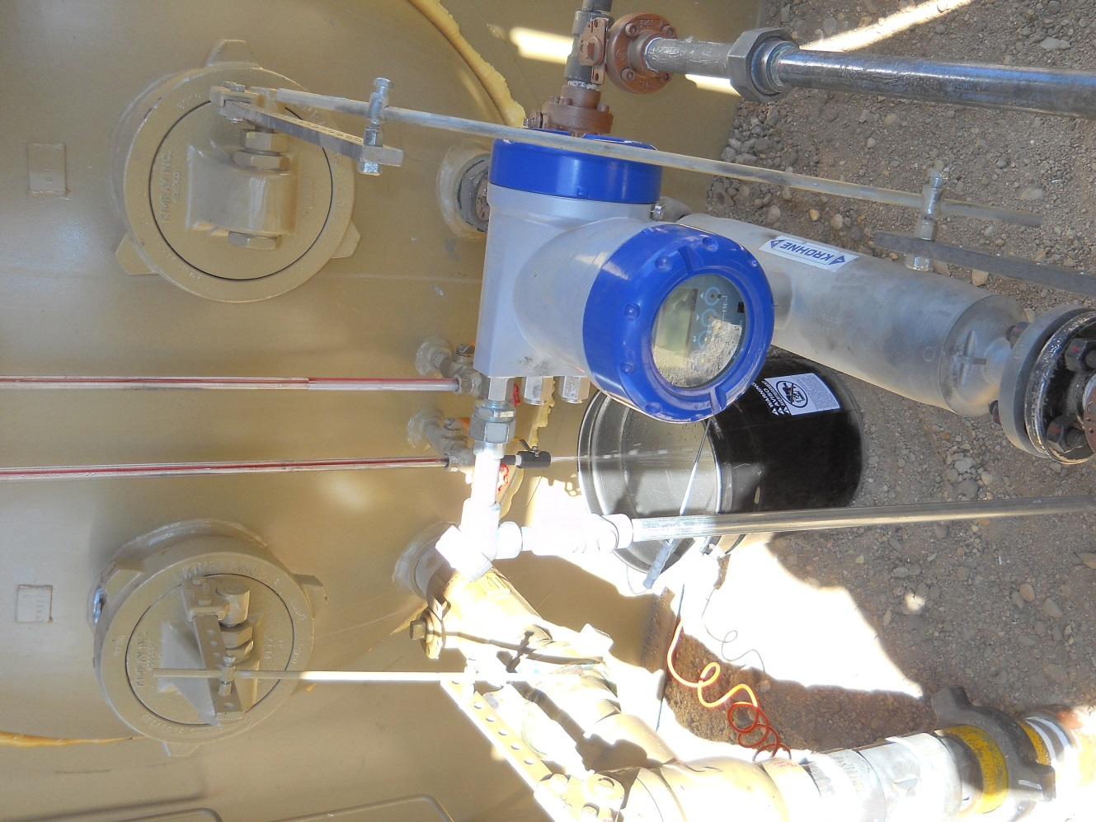

Samples collected from vertical separator at a flowback site
These systems may be pressurized and should only be opened by operator’s staff or contractors. Inside the berm was considered a possible zone with elevated levels of hydrocarbons and we were reminded to not bring in electronic devices unless they were “intrinsically safe”. So I do not have photos of the valve and bucket we used to collect samples. Samples from this site contained significant concentrations of light hydrocarbons (condensates) as these separators are not as effective as the units typically found at production wells. Bottles were filled outside the bermed containment area by pouring from the bucket through funnel into the laboratory provided containers.


