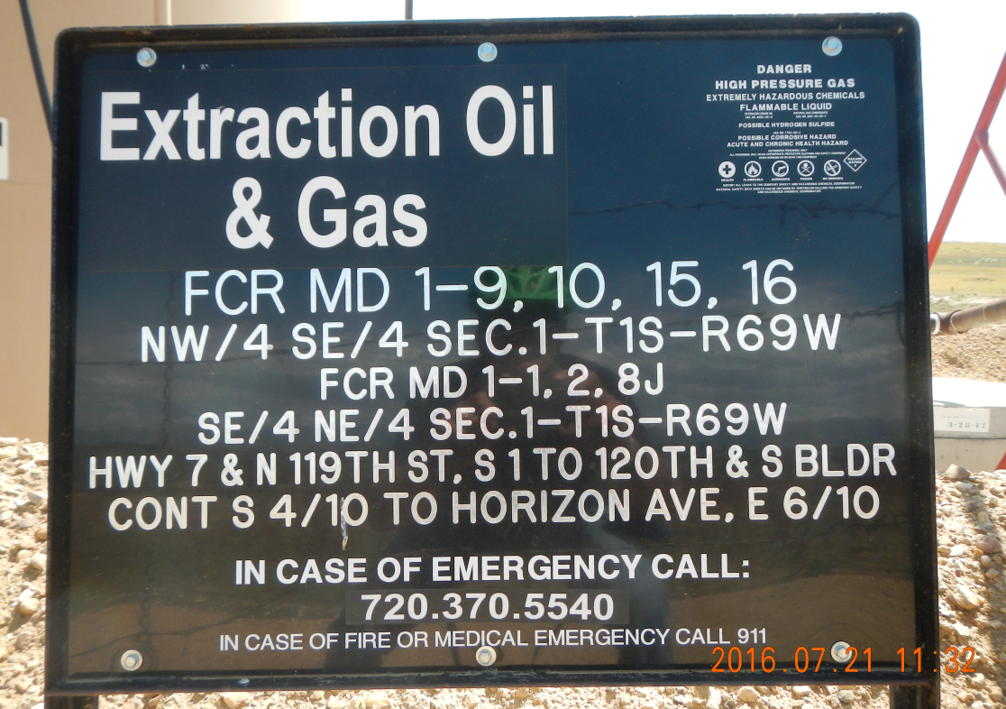
Location sign
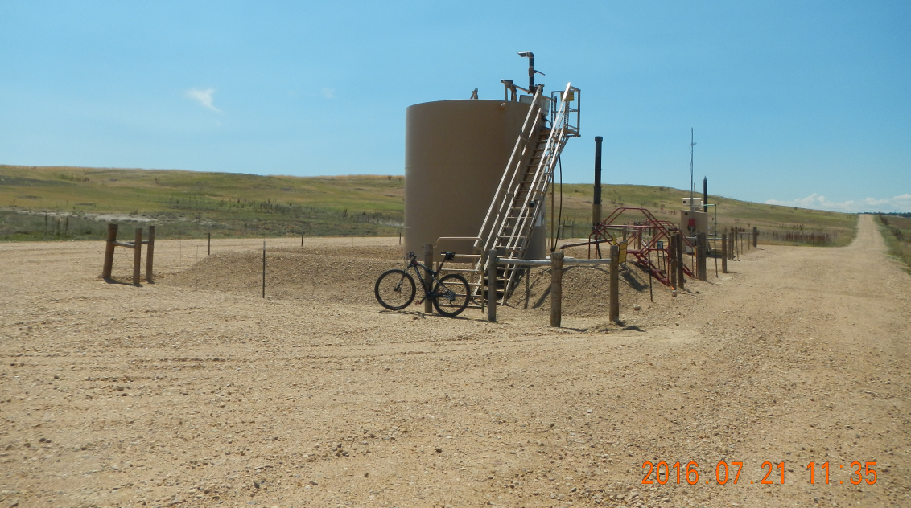
Looking south across the subject location
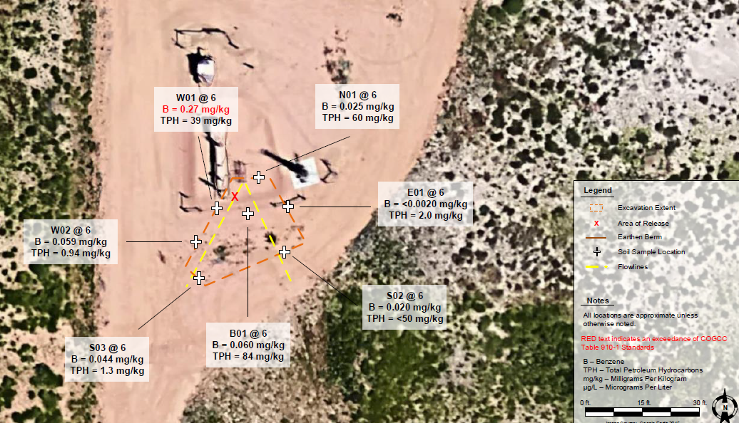
Figure depicting the flowline release point and corrective action excavation limits.
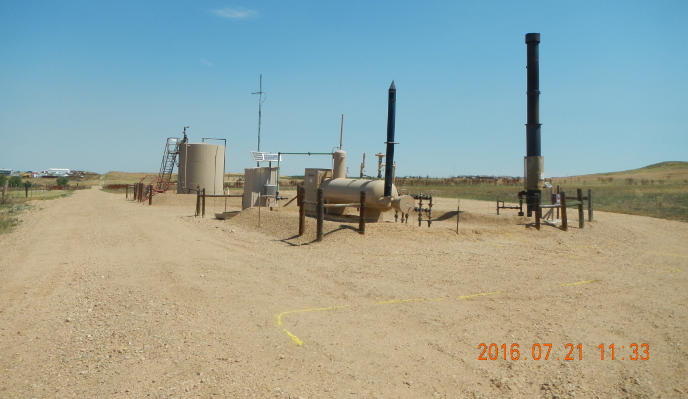
Looking north across the flowline release point and site of the corrective action excavation.
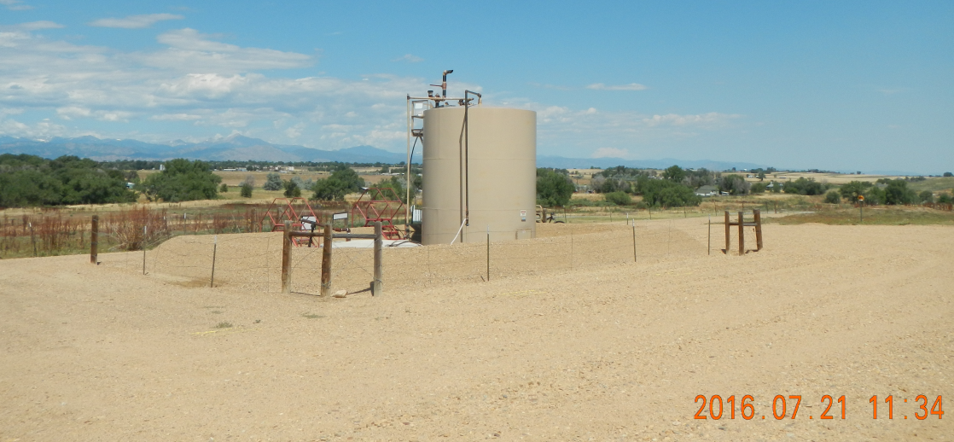
Looking west across the subject location

