The NELSON 1, API # 123-09110, well location is built on the edge of a cultivated field. The well, pump jack, electrical breakers and transformers and a portable propane tank remain on location.
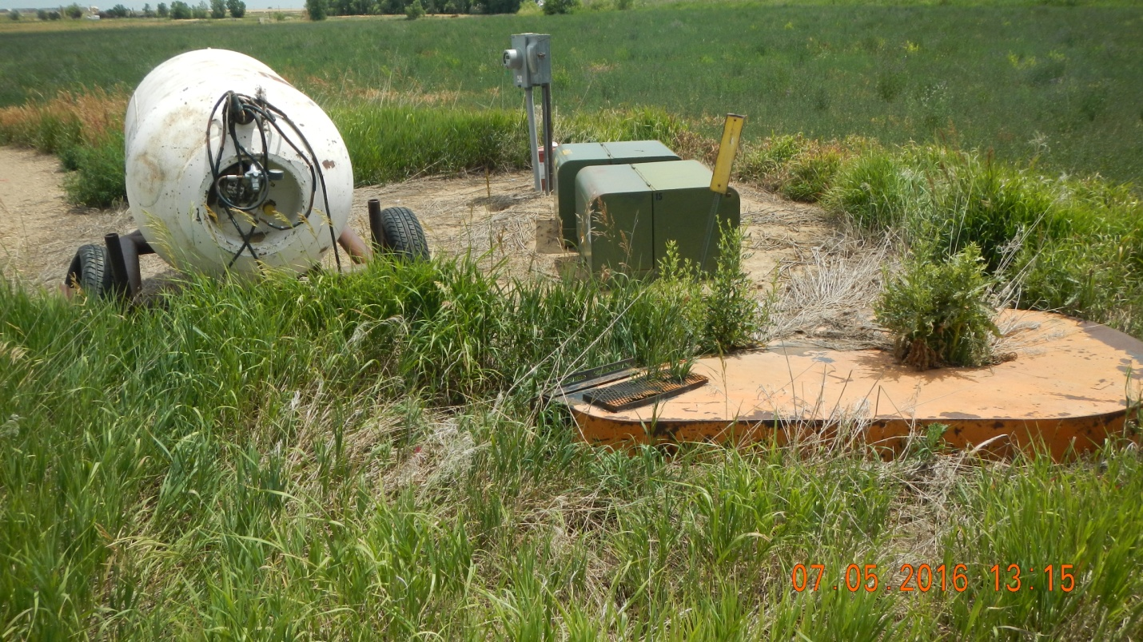
There is oily soil at the well head. T 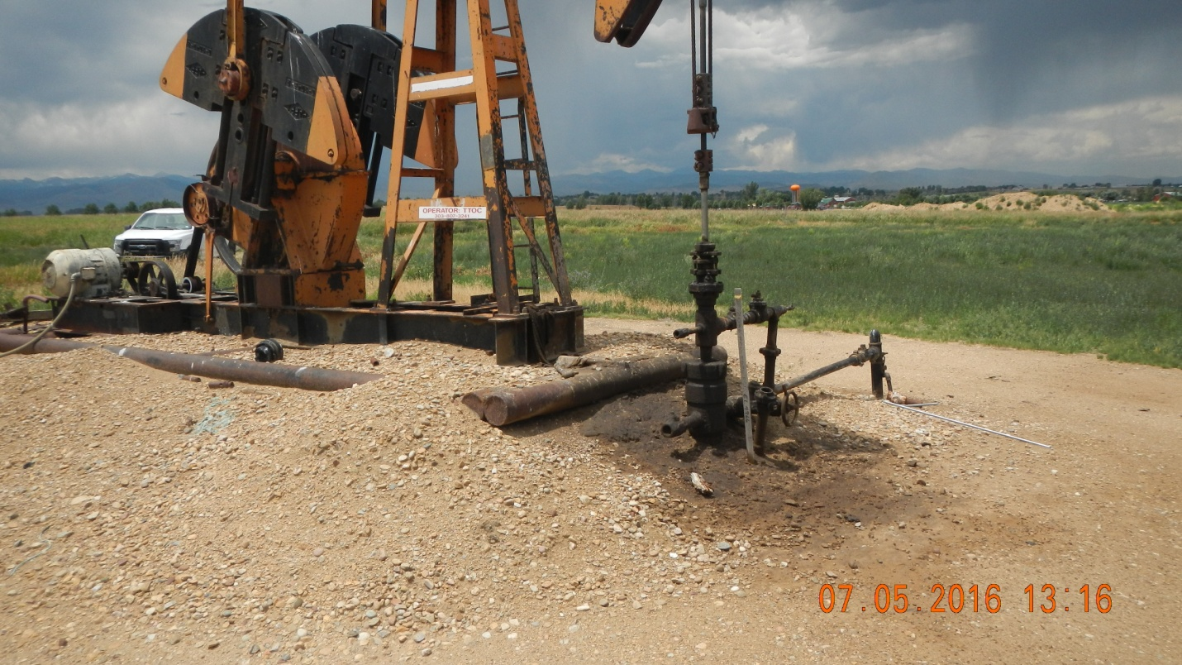

The production equipment has been removed from the production facility for all six (6) Texas Tea wells in Sec 32, Twp 2N, Range 68W. A riser remains at the production facility location which is at the intersection of the access road for API # 123-09110 and CR 320 Latitude: 40.094795 Longitude: -105.031844.
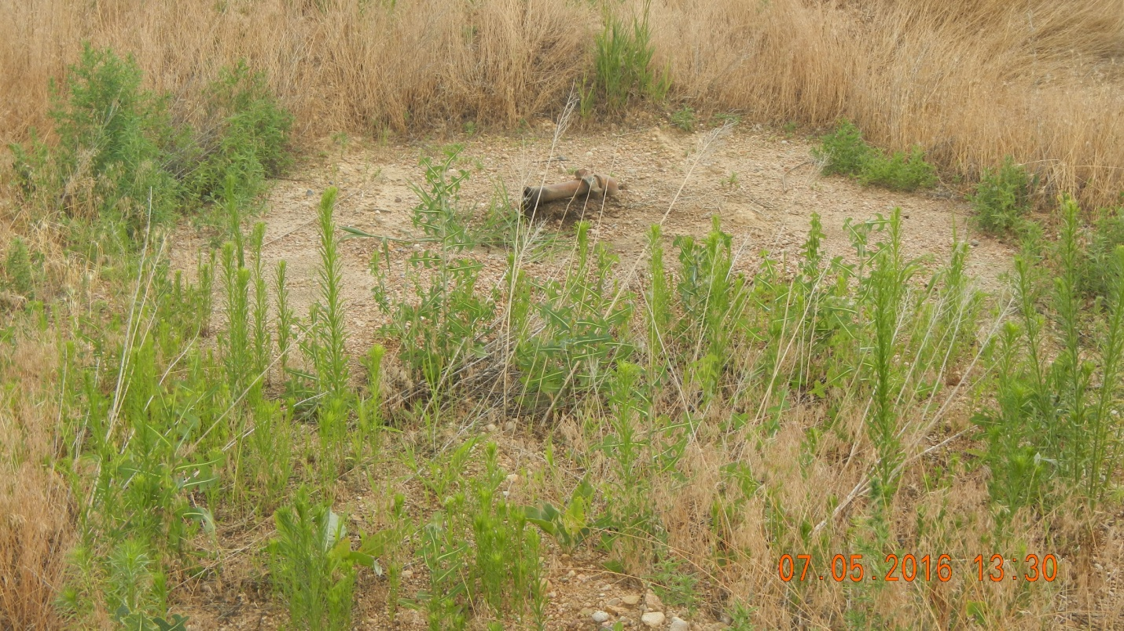

T

