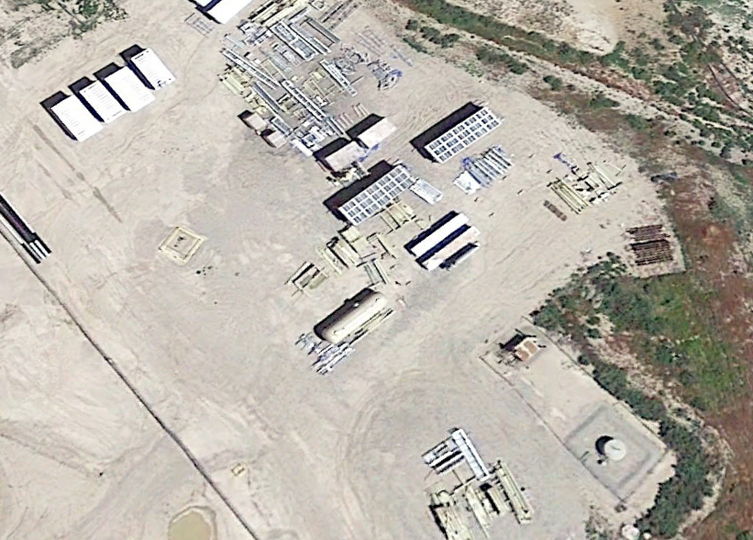
WPX Williams GM-207-28 Variance Request
Associated Facilities
Well Head

