Tank battery for KORTUM #7 and KORTUM #3. Weeds in tank berm. 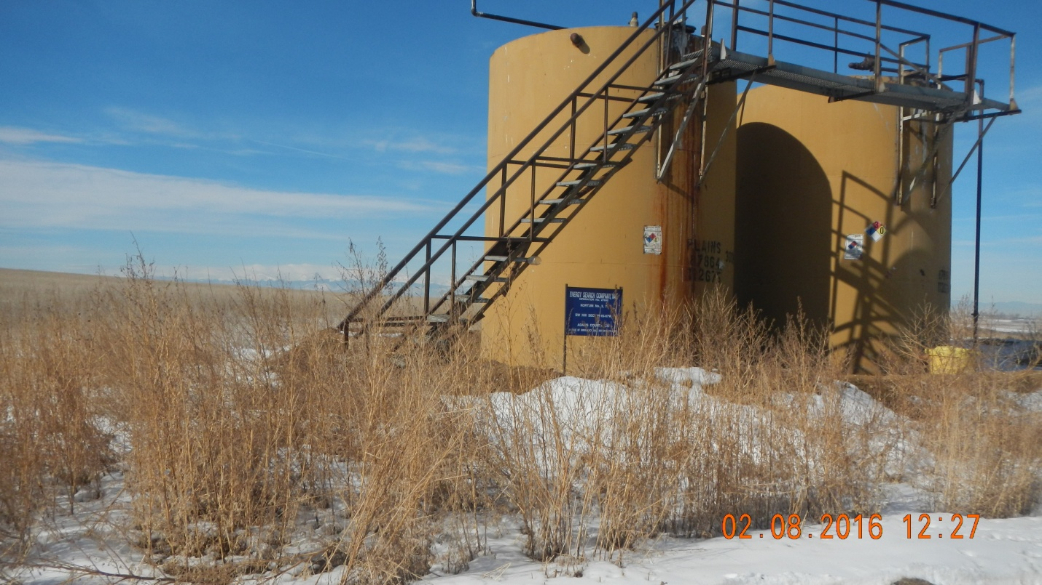

Open access to wildlife in burner. 

