API # 001-06190, bredenhead not plumbed to surface. 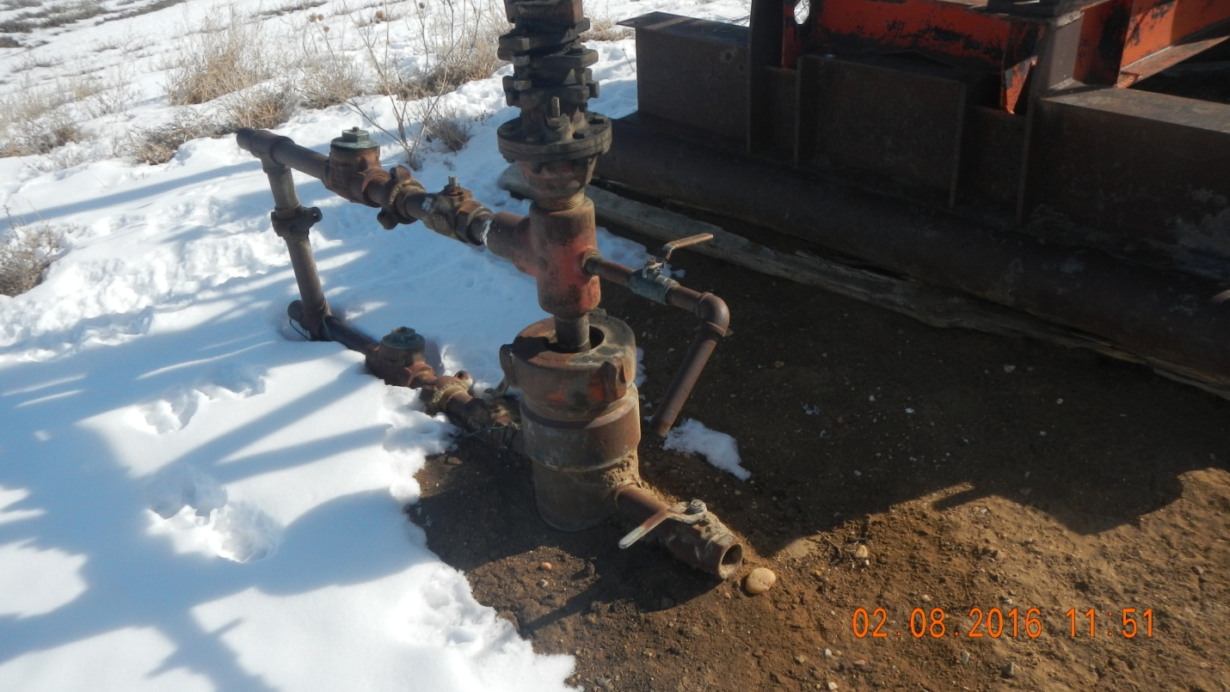
Access road erosion. Access ro 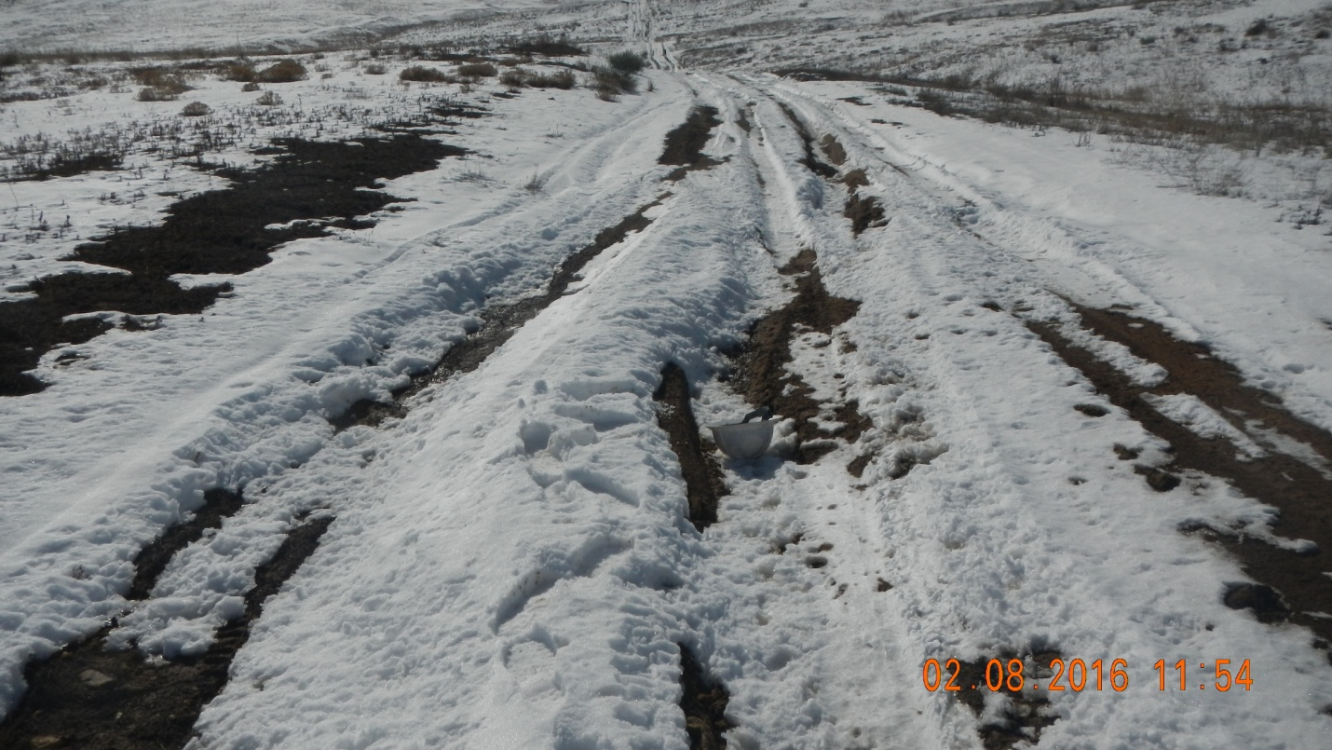

Access road erosion.


