API # 123-09069, WEEDS AT ACCESS ROAD. 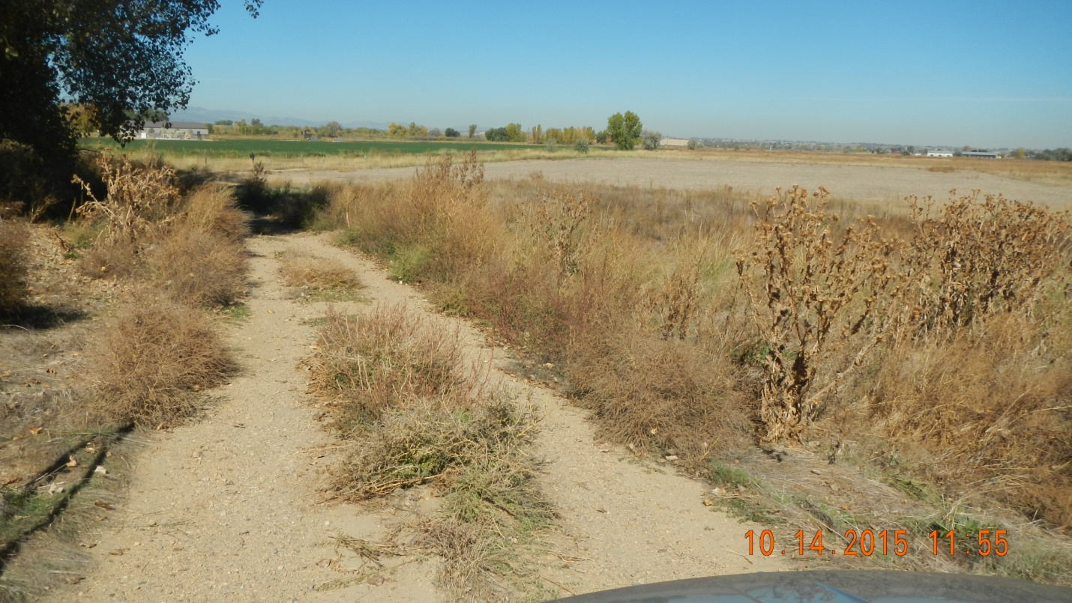
STAINED SOIL AT WELL HEAD. 

