API # 123-19991, stained soil at well head. 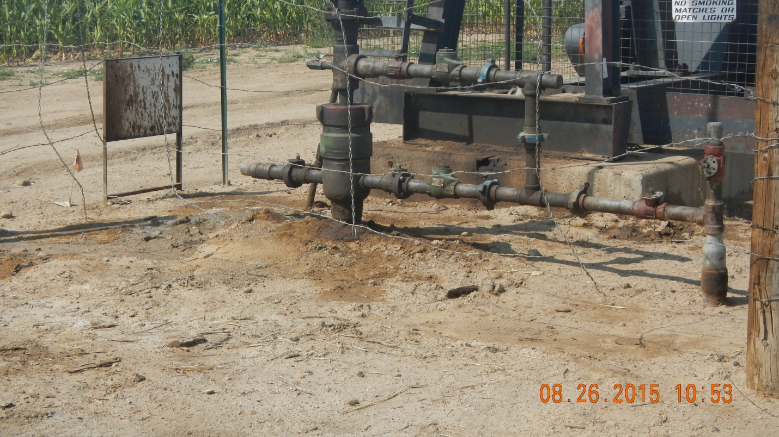
Stained soil and leaking lube oil at pump jack. 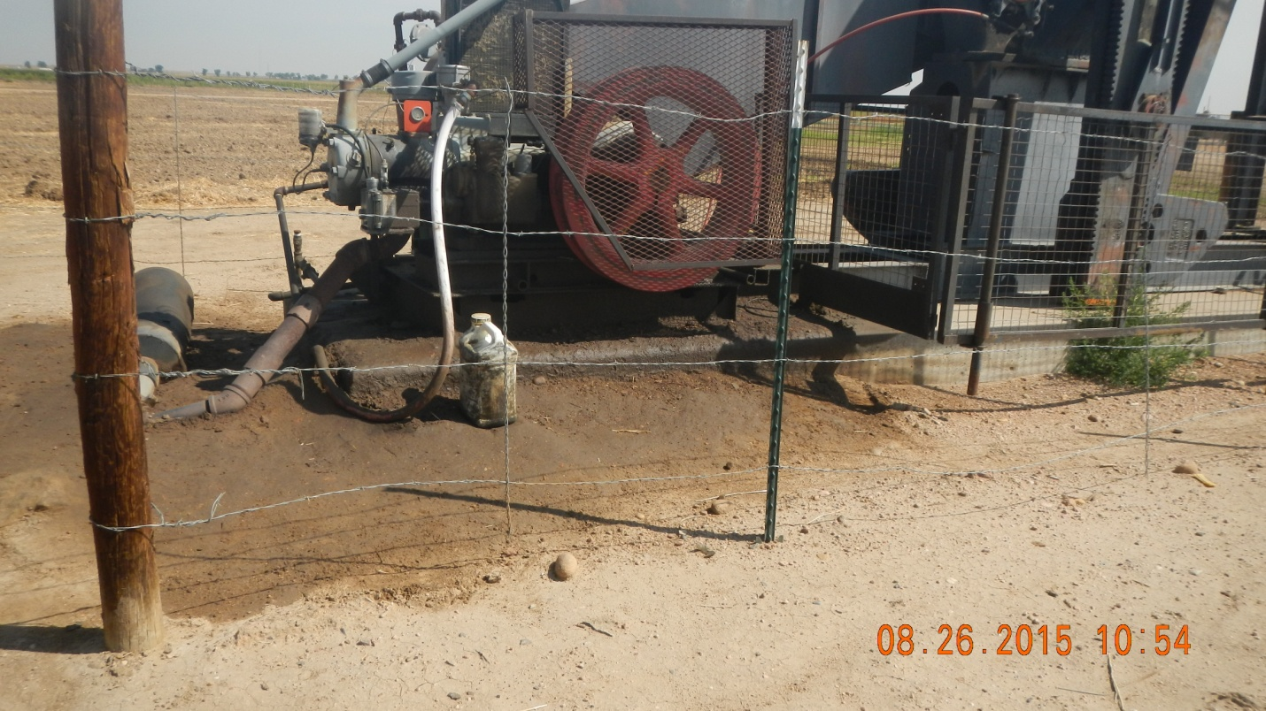

API # 123-19991, ruts in access road. 

