API # 123-09377, Faded sign and lube oil on pump jack. 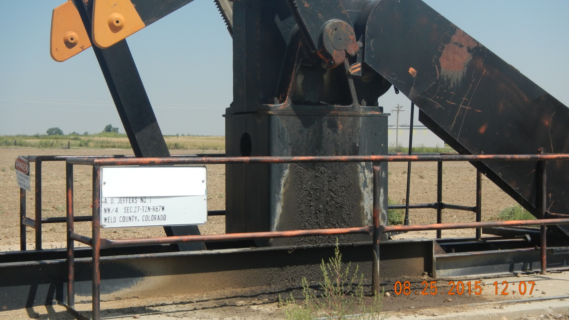
Weeds and stained soil. 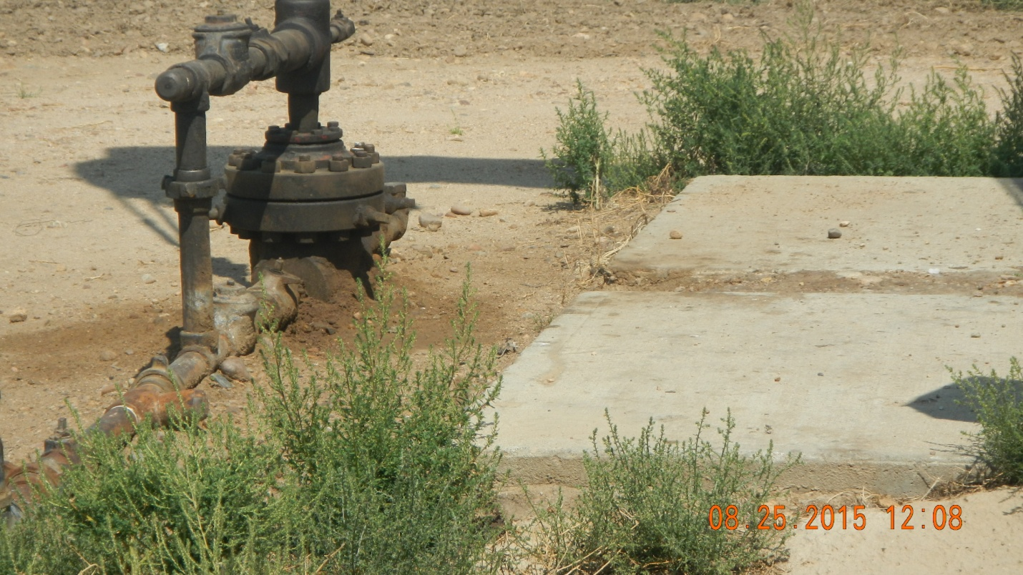

API # 123-09377 weeds on access road. 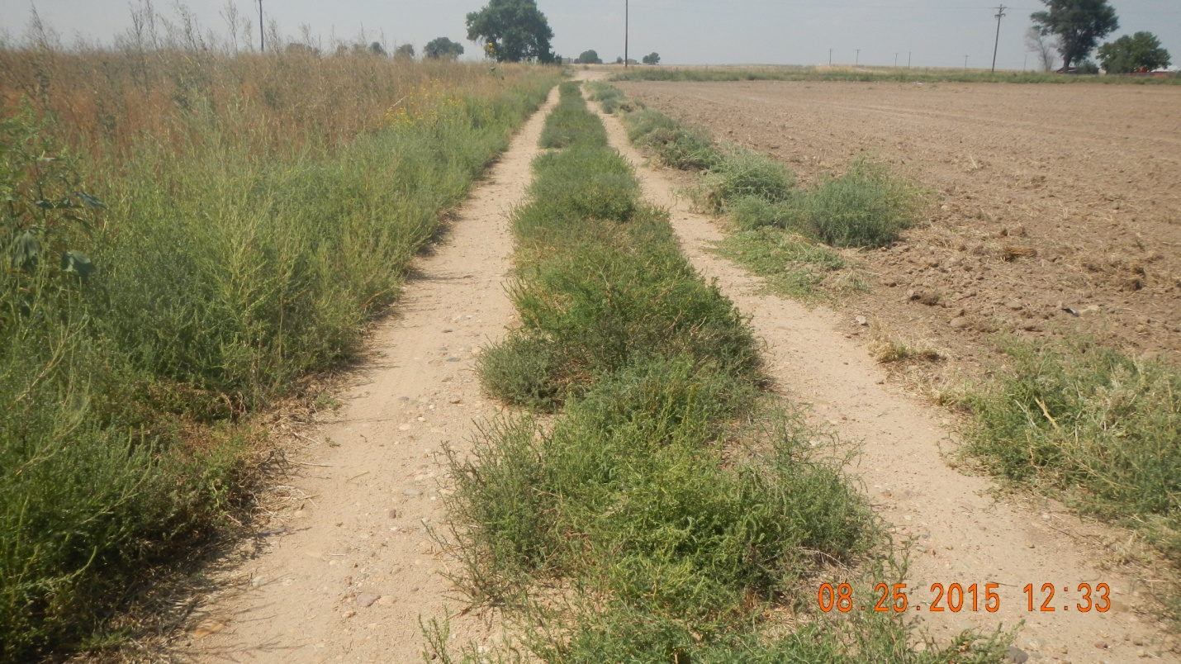
Weeds on well site. 

