API # 123-09228, equipment open to wildlife intrusion. 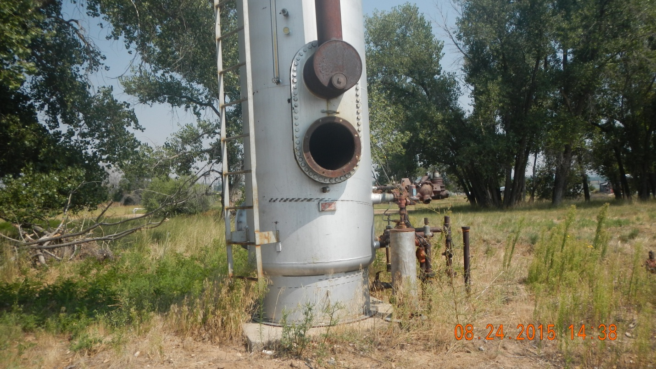
Unused equipment

