34-8 #26-2 FC
July 3, 2015

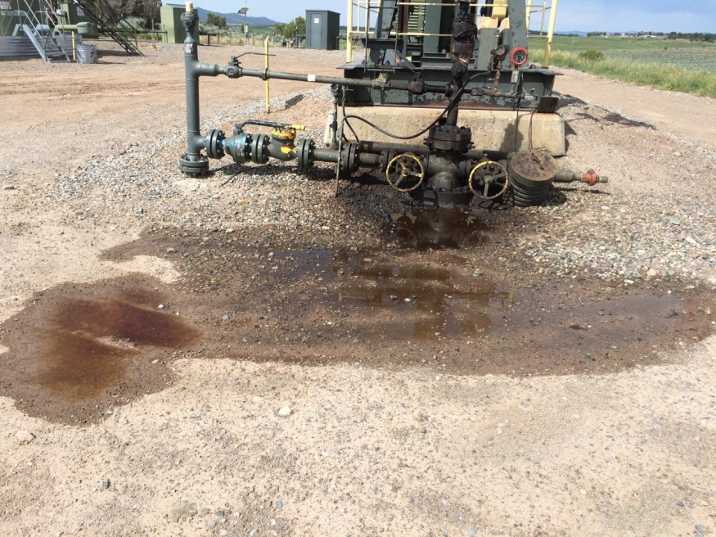
Figure 1. Packing leak caused 7.3 bbl to spill onto the ground around the wellhead.

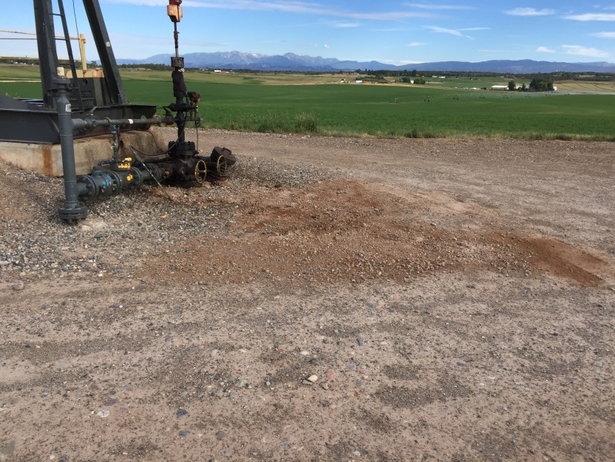
Figure 2. Spill area after oily dirt was removed and bugs were placed on the ground.

