Location # 331351 soil pile
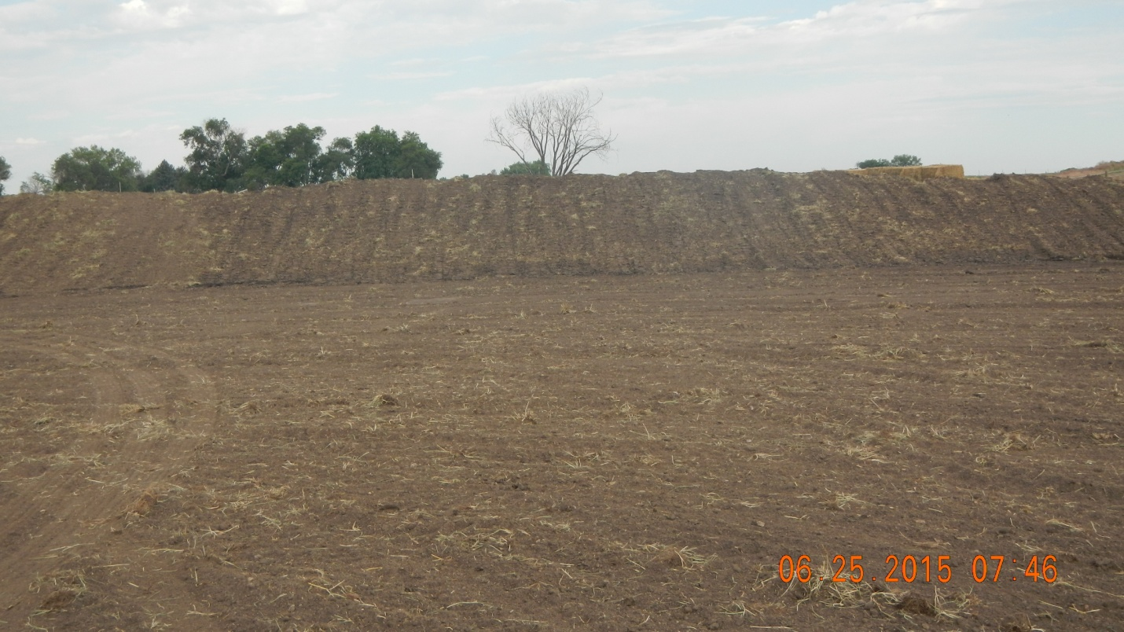
Ditch and berm in process of being compacted. 

