API # 123-28105, 123-34628 and 123-28140 weeds on location.
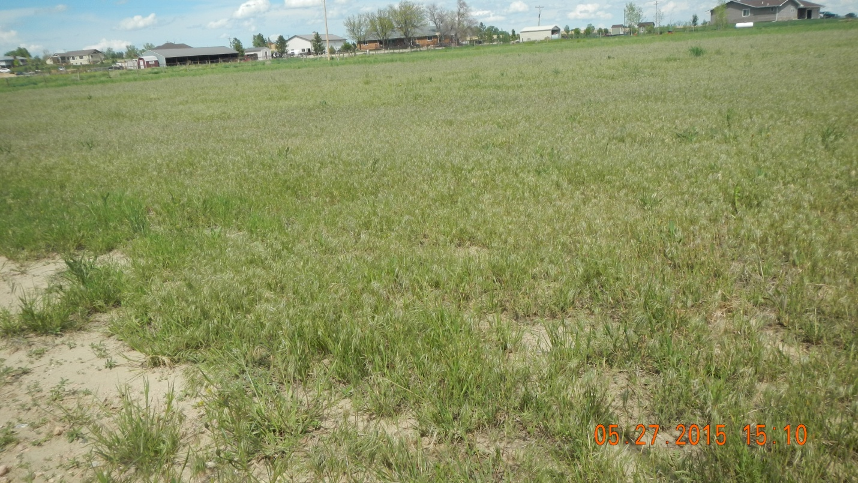
Reference area.


