Location # 441675. From east looking west along north sound wall. Ditch and berm.

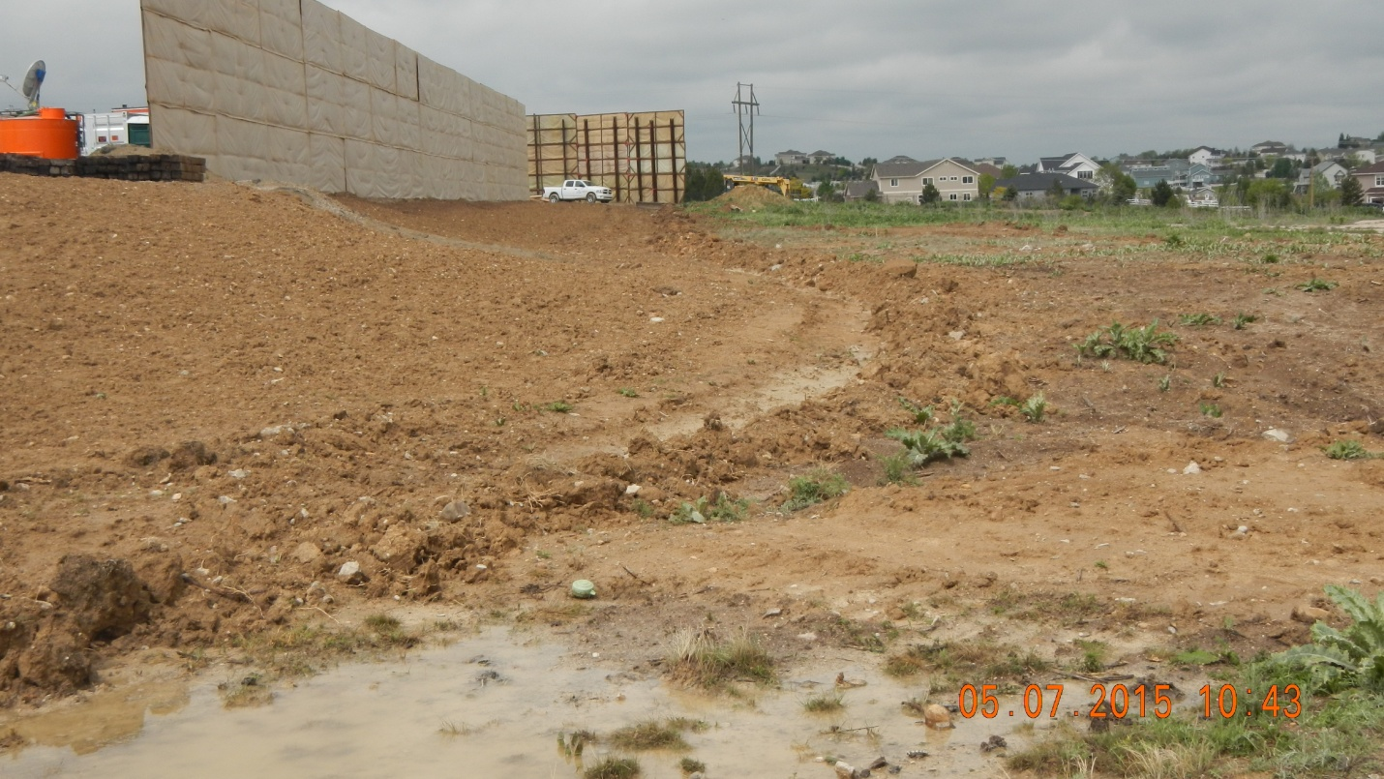

Soil pile from north looking south.


