Edge Energy Rule 306.e.(5) Operator Certification
Long 22-B Pad (22-1N-65W)
April 21, 2015

To satisfy our obligations under Rule 306, Edge Energy representatives, Steve Enger and Paul Onsager, voluntarily met with Building Unit Owners Judy Humphrey and Tom Heiney, as well as adjacent landowners Kenneth and Lori Pangle on March 6, 2015, in Hudson, Colorado from 10:00 to 11:30 am to discuss the Long 22-B pad development plans. Ms. Humphrey and Mr. Heiney's home is located within the Buffer Zone at 819 ft from the closest well that Edge is permitting on the Long 22-B pad in the NENW of Section 22. The Pangle's home is located roughly 2,500 ft from the well pad in the SENE of Section 22, which is outside of the Buffer Zone. Edge initiated the contact with Ms. Humphrey and allowed her to arrange the meeting time and place.
At the meeting, we reviewed the submitted Form-2A, including all exhibits, and all of the BMPs. We also reviewed the Form-2 for the Long 22-15-4NBH well. We provided copies of both to Ms. Humphrey and the Pangle's. We provided an estimated construction start date of April 1st, and generally discussed the time requirements for various phases of the operation for a total time estimate of 30 to 45 days from construction start to putting the well on production.
This document provides written confirmation by Edge Energy as to the topics, issues, and BMPs discussed at the meeting, as well as additional information to address and mitigate concerns raised by the Building Unit Owners at the meeting.

Specific Items Discussed:
Visual Impacts/Westerly View Obstruction
Edge Energy has stated in the Form 2A that "there would be landscaping utilized to visually mitigate the facility from the mountain view". While we do not believe that the mountain view from the Humphrey home will be obstructed by the facility, because the pad location is approximately 20 ft lower than the Humphrey home, we discussed ideas for landscaping that could address this concern at the March 6th meeting. Nothing definitive with respect to landscaping was finalized at this first meeting, but we agreed to continue to work with the homeowner to determine what type of feasible landscaping will address her concerns. The Building Unit Owners stated that they would care for the landscaping on their property.
It is important to note that per the 24K topo maps for this well pad from the COGCC website, the Humphrey home is located at an elevation of 5,070 to 5,075 ft, which is roughly 20 ft higher than the planned pad elevation of 5,052 ft at a distance of over 1,000 ft to the location of the facilties. This difference in elevation is easily seen in the photograph (see Figure 1) from the wellhead stakes looking east toward the Humphrey home. Because of this elevation difference at a distance of more than 1,000 ft to the facilities, we do not believe that the mountain view from the Humphrey home will be obstructed (See Figure 2).

Traffic/Mud on County Road
Ms. Humphrey brought up the issue that mud will get on County Road 8. Edge agreed to contact both Weld County and COGCC to review their respective requirements regarding mud on county roads.
Ms. Humphrey brought up the issue that her driveway has been used for a turn-around for vehicle traffic. Edge agreed that it would post an appropriate sign indicating that her driveway was a private road and that no turn-around would be allowed by Edge personnel or its contractors.
In addition, traffic planning requirements have been met in our approved Weld County Road access permit (copy attached) for access off of County Road 8.
BMP Discussed - 604.c.(2)D Traffic Plan: If required by the local government, a traffic plan shall be coordinated with the local jurisdiction prior to commencement of move in and rig up. Any subsequent modification to the traffic plan must be coordinated with the local jurisdiction.

Leak Prevention, Spill Detection, Odors, and Emissions Mitigation
We discussed that the facility will be inspected daily by a pumper for leaks and/or spills. The well pad will be governed by SPCC requirements. We discussed that CDPHE Regulations will apply to the facility, specifically limiting fugitive emissions and requiring the destruction of VOCs to 95% efficiency with an emissions control device.
BMP Discussed - 604.c.(2)F. Leak Detention Plan: Pumper will visit the location daily and visually inspect all tanks and fittings for leaks. Additionally, monthly documented SPCCP inspections are conducted pursuant to 40 CFR 112.
BMP Discussed - 604.c.(2)R Tank Specifications: Tanks will be designed, constructed and maintained in accordance with NFPA Code 30. The tanks are visually inspected once a day for issues, and recorded inspections are conducted once a month.
BMP Discussed - 604.c.(2)C.i. Green Completions - Emission Control Systems: Test separators and associated flow lines and sand traps shall be installed on-site to accommodate green completions techniques pursuant to COGCC Rules. In the anticipated absence of a viable gas sales line, the flowback gas shall be thermally oxidized in an emissions control device (ECD), which will be installed and kept in operable condition for least the first 90-days of production pursuant to CDPHE rules. This ECD shall have an adequate capacity for 1.5 times the largest flowback within a 10 mile radius, will be flanged to route gas to other or permanent oxidizing equipment and shall be provided with the equipment needed to maintain combustions where non-combustible gases are present.
BMP Discussed - 805 Odors and Dust: Oil & gas facilities and equipment shall be operated in such a manner that odors and dust do not constitute a nuisance or hazard to public welfare.

Lighting
We discussed the provisions of the BMP for Rule 803 regarding the use of downward lighting on location during drilling and completion operations, and that there would be no permanently installed lighting on site for normal production operations.
BMP Discussed - Rule 803 Lighting: During all phases of operations will be directed downwards and away from occupied structures where possible. Once the drilling and completion rigs leave the site, there will be no permanently installed lighting on site. Lighting shall be mounted at compressor stations on a pole or building and directed downward to illuminate key areas within the facility, while minimizing the amount of light projected outside the facility.

Noise Mitigation
Edge Energy plans to hire a qualified sound consultant to conduct a noise survey (Ms. Humphrey provided verbal permission to gather data on her property) and model the specific drilling rig to be used for the drilling operations. We will use the results of the model to design a noise mitigation program, up to and including the use of engineered sound walls, to be in compliance with COGCC rules.
We reviewed copies of our sound consultant's technical materials and brochures regarding sound modelling and mitigation measures at the meeting. We subsequently e-mailed pdf copies of the brochures to Ms. Humphrey, as directed, at tumbleweed737@hotmail.com.
BMP Discussed - 604.c.(2)A. Noise: Sound walls and/or hay bales will be used where necessary to surround the well site during drilling operations.

Dust Mitigation
We reviewed the dust mitigation BMPs in the Form-2A. The location is directly off of Weld County Road 8, so no extended access road will be necessary, which will serve to reduce the potential for dust. The location and short access from County Road 8 will be plated with Class 6 Road base to stabilize the location, and to reduce mud and dust.
BMP Discussed - 805 Odors and Dust: Oil & gas facilities and equipment shall be operated in such a manner that odors and dust do not constitute a nuisance or hazard to public welfare.

Water Well Concerns
Ms. Humphrey raised concerns about the existing condition of her water well. She mentioned corrosion and what sounded like the potential for methane being present. Although Ms. Humphrey's water well is not located within the same governmental quarter section as described in Rule 318.A.f.(2).A for a potential well to be tested, Edge Energy plans to test the Humphrey well in addition to the land owner's water well in the NW Section 22, T1N, R65W (Mr. Larry Long's well, assuming that it qualifies as an available water source and he grants permission). We plan to follow the testing protocols specified in Rule 318.A.f with respect to the specified list of analytes (including pH, specific conductance, total dissolved solids (TDS), dissolved gases (methane, ethane, propane), alkalinity (total bicarbonate and carbonate as CaCO3), major anions (bromide, chloride, fluoride, sulfate, nitrate and nitrite as N, phosphorus), major cations (calcium, iron, magnesium, manganese, potassium, sodium), other elements (barium, boron, selenium and strontium), presence of bacteria (iron related, sulfate reducing, slime forming), total petroleum hydrocarbons (TPH) and BTEX compounds (benzene, toluene, ethylbenzene and xylenes) for the Humphrey water well test. We obtained verbal permission from Ms. Humphrey at the meeting to test her well prior to commencing drilling. We plan to sample the well between 6 and 12 months following completion of the first well on the pad as described in Rule 318.A.f.(4).B.

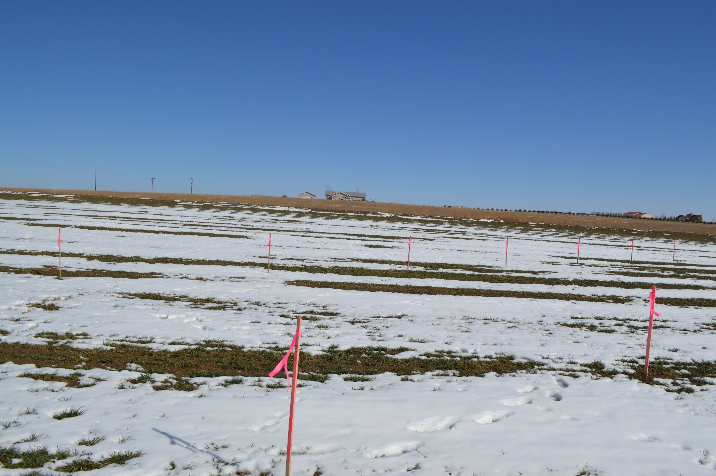
Figure 1: View of the Humphrey home looking east from wellhead stakes
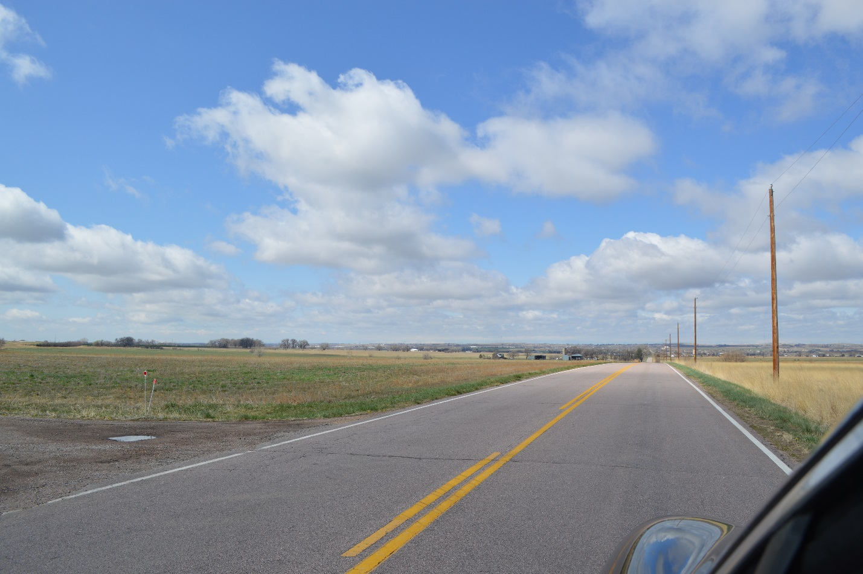
Figure 2: View looking west on County Road 8 at the location of the Humphrey home towards the well pad

