Location # 441121, Un-compacted berm and ditch.
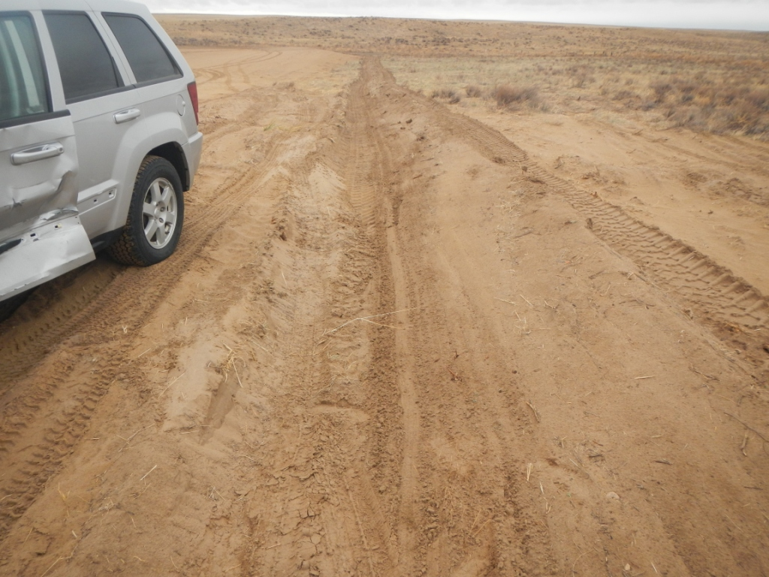
No top soil pile.


