Location # 441093, un-compacted berm and ditch.
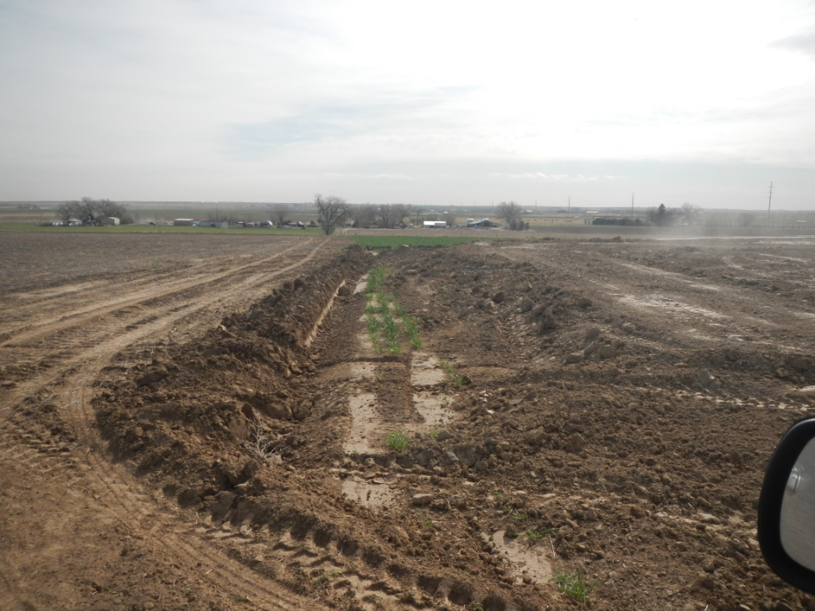
Soil pile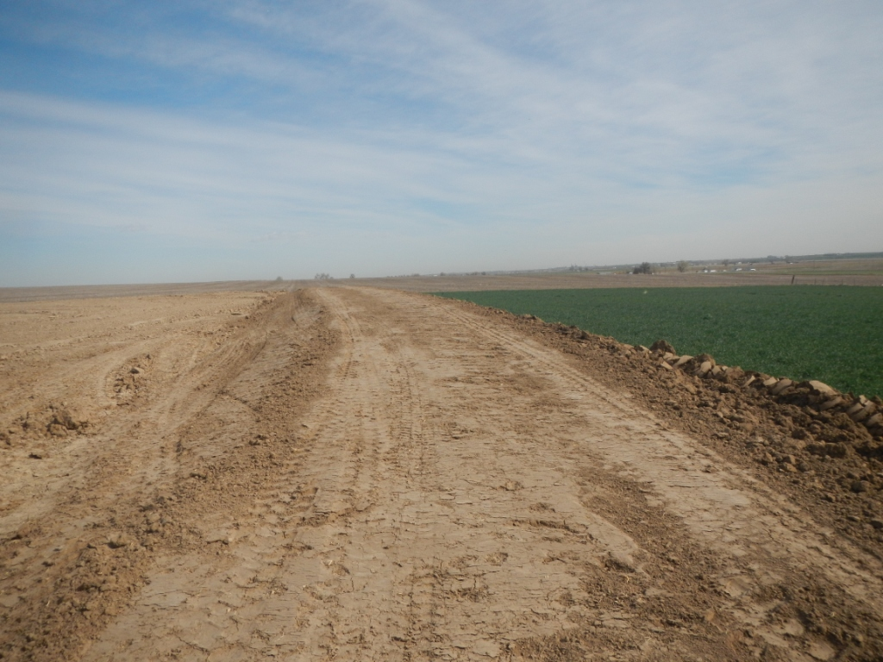
Un-compacted berm and ditch at cut bank. 

