API # 05-123-30994,
Picture taken: 3/18/2015
From center of pad facing North
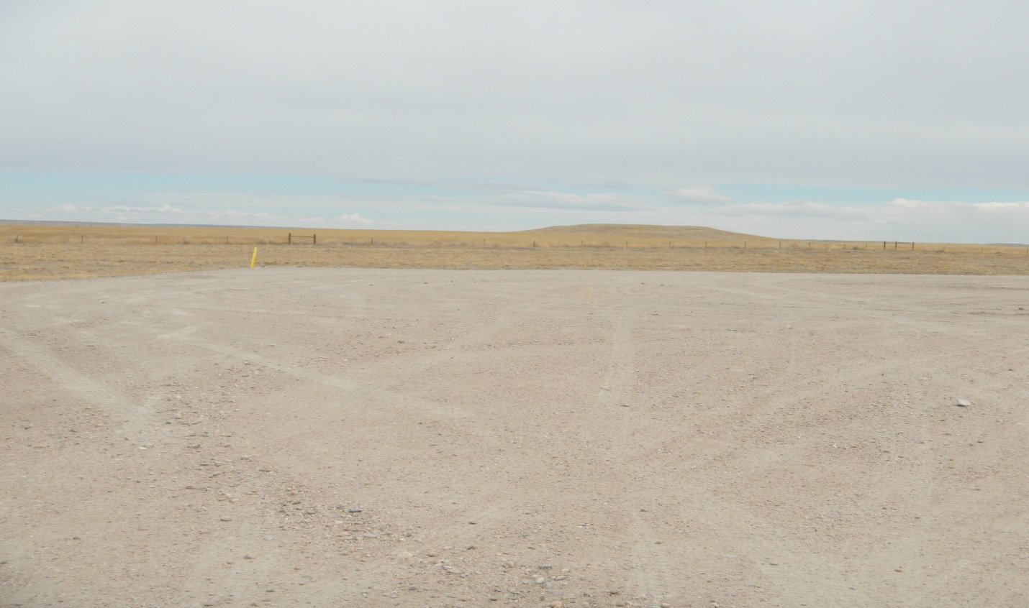

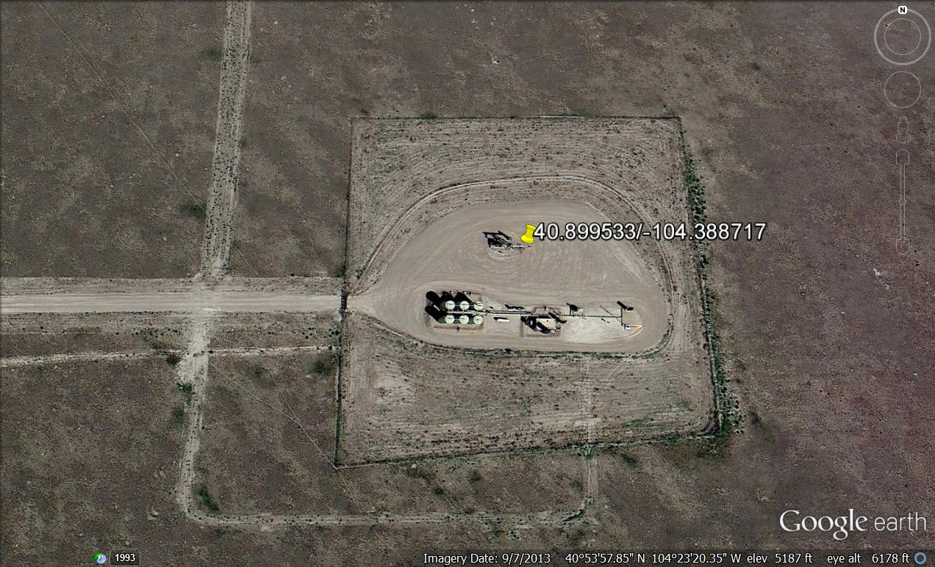
Estimated size of pad required for production activities. Approximately 1 ½ acres.

