API # 123-32365, Gas metering building on site.
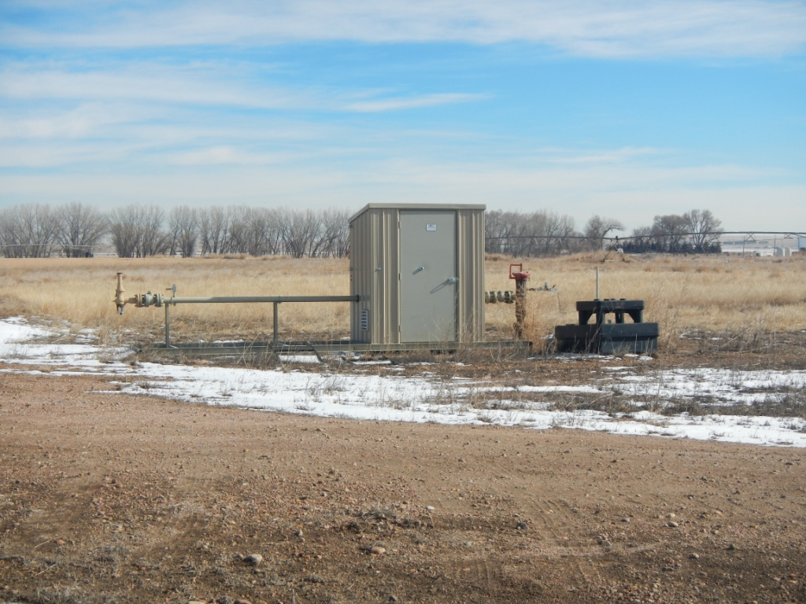
Lack of growth on P/A location.


