Location # 440427, Lack of compaction on berm and ditch.
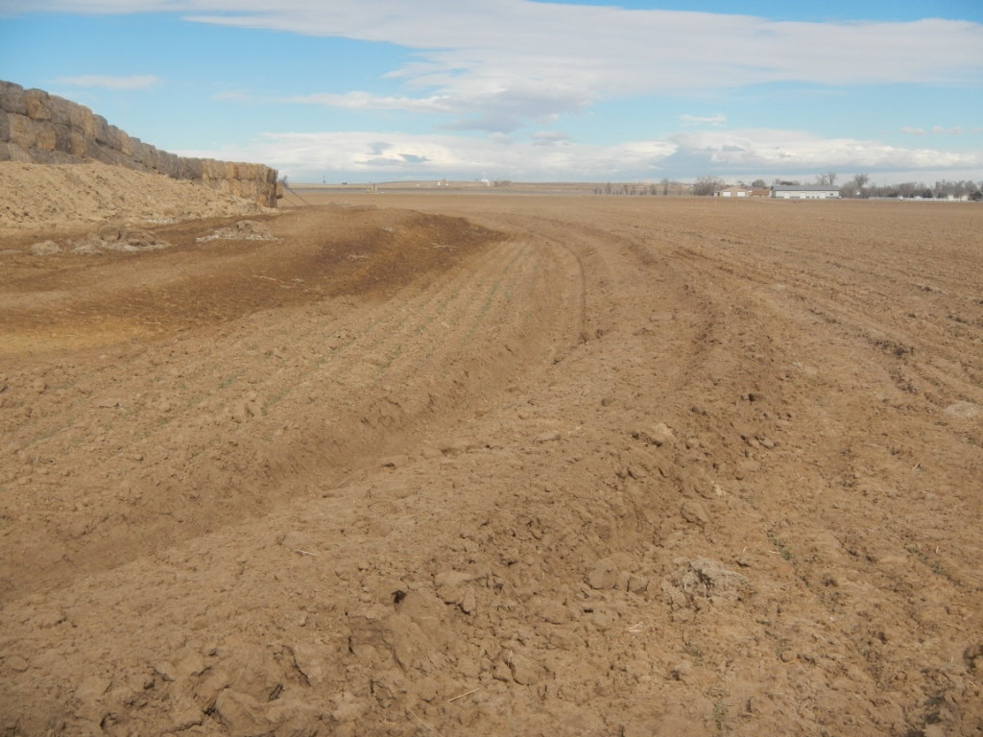
Soil Pile


