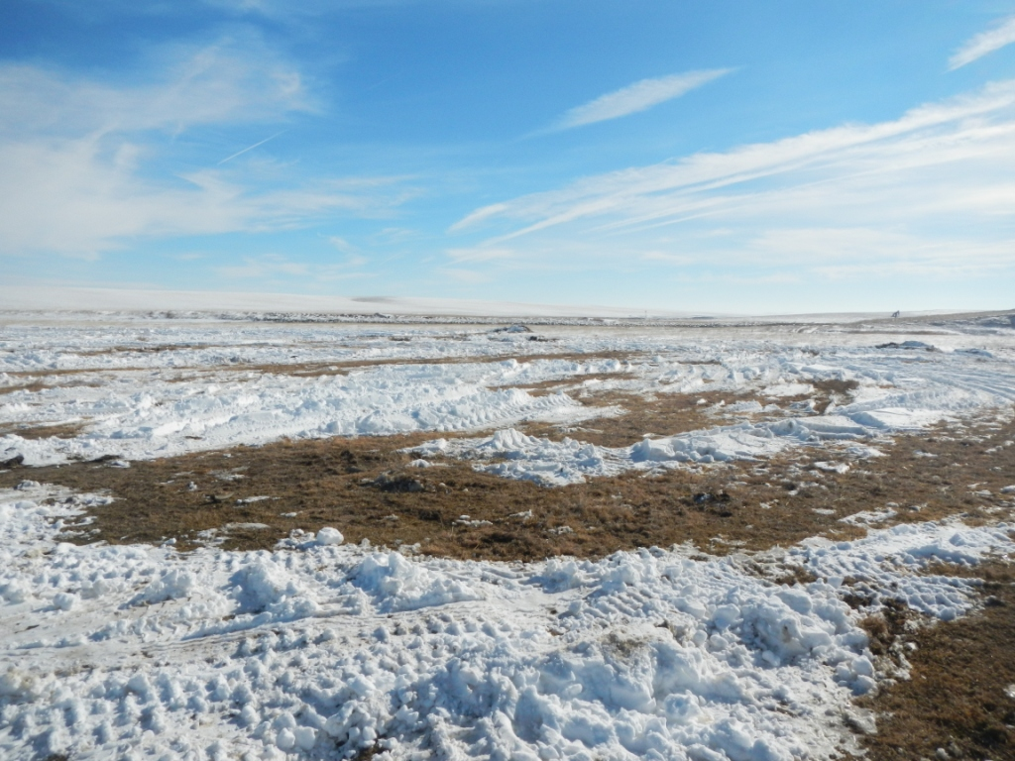
API # 121-09826. No evidence of new construction.

