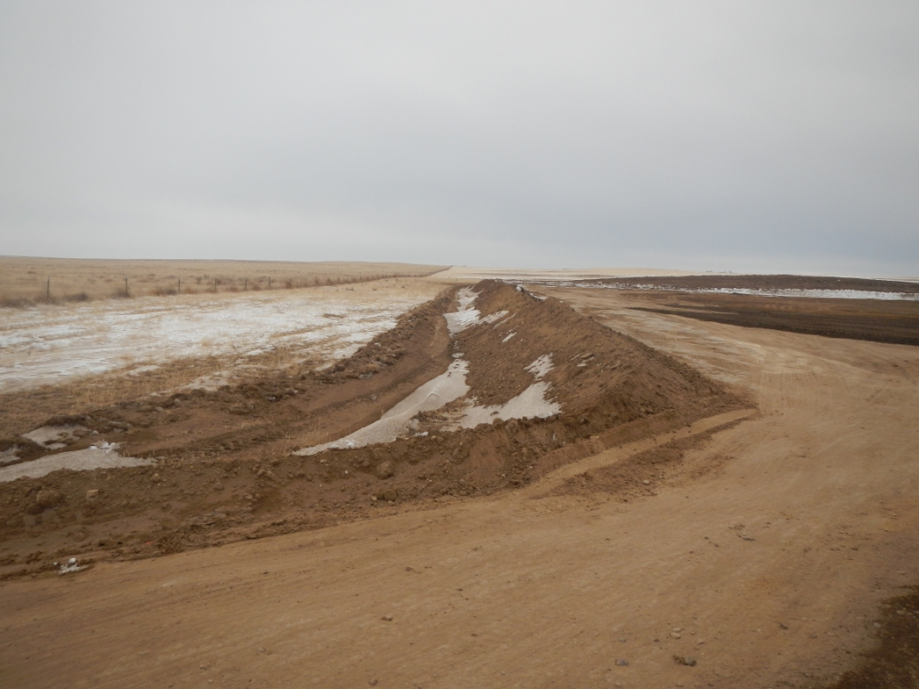
Location 438766. Berm and ditsh downslope.
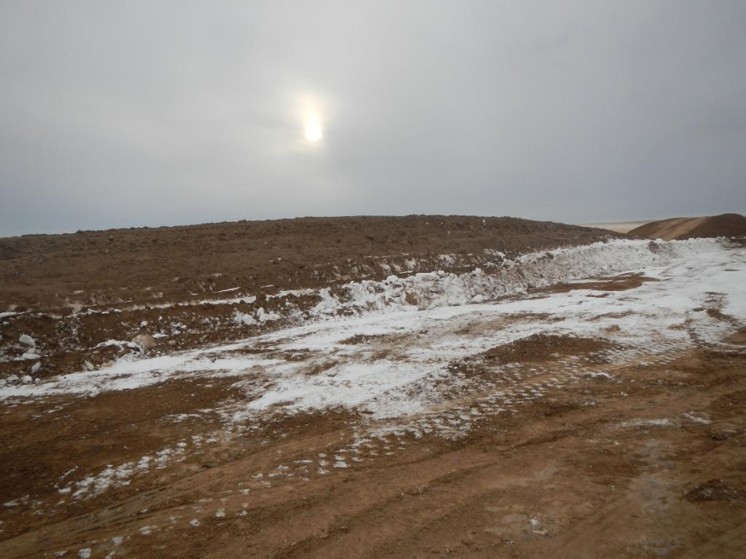
Location 438766. Top soil pile.
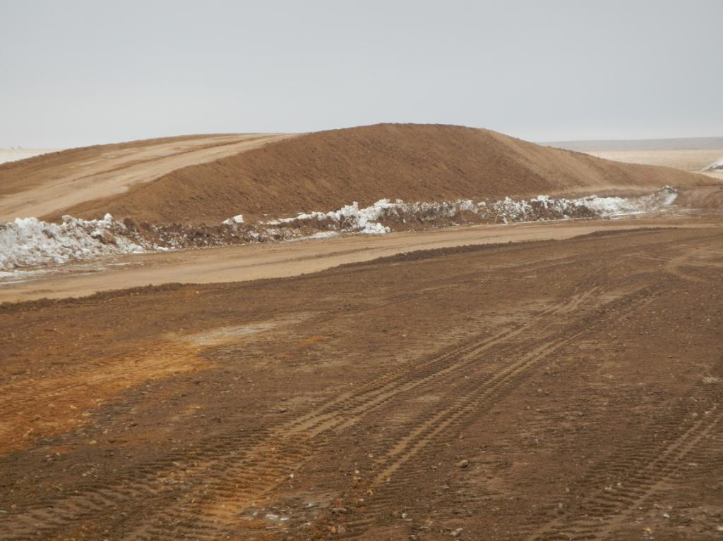
Location 438766. Spoil pile.

