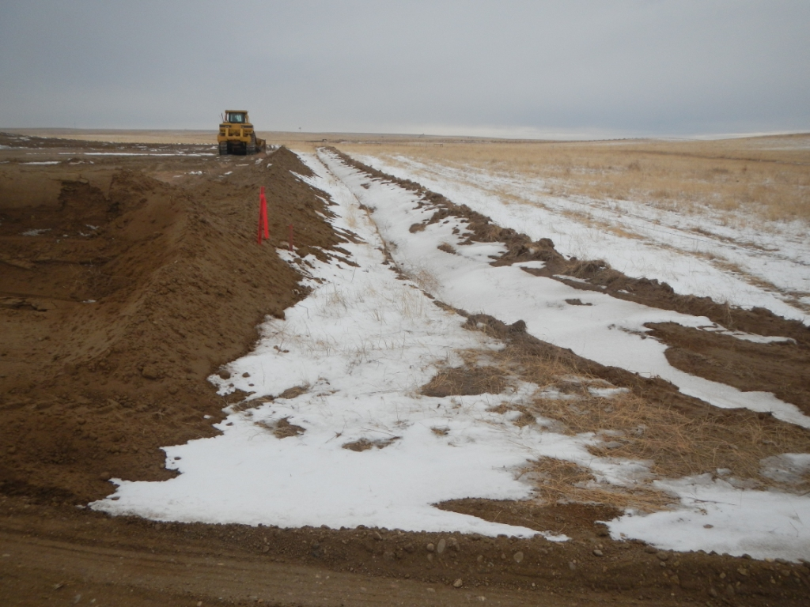Location 438482. Berm and ditch downslope.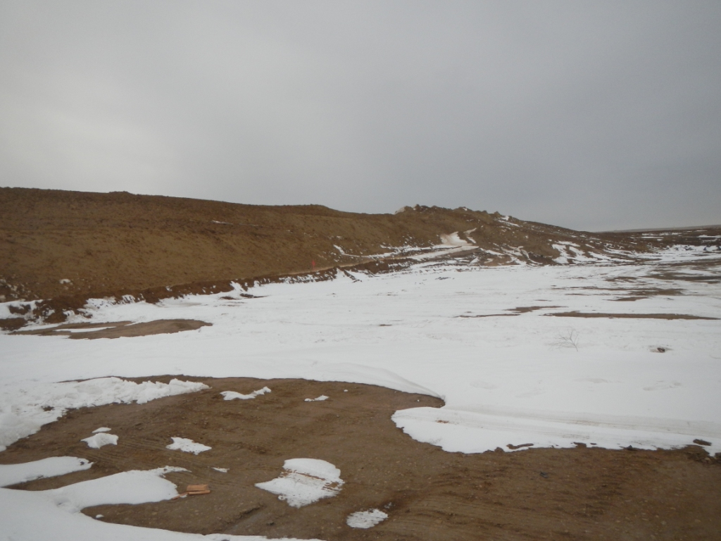
Location 438482. Spoil pile
S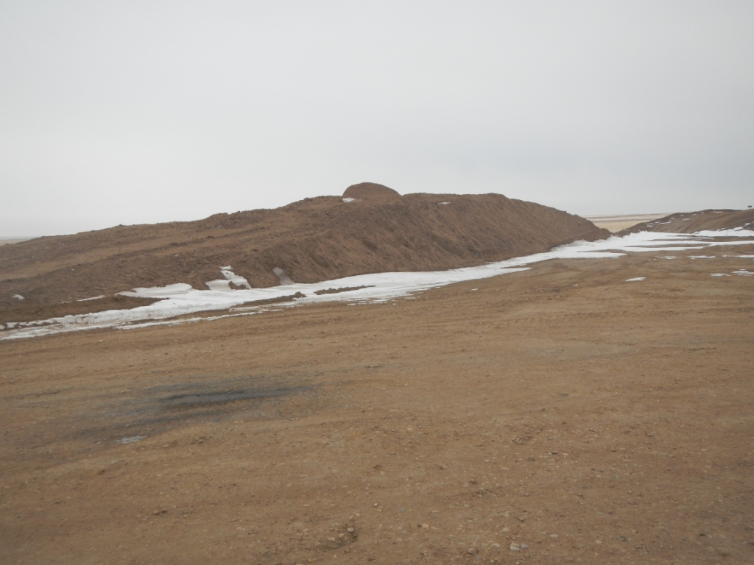
Location 438482. Top soil.

