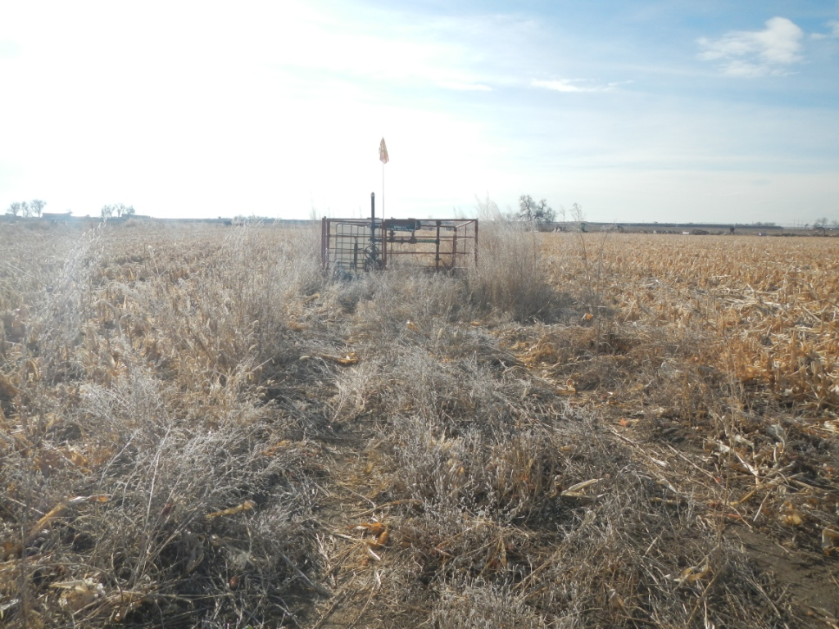
API # 123-16524. Weeds.

