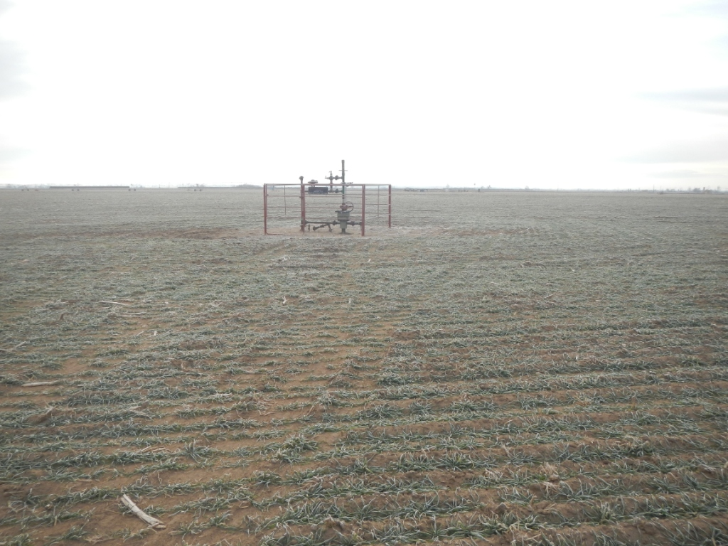
API # 123-30529 and 123-30540. A/L on Location # 331164 owned by Noble.

