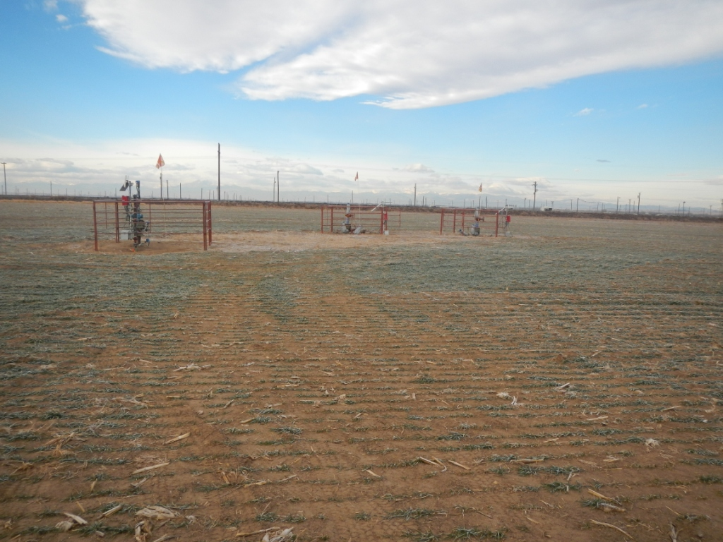
API # 123-19485, 123-32299 and 123-32269.

