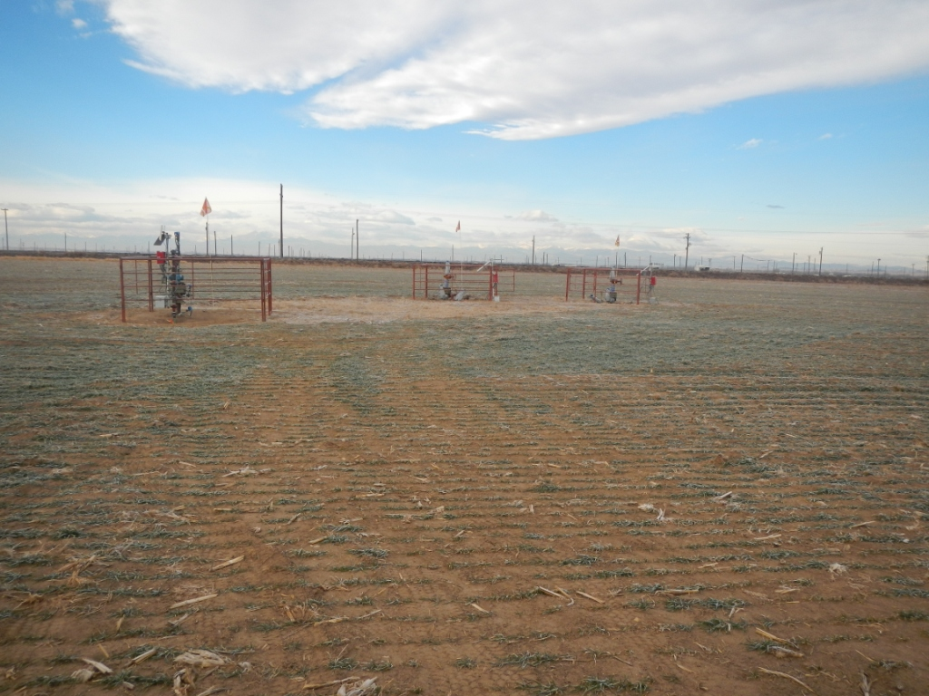
API # 123-30447 and 123-30530. A/L on Location # 330702 owned by Noble.

