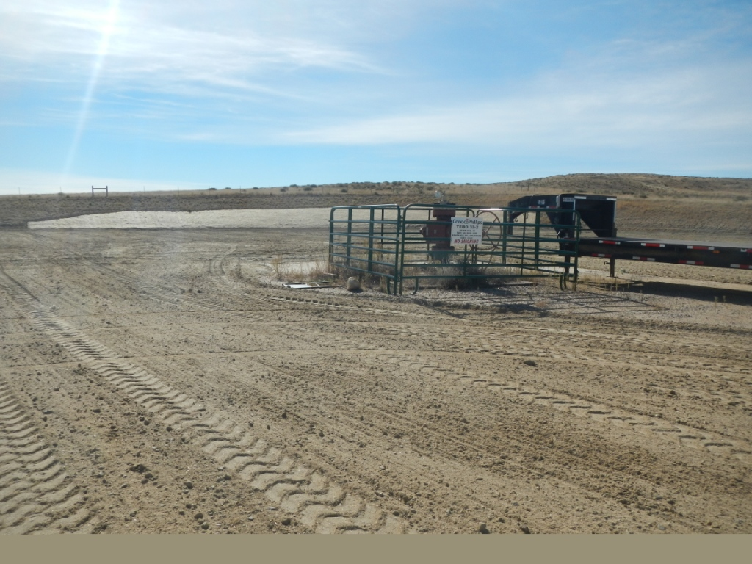
API #005-07177 Well, no interim reclamation.

