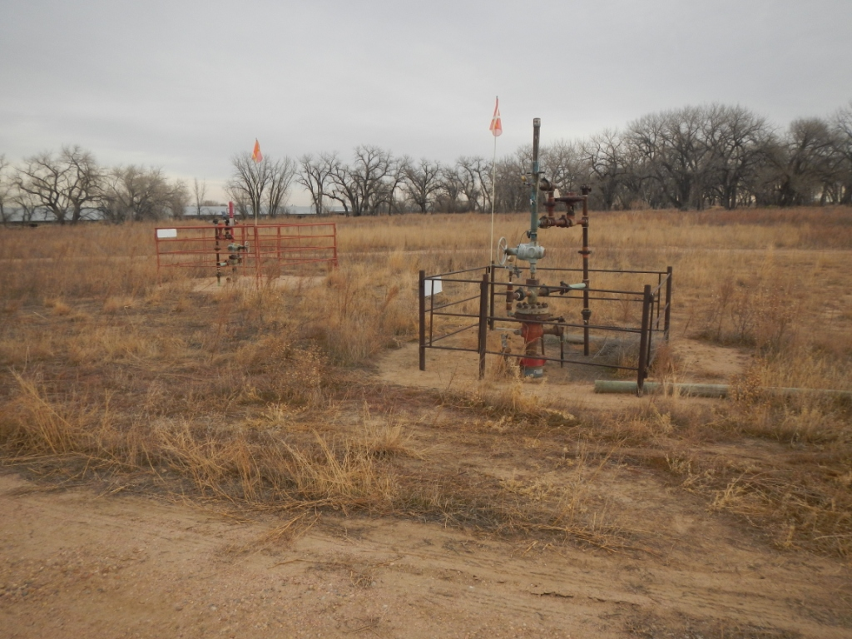
API #AND 123-13424 WELLS. 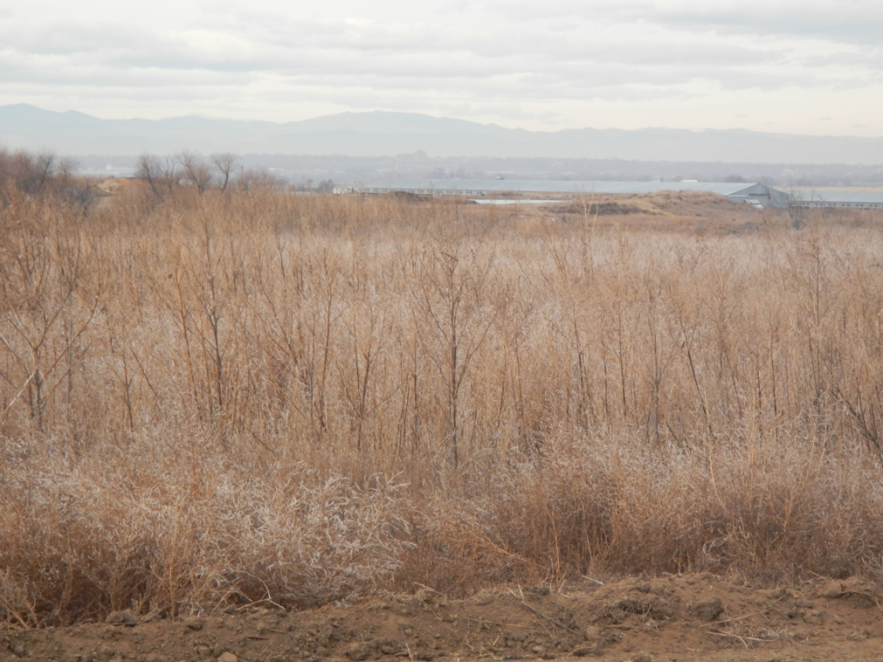
API #123-26873 AND 123-13424 REFERENCE.

