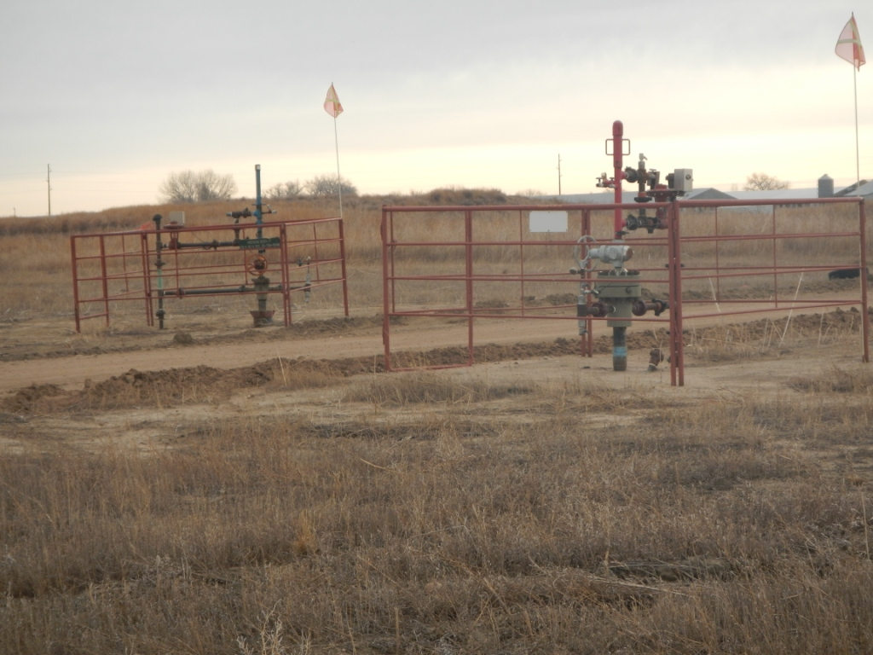
API # 123-13422 AND 123-06874, WELLS. 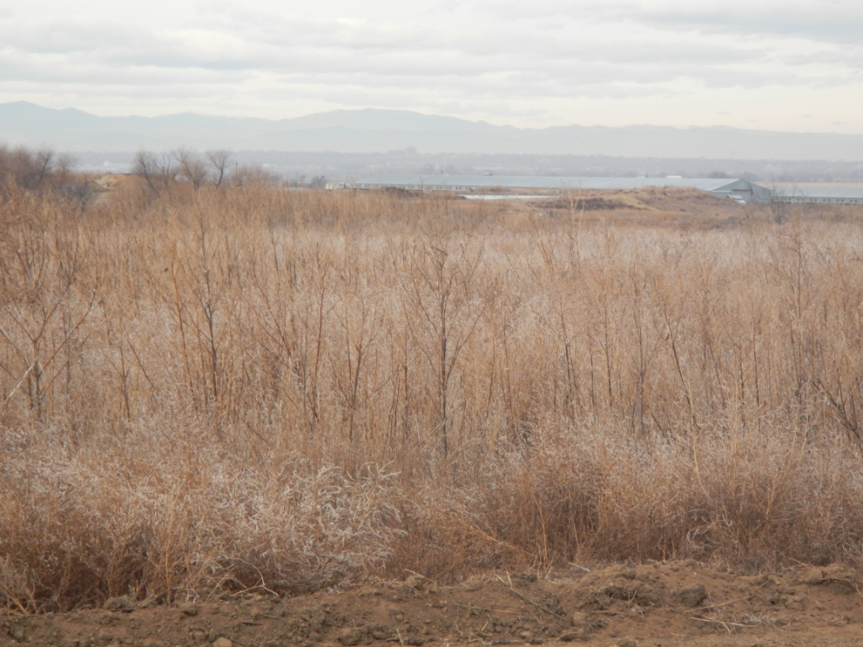
API # 123-13422 AND 123-06874, REFERENCE.

