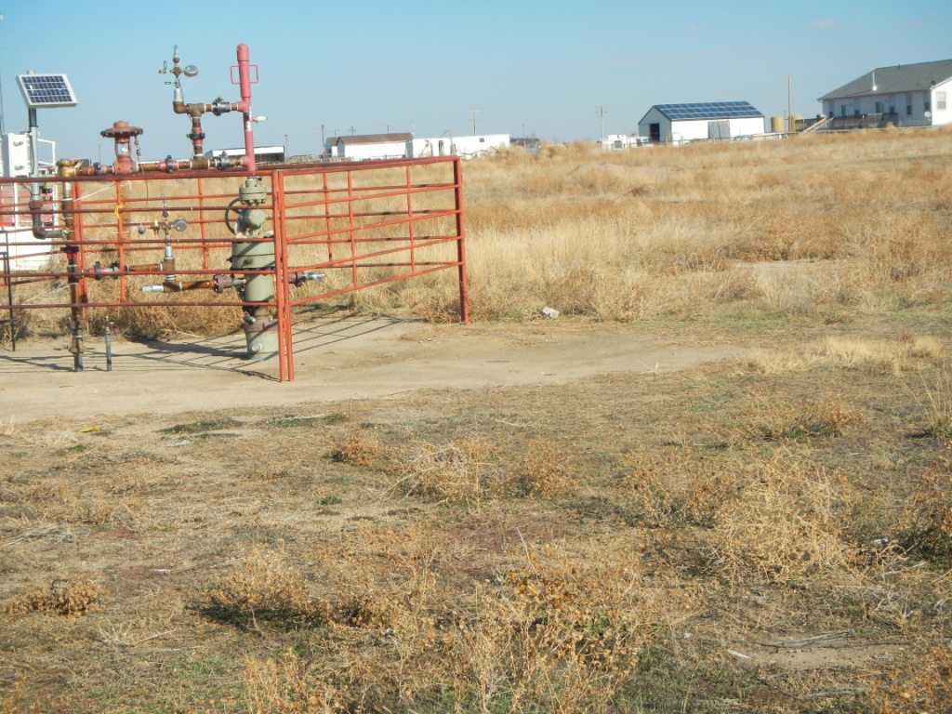
API # 123-09717 well.

API # 123-09717 and API # 123-21512 reference 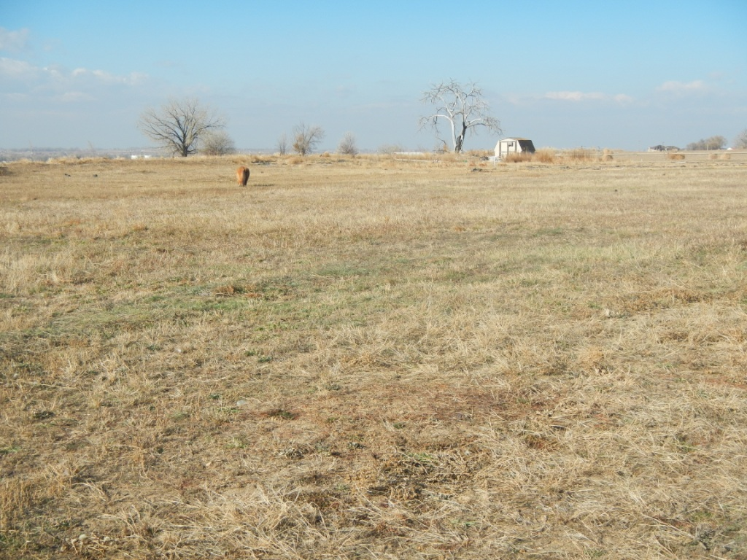

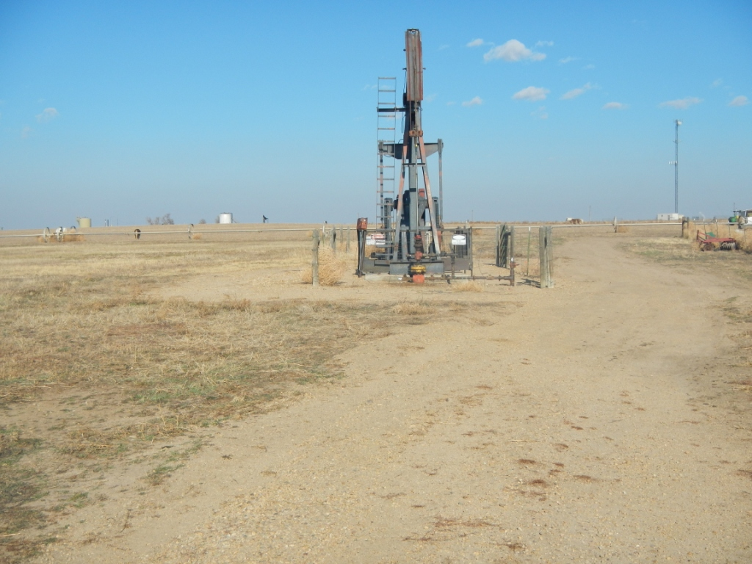
API # 123-21512 well

AAPIAr

