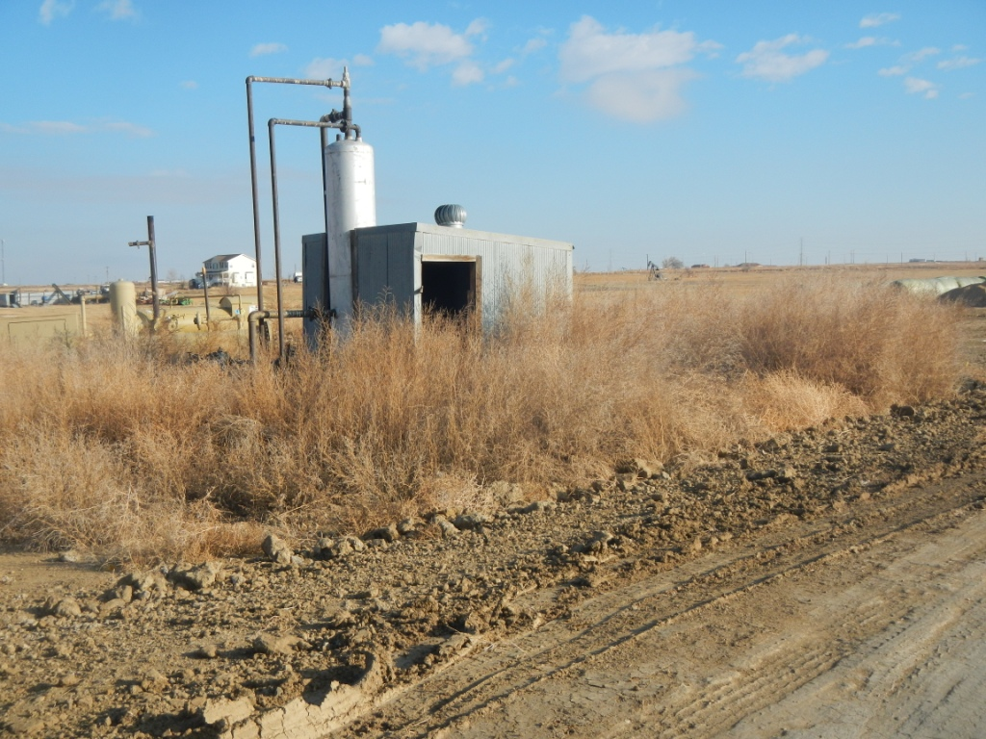
API #123-07348 Weeds.
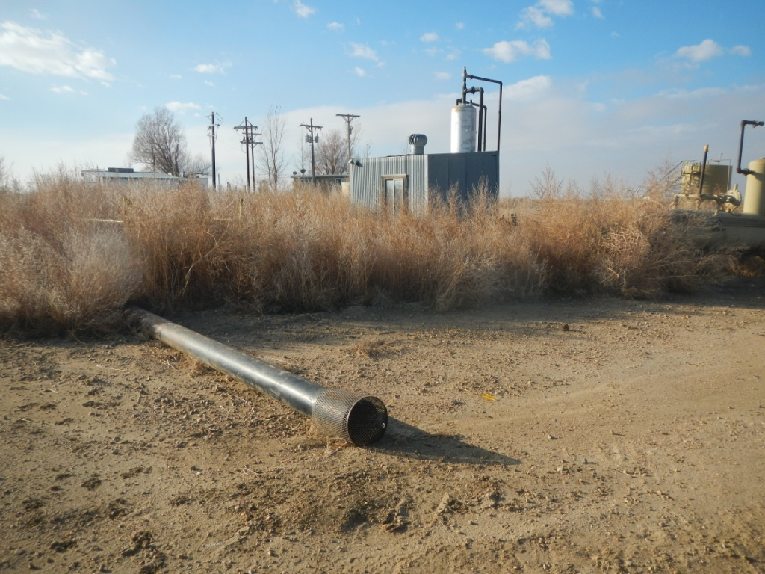
API #123-07348, Unused equipment.

