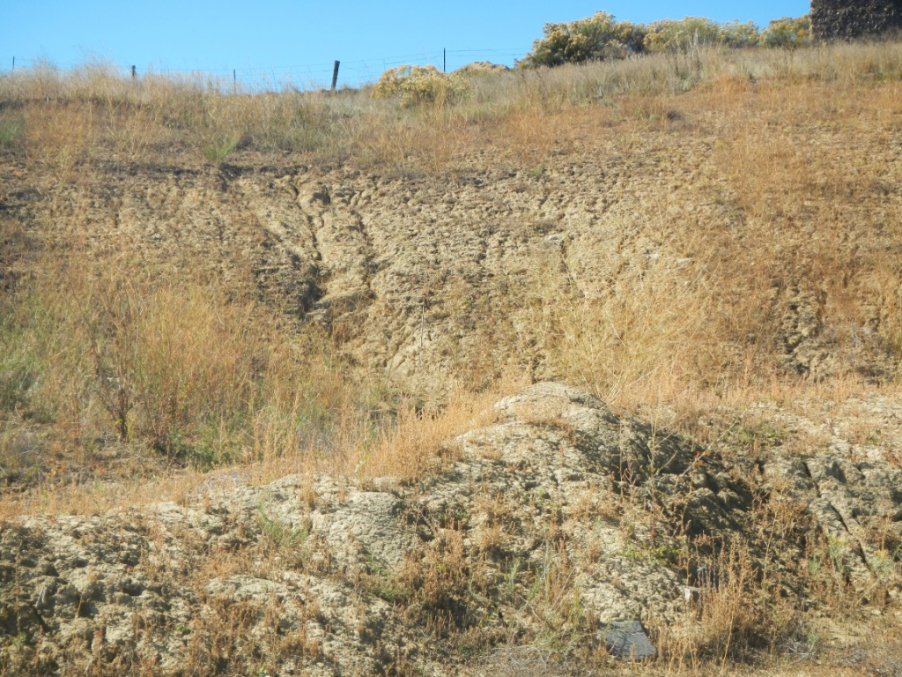
RANCHERS EXPLORATION PARTNERS LLC: Retta J 1, API 069-06431. Picture taken 10/14/14 of south west cut bank showing erosion and weeds.
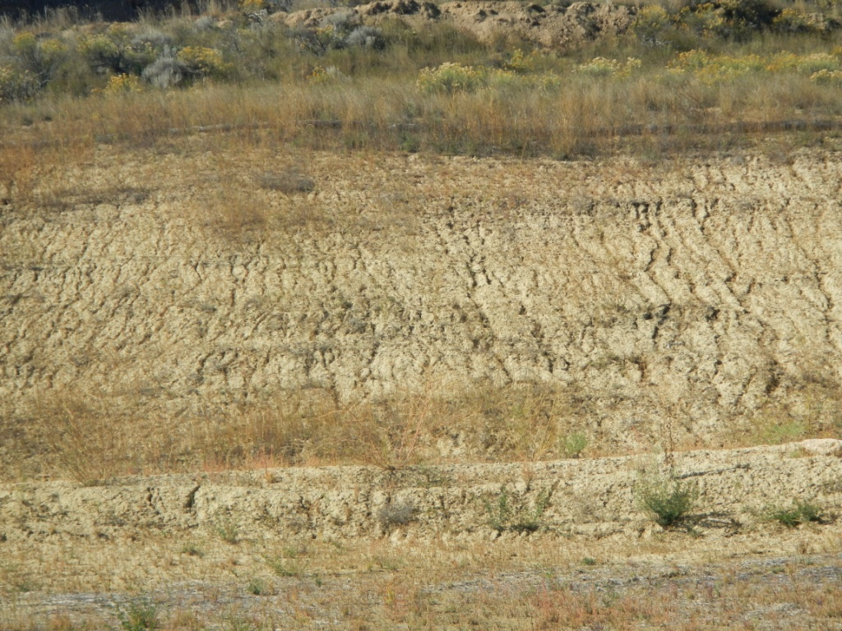

RANCHERS EXPLORATION PARTNERS LLC: Retta J 1, API 069-06431. Picture taken 10/14/14 of west cut bank showing erosion and weeds.

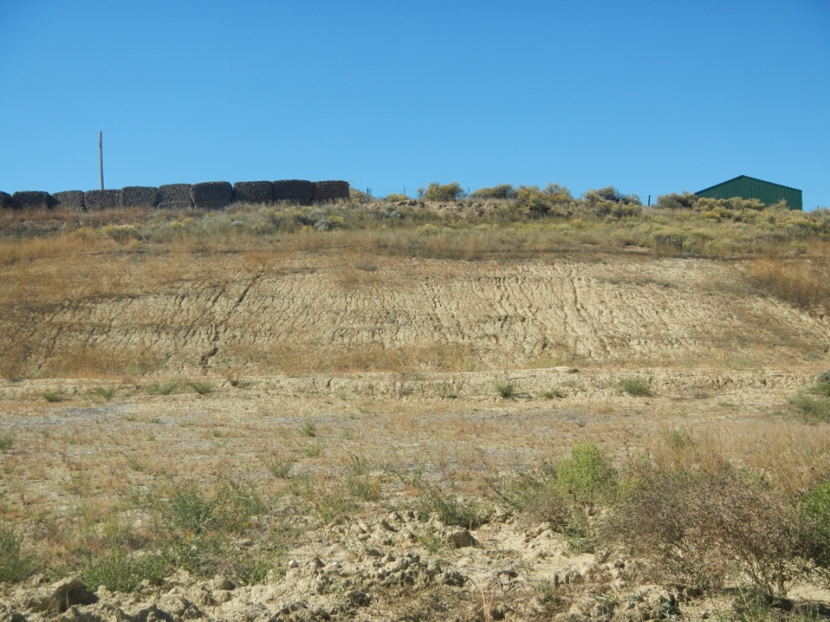

RANCHERS EXPLORATION PARTNERS LLC: Retta J 1, API 069-06431. Picture taken 10/14/14 of west cut bank showing erosion and weeds.

