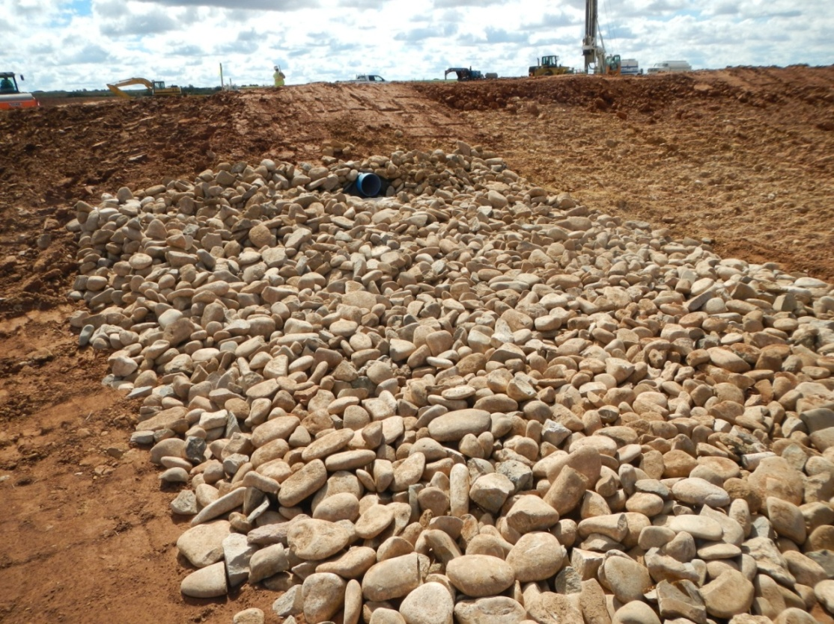
Photo 1. View of well pad drain outlet that is armored with cobble.
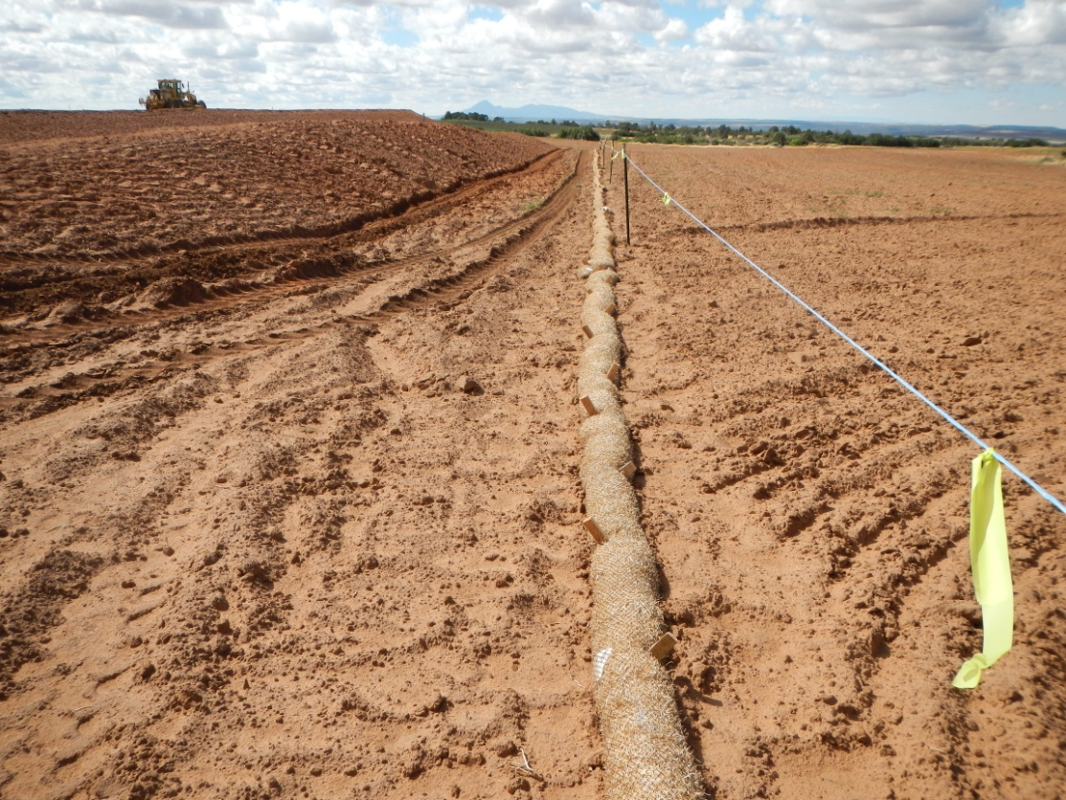
Photo 2. View of straw wattle and wildlife fence on the western edge of the project area.
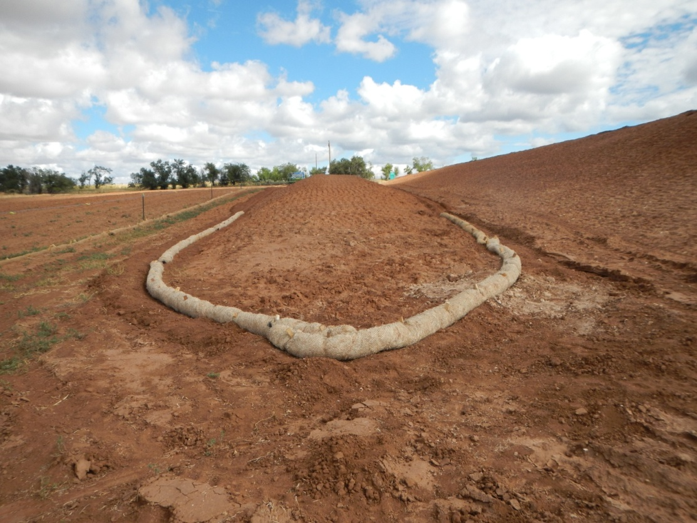
Photo 3. View of stockpiled topsoil with straw wattles.
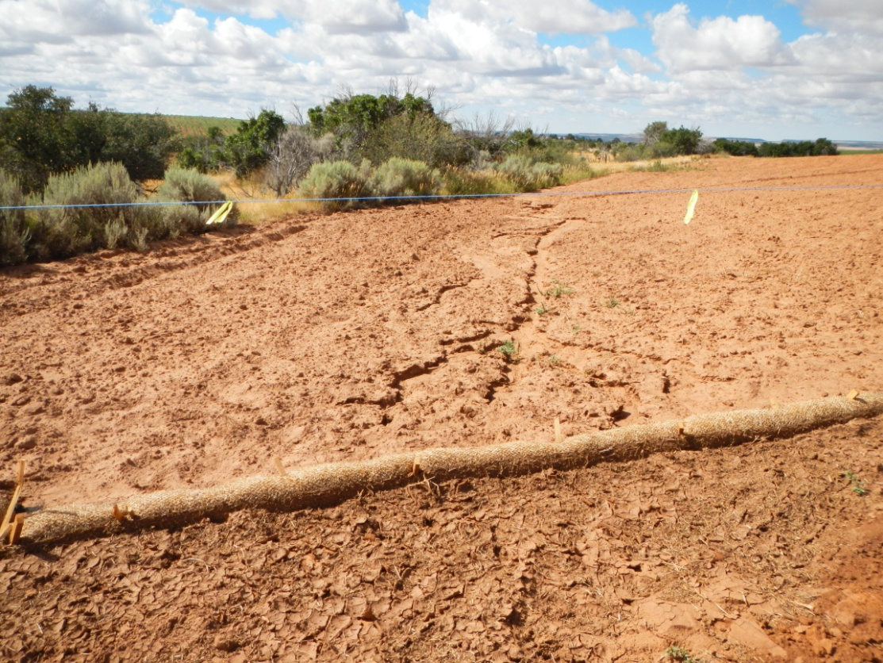
Photo 4. View of erosion at the southeastern corner of well pad.

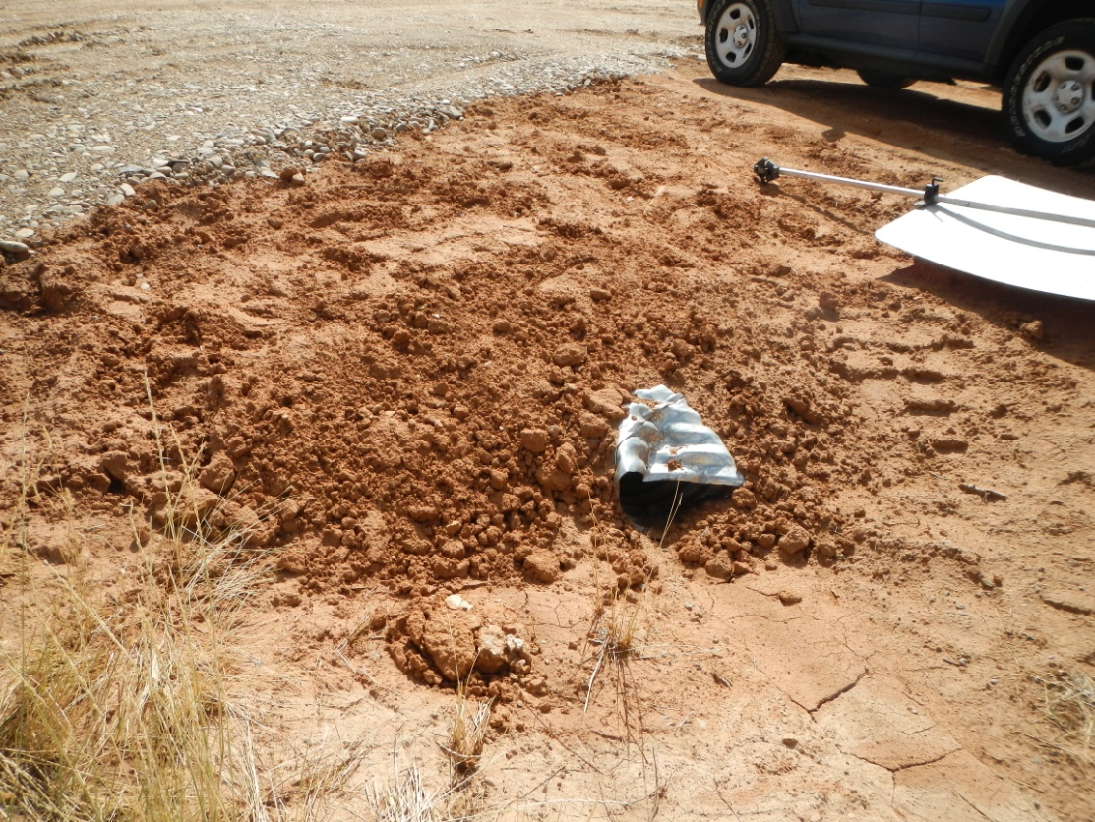
Photo 5. View of damaged culvert at entrance to well pad.

