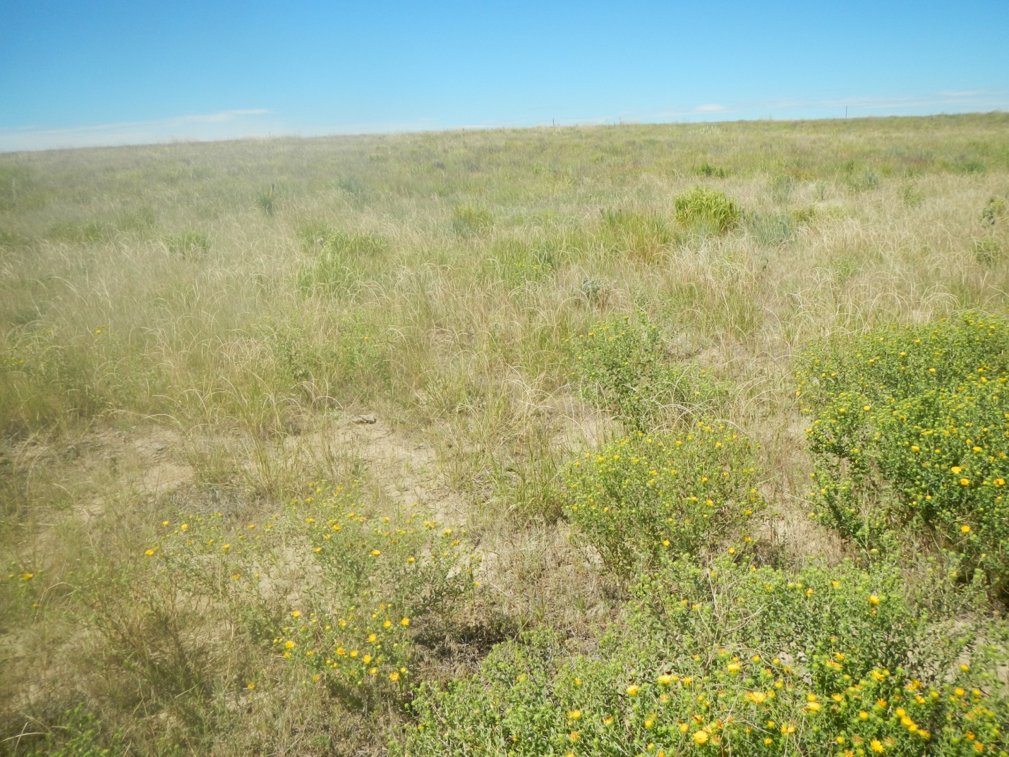
087-06634 South side of reference area looking North
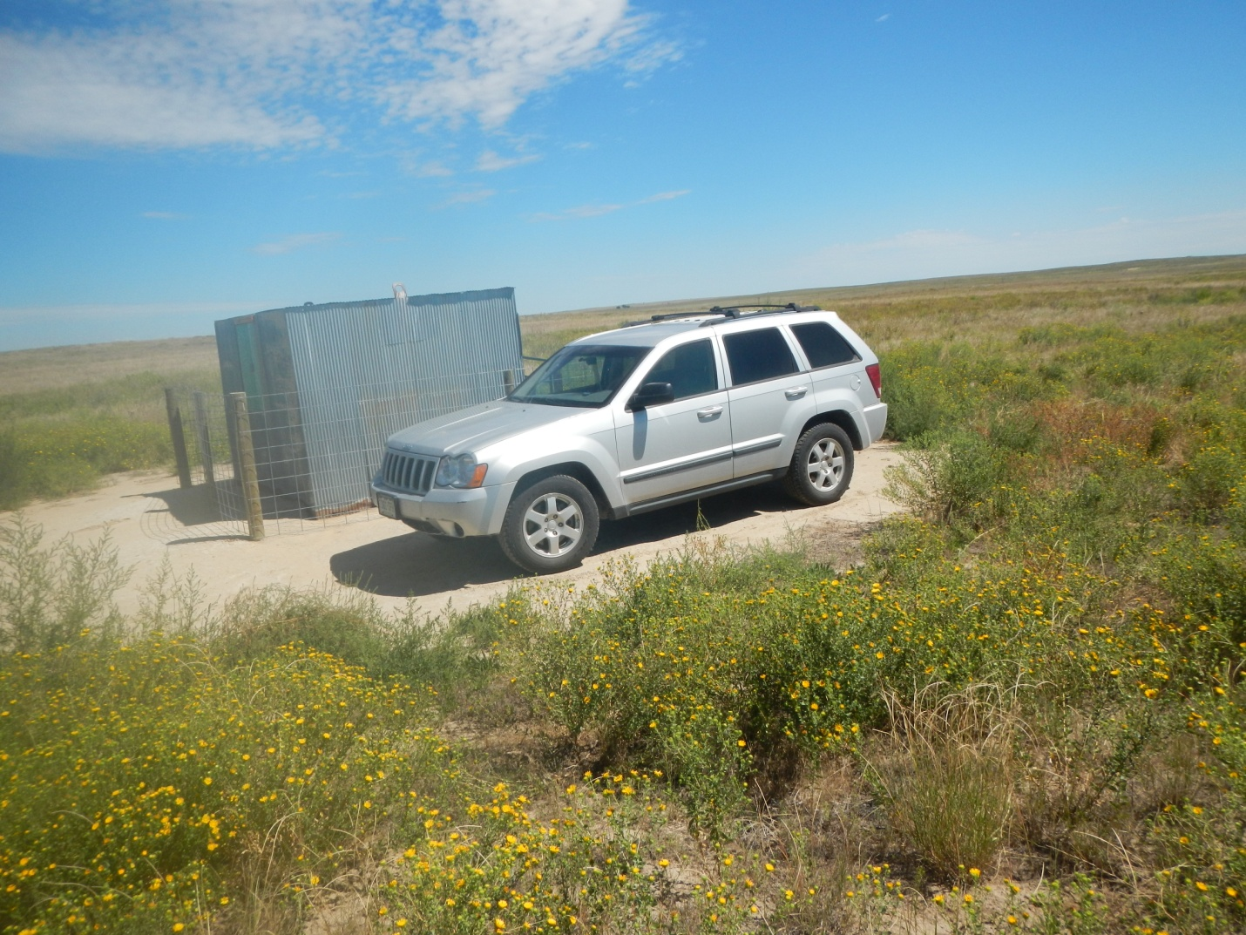
087-06634 South side of location looking North.

