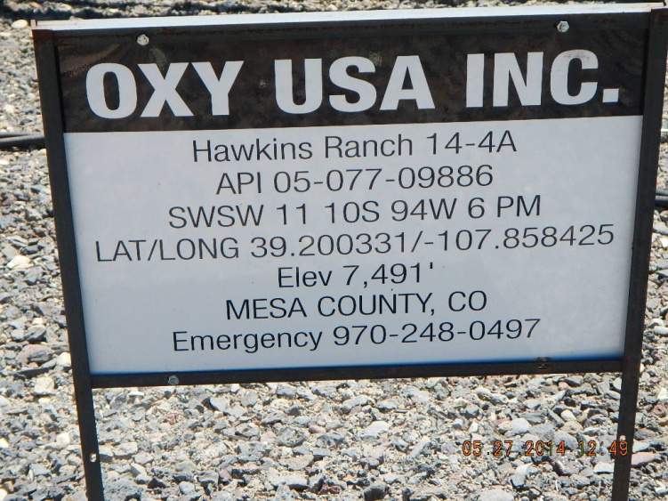

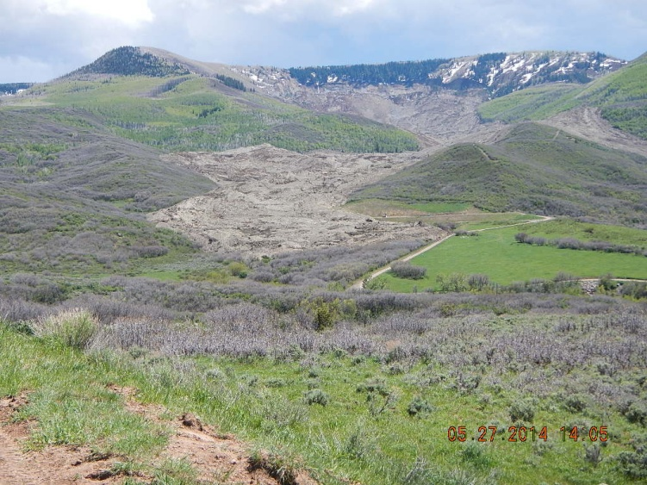 OXY Pad is at lower right edge of slide
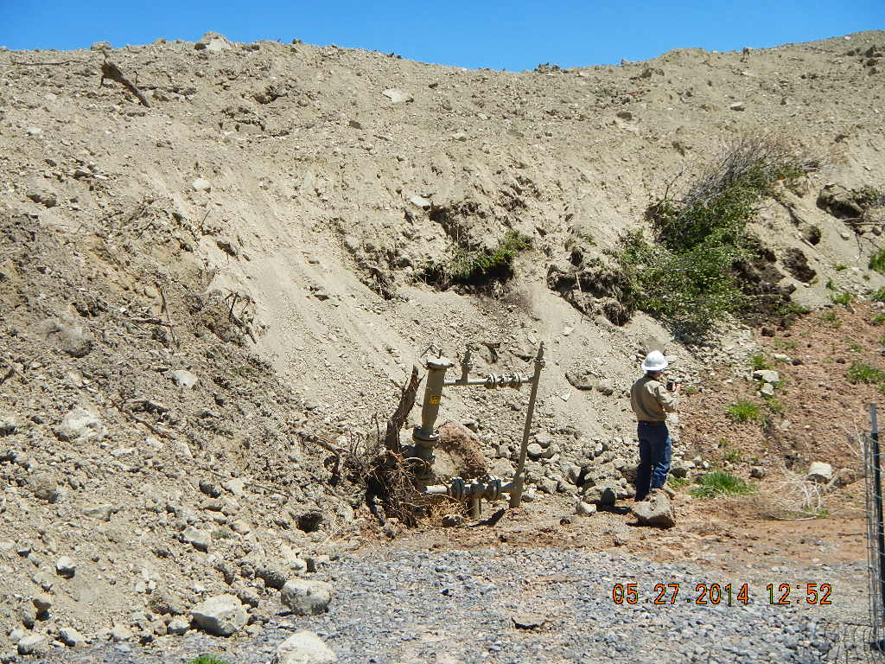 Bent pipeline riser at east edge of pad
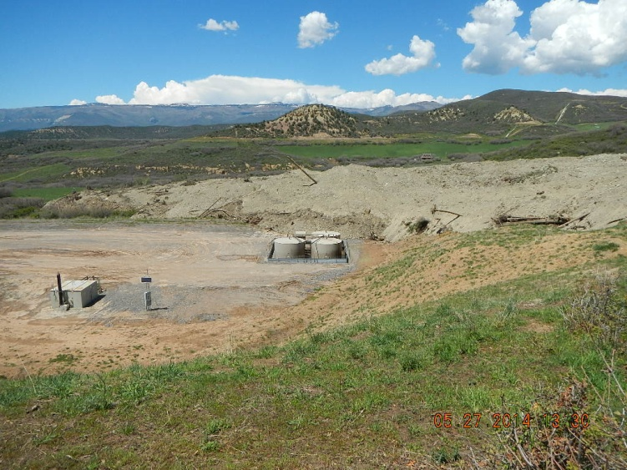 View of pad looking NE downslope. Wells are to the west.

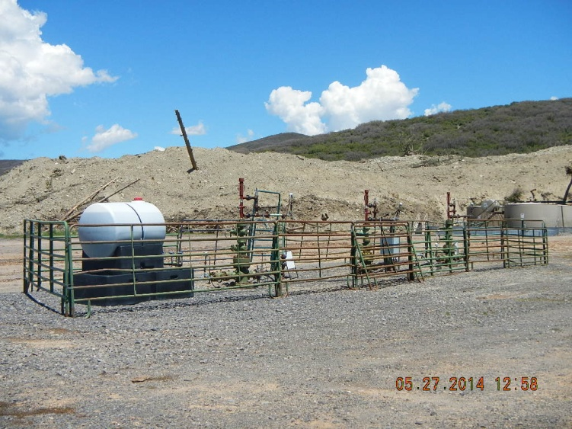 Thee shut in wells to the west of slidle path

